

LOGISTICS OPERATIONS GUIDE (LOG)

Advanced draft – DECEMBER 2006

(open for comment - all comments to be sent to info@unjlc.org).

LOG 1 – SECTION 1: INTRODUCTION
Mission Statement
The mission of the United Nations Joint Logistics Centre (UNJLC) is The United Nations Joint Logistic Centre (UNJLC) is an inter-agency Humanitarian Common Service. Its mandate is to provide Logistics Information Management support and services to complement and support the logistics capabilities of cooperating humanitarian agencies, as well as to the Global and Field Logistics clusters, during complex and large-scale emergencies.
Activation Process
The UNJLC is a facility, which is activated when intensified field-based inter-agency logistics activities are required either during the build-up phase or immediately after the onset of large-scale emergencies. The formal activation of the UNJLC will be considered through an inter-agency consultation at Field and Headquarters level among decision-makers designated by the Interagency Standing Committee Working Group (IASC WG). The decision to activate is made within 24 hours after the formal request, in accordance with the modalities described in the Concept (March 2002). (See LOG 2 Section 3 for detailed description of the activation process.) Once mobilised, the UNJLC will support the Agencies in their respective coordinated activities but its service may be expanded to include logistics support to other humanitarian organisations. In this context, it will seek the widest possible participation among humanitarian logistics actors.
Purpose
While the Concept provides the platform for deciding on the activation of the UNJLC, this Logistics Operations Guide (LOG) is the reference tool for UNJLC Core Unit as well as those individuals sent to the site of an emergency; these may be Core Unit staff, seconded staff or consultants. The LOG will also be valuable for other actors in a humanitarian emergency response, providing a wealth of key information about: humanitarian logistics and emergency operations of the United Nations; the modus operandi of militaries and international organizations; the function of inter-governmental agreements; and, the functioning of international platforms for cooperation.
Approach
The LOG covers a wide spectrum of functions and activities. However, UNJLC responsibilities will be determined on a case-by-case basis, depending on the context and the nature of any humanitarian emergency. The LOG is based on a logical sequence of chronological actions taken after the onset of a large-scale emergency requiring multi-sectoral humanitarian support. Although the approach takes into account the uncertainty and the unpredictability that surround humanitarian emergencies, it is possible that, depending on the circumstances, the structures and actions described in this LOG may have to be modified, limited or expanded. Therefore, the LOG should only be considered as generic guidance to help the staff officers in their tasks, in particular during the early phases of the deployment. Besides the application of procedures and checklists recommended in this manual, professional skills and sound judgement, complemented by a cooperative spirit between staff officers, agencies, other humanitarian actors and governments will be a prerequisite to guarantee a smooth and efficient functioning of the system.
Structure of the LOG and How to Use the LOG
LOG 1 is the core of the LOG and is available in hardcopy handbook and electronic format. It provides an overview of the humanitarian environment, describes the range of possible UNJLC functions, and provides guidelines to the staff. LOG 2 and 3 are only available in electronic format and contain background information, forms and guidelines to support the functions described in LOG 1 (Handbook).
LOG 1 and 2 are accessible via www.unjlc.org while LOG 3 is for internal use. The full Logistics Operations Guide is available on CDROM. To obtain the CDROM, please contact info@unjlc.org. In electronic form there are two versions one red CD for UNJLC staff (includes LOG 1, 2, AND LOG 3 – the UNJLC operations support documents and MOUs); and one blue CD/ Flash-drive, for general distribution that includes LOG 1 and 2.

REMARK:

Within the UN Humanitarian reform process, WFP established a Working Group on Logistics and engaged in interagency and discussion with NGO partners. Agreement was reached on an Executive Summary of the Cluster Working Group on Logistics. On 12 December 2005 the Executive Summary was presented to the Inter-agency Standing Committee Principals Meeting.

The Logistics Cluster working group is led by WFP and participants at the global level include IOM, WHO, UNHCR, UNICEF, OCHA, the United Nations Joint Logistic Center (UNJLC), UNFPA, ICRC, IFRC World Vision International (WVI), Care, Catholic Relief Services (CRS), Save the Children (SC), and FAO.

The Logistics Cluster Working Group aims to improve surge capacity, speed and effectiveness of humanitarian response ensuring better logistics preparedness and response, and facilitating improved inter-agency interoperability through the pooling of resources.

Following the establishment of the Cluster approach and the recognition of a Logistics Cluster, operational functions and activities described in the LOG might fall under the responsibility of the Logistics Cluster, instead of UNJLC, if a field Logistics Cluster is established in a given crisis.

LOG 1: SECTION 2

UNJLC LOGISTICS OPERATIONS GUIDE (LOG) TABLE of CONTENTS

LOG 1: HANDBOOK

Section 1. INTRODUCTION

Section 2. TABLE OF CONTENTS

Section 3. UNJLC FUNCTIONS, STRUCTURE
3.1. UNJLC Mission and Objectives
3.2. UNJLC Core Unit
3.3. Activation and Deployment
3.4. Reporting Lines
3.5. UNJLC Structure during Operations
3.6. Exit Strategy

Section 4. COORDINATION and COORDINATING BODIES during EMERGENCIES
4.1. Introduction
4.2. Coordination
4.2.1. Mechanisms/Tools for Coordination in Emergencies
4.2.2. Coordination at Strategic or Policy Level
4.2.3. Coordination at Field Level
4.2.4. Effective Coordination of Emergency Response
4.2.5. Cluster Approach
4.3. Variations between Natural disasters and Complex Emergencies
4.3.1. Complex Emergencies
4.3.2. Natural Disasters
4.3.3. Guiding Principles
4.3.4. Time frame
4.4. HQ Management and Coordination Mechanisms
4.4.1. OCHA
4.4.2. IASC
4.5. Field Management and Coordination Mechanisms
4.5.1. SRSG
4.5.2. Resident Representative/Coordinator
4.5.3. Humanitarian Coordinator
4.5.4. LEMA
4.5.5. UN Country Team (UNCT) / UN Disaster Management Team (DMT)
4.5.6. OCHA and the UNDAC Team
4.5.7. Humanitarian Common Services (HCS)
4.5.8. Department of Peacekeeping Operations (DPKO)
4.5.9. Civil/Military Coordination

Section 5. COOPERATION WITH UNDAC
5.1. The UNDAC Mission
5.2. Assisting the UNDAC Team
5.2.1. Logistics Information Management
5.2.2. Movement Coordination

Section 6. STAFF OFFICERS GUIDELINES BEFORE DEPARTING
6.1. Contractual and Administrative Issues
6.2. Items to Carry
6.2.1. Personal items
6.2.2. Health items and medical tips
6.2.3. Items provided by UNJLC
6.3. Items to Read and to Study

Section 7. HEAD UNJLC & OPERATIONS COORDINATOR (DEPUTY)
7.1. Responsibilities
7.2. Pre-Departure Actions
7.3. SUMMARY OF KEY ACTIONS IN THE FIRST 72 HOURS
7.4. Ongoing Operations
7.5. Operations Coordinator
7.6. EXIT STRATEGY – KEY ACTIONS IN THE LAST MONTH OF A MISSION

Section 8. MOVEMENT COORDINATION
8.1. Introduction
8.2. Considerations on Means of Transport
8.2.1. Boats and Barges
8.2.2. Train
8.2.3. Road
8.2.4. Air
8.2.5. Maritime
8.2.6. Summary – Advantages and Limitations of Different Modes
8.3. Senior Movement Coordination Officer
8.4. Movement Planning Officer Movement Monitoring Officer

Section 9. AIR OPERATIONS
9.1. INTRODUCTION
9.2. UNJLC/UNHAS relationship
9.3. Context
9.3.1. Regional versus Strategic Air Operations
9.3.2. De-congestion of Airfields
9.3.3. Staging Areas or Hubs
9.4. SCENARIO-RELATED COORDINATION OPTIONS
9.4.1. Management of Aircraft Flow (Slot time allocation)
9.4.2. Coordination and Management of Strategic Airlift
9.4.3. COORDINATION OF REGIONAL AIRLIFT
9.5. Required Infrastructure and ICT

Section 10. INFORMATION MANAGEMENT
  - Introduction
  - Core Unit Functions, Role Upon Activation, Interface with Field Activities
  - INFOCOMMS UNIT IN A MISSION
  - General Logistical Data
  - Logistics Assessments
  - UNJLC Liaison with Data Sources & Standardised Data Formats
  - INFOCOMMS PRODUCTS
  - Commodity Tracking and Cargo Movement Control / Coordination
  - Guidelines on Speaking to the Press
  - Exit Strategy: UNJLC INFOCOMMS UNIT Key Actions in the last month of a mission
  - SUMMARY: Staff Officer’s Checklist – Key Actions in the first 72 hours

Section 11. ROAD and RAILROAD INFRASTRUCTURE
11.1. Introduction
11.2. Infrastructure officer
11.2.1. Responsibilities
11.2.2. Actions

Section 12. FUEL
12.1. Introduction
12.2. Strategic Analysis of Fuels Supply
12.2.1. FUEL EXPERT – Country-wide Fuel Survey
  - Fuel Planning Officers in Field Deployments
12.3.1 FUEL PLANNING OFFICER

Section 13. CUSTOMS
13.1. Introduction
13.2. Sudden-onset versus Complex Emergencies
13.3. Functions and Duties of the UNJLC CUSTOMS OFFICER
  - Exit Strategy / End of Mission Tasks
  - SUMMARY: STAFF OFFICERS’CHECKLISTS

Section 14. SUPPLY & WAREHOUSING
14.1. Introduction
14.2. Key Action Points for UNJLC SUPPLY AND WAREHOUSING Staff in the first 72 hours of a mission
14.3. Supporting Documents, Forms and Tables
14.4. Exit Strategy / End of Mission Tasks

Section 15. OFFICE ADMINISTRATOR
15.1. Introduction
15.2. Duties

Section 16. FIELD COORDINATION (Satellite UNJLC)
16.1. Introduction
16.2. Responsibilities
16.3. Actions
16.3.1. On Arrival
16.3.2. Ongoing Operations
16.3.3. Actions before leaving
16.4. Admin Matters

Section 17. CMLOG (CIVIL/MILITARY LOGISTICS COORDINATION)
17.1. Introduction
17.2. Civil/Military Coordination at different levels
17.3. CMLog functions within UNJLC
17.4 CMLog within Military Headquarters
17.4.1. Context
17.4.2. Responsibilities before Departure
17.4.3. Responsibilities on Arrival
17.4.4. Ongoing Operations
17.4.5. End of duty Responsibilities
17.5. Liaison Officers
17.5.1. General
17.5.2. Accountabilities
17.5.3. Responsibilities before Departure
17.5.4. Responsibilities on Arrival
17.5.5. Ongoing Responsibilities
17.5.6. End of Duty Responsibilities
17.5.7. Qualification Requirements

ANNEXES:
A1: Humanitarian Organizations involved in Relief Operations
A2: Personal Security
A3: Generic Standard Operating Procedures for Transiting and Importing Commodities
A4: Logistics Assessments
A5: Considerations on Mode of Transport
A6: Aircraft and Helicopter Operating Requirements and Capacities
A7: Acronyms, Terms and Useful Websites
A8: Conversion Tables and Container Sizes
A9: Medical Evacuation (Medivac, Medevac)
A10: MINIMUM OPERATING SECURITY STANDARDS (MOSS)

LOG 2: SUPPORTING DOCUMENTS

Section 1. INTRODUCTION

Section 2. TABLE of CONTENTS PART 2

Section 3. UNJLC FUNCTIONS, STRUCTURES and ACTIVATION
3.1. Core Unit Organisational Structure
3.2. Flyaway Kit
3.3. Contingency Planning
3.4. UNJLC TOR Planning Phase (Model)
3.5. UNJLC Activation Timeline
3.6. UNJLC TOR (Model)
3.7. UNJLC Structure
3.8. UNJLC Reporting Diagram (Natural Disaster)
3.9. UNJLC Reporting Diagram (Complex Emergency)

Section 4. COORDINATION and COORDINATING BODIES
4.1. IASC TOR 1998
4.2. IASC Recommendations
4.3. IASC Exit Strategy
4.4. Consolidated Appeal (CAP)
4.5. Coordination Power Point Presentation

Section 5. ASSISTING THE UNDAC TEAM
5.1. Logistics Assessment Forms
5.2. UNDAC Handbook
5.3. UNDAC TORs
5.4. INSARAG Guidelines
5.5. Guidelines for Common Country Assessment (CCA)

Section 6. GUIDELINES BEFORE DEPARTURE
6.1. UN Security in the Field
6.2. Security Tips
6.3. Lotus Archiving
6.4. USB Removable Stick
6.5. Thuraya Coverage
6.6. Lotus Notes Frequently Asked Questions
6.7. How to use laptops manual
6.8. Lotus Notes Replication
6.9. GPS Manual
6.10. Satellite Modem Manual

Section 7 HEAD UNJLC

Section 8. MOVEMENT COORDINATION
8.1. Sample Concept Common Pipeline (Sudan)
8.2. Cargo Movement Coordination Cell-Sudan
8.3. Sample Ground Transport Contract
8.4. Sample Transport Agreement
8.5. Time required for Ocean Transportation
8.6 Movement Coordination power point presentation
8.7 Cargo Information Management System (CIMS) Users Guide

Section 9. AIR OPERATIONS
9.1. Airfield Assessment Forms
9.2. Air Management Process
9.3. TOR ACC Staff Officers
9.4. TOR Strategic Air Ops staff
9.5. TOR Regional Air Ops Staff
9.6. Users Group Committee (UGC) Sample TOR
9.7. Sample SAOP (Air)
9.8. Movement Request Form (Cargo)
9.9. Cargo Preparation for Air Transport
9.10. Slot Request Form
9.11. Slot Request Summary
9.12. Cargo Manifest
9.13. Passengers Manifest
9.14. Airway Bill
9.15. General Declaration
9.16. Dangerous Goods Declaration
9.17. Incident Report
9.18. Special Instructions for Aircrew (SPINS)
9.19. Statement of Liability
9.20. Flight Watch Procedures
9.21. Overflight Request (Model)
9.22. Sample MOU for Establishing Cargo Facility
9.23. Sample Agreement Cooperation with DPKO
9.24. Air Diagrams

Section 10 Information Management and Communications (INFOCOMMS)
10.1. Bulletin Guidelines
10.2. Bulletin Workflow
10.3. Overview UNJLC
10.4. UNJLC General Handout
10.5. UNJLC History Fact sheet
10.6. UNJLC Brief English
10.7. UN Structures IASC Common services
10.8. Recent Activities
10.9. UNJLC Information management description
10.10. UNDAC
10.11. Humanitarian Response Network (HRN
10.12. FUEL
10.13. Customs
10.14. UNJLC Air Operations Responsibilities
10.15. Sri Lanka Activation
10.16. MCDU-MCDA-CMCoord
10.17. Synthesis Review
10.18. Contingency Planning
10.19. Coordination
10.20. UNJLC GIS presentation
10.21. Activation, Deployment and Exit strategy
10.22. UNJLC General Disclaimers
10.23. UNJLC General Filing Guidelines
10.24. UNJLC General Document Standard Guidelines
10.25. UNJLC Sources Guidelines
10.26. UNJLC General Mapping Guidelines
10.27. UNJLC Sitrep Guidelines.
10.28. SHARE (Structured Humanitarian Assistance Reporting GIST)
10.29. OCHA-HIC P-Code Quick Guide
10.30. OCHA HIC Symposium on Information Management Final Statement
10.31. Miscellaneous Logos
10.32. UNJLC and WFP Logos
10.33. Documents and Report Templates

Section 11. INFRASTRUCTURE
11.1 Bridge assessments – Bagh
11.2 Bridge LOC
11.3. Calang North and South Bridge Location and Condition
11.4. Concern Bridge Coordinates
11.5. Detail of Bridges in AK
11.6. IOM IOT IDN Sumatra Roads Assessment
11.7. Iraq Scoping Mission Report
11.8. Meulaboh to Cut Nuak Dien Afld
11.9. Rail Assessment Web
11.10. UNJLC IOT IDN Customs
11.11. UNJLC IOT IDN Medan
11.12. UNJLC IOT LKA Customs Procedures
11.13. UNJLC IOT LKA Logistics Overview
11.14. UNJLC Liberia Customs-Immigration Guide
11.15. UNJLC PAK Bridge Assessment Guide
11.16. UNJLC PAK SOA Road Report
11.17. UNJLC SDN Sudan Rail Corporation
11.18. UNJLC SDN Sudan River Transports-Barges Corporation
11.19. UNJLC SOA ISB Customs Advisory LNB
11.20. UNJLC SOA ISB Pak Schematic
11.21. UNJLC SOA PAK PORTS
11.22. UNJLC SOA RoadBlock
11.23. UNJLC SOA RoadBlock
11.24. Iraq Scoping Mission Report

Section 12. FUEL
12.1. UNJLC SUDAN Overview Fuel Report
12.2. Fuel Storage Capacity in Liberia
12.3. Liberia Fuel Stations Locations
12.4. Liberia Fuel Study
12.5. UNJLC Liberia Fuel Contingency Paper
12.6. UNJLC Liberia Fuel Tankers Survey
12.7. UNJLC Liberia Fuel Update
12.8. UNJLC Liberia Fuel Distribution Update
12.9. UNJLC Liberia Fuel Storage Handout
12.10. UNJLC Liberia Fuel Study
12.11. UNJLC Sudan Fuel Survey
12.12. Fuel update Iraq

Section 13. CUSTOMS
13.1. Customs Officer TOR
13.2 Entry Point Assessment Forms
13.3. Model Agreement (French)
13.4. Model Agreement (Spanish)
13.5. Model Agreement (English)
13.6. Model Rules for facilitation Measures (General)
13.7. Kyoto Convention Annex J - Relief Consignments
13.8. Sample Protocol (Uzbekistan)
13.9. Tampere Convention
13.10. UN General Assembly Resolution 46-182
13.11 Basic Guidelines on Relief Consignments
13.12. Iraq Scoping Mission Report
13.13. UNJLC IOT IDN Customs
13.14. UNJLC IOT IDN Medan
13.15. UNJLC IOT LKA Customs Procedures
13.16. UNJLC Liberia Customs Immigration Guide
13.17. UNJLC SOA ISB Customs Advisory LNB
13.18. ASEAN Agreement on Disaster Management and Emergency Response
13.19. Invoice UNeDocs

Section 14. SUPPLY WAREHOUSING
14.1. Warehouse Assessment Forms
14.2. Quick Reference Tables
14.3. Sample MOU Warehouse
14.4. Transit Warehouse Layout
14.5. Supply arrival Form
14.6. Supply Dispatch Form
14.7. In/Out Stock Report (Sample Subang)

Section 2.15. ADMINISTRATION

Section 2.16 FIELD CO_ORDINATION
16.1. UNJLC Field Report (Model)

Section 2.17. CIVIL/MILITARY (LOGISTICS) COORDINATION
17.1. MCDA Guidelines Natural Disasters
17.2. MCDA Guidelines Complex Emergencies
17.3. CMCoord Concept
17.4. DPKO CMCoord Policy
17.5. Sample Guidelines for Coordination with the Military (Afghanistan)
17.6. CMCoord at different levels

Section 2.18. AGENCIES’ HANDBOOKS and CHECKLISTS
18.1. UNHCR Handbook for Emergencies
18.2. UNHCR Operations Handbook for Partners
18.3. WFP Field Handbook
18.4. WFP - NGO HANDBOOK
18.5. WHO Emergency Essentials
18.6. PAHO Humanitarian Supply Management Handbook
18.7. UNICEF EFH 2005
18.8. OCHA Orientation Handbook 2002
18.9. IFRC Disasters Needs Management
18.10. ICRC Logistics Field Manual
18.11. IOM Emergency Operations Manual (EOM)
18.12. USAID Field Operations Guide Version 4.0
18.13 Sphere Handbook

LOG 3: INTERNAL DOCUMENTS

Section 1. ADMINISTRATION
1.0. Admin - HR Officers Introduction Guidelines

ANNEXES:
ANNEX I: Finance Officer's Manual
ANNEX II: UNJLC AMD Usage Guidelines - (Feb 2006)
ANNEX III: Admin WFP Travel Authorization
ANNEX IV: FIN Travel Expense Claim Form
ANNEX V: Procurement Handbook v1
ANNEX VI: Consultants Recruitment Guideline
ANNEX VI: B_ Recruitment Guidelines
ANNEX VI: C_ Guidelines-SBA
ANNEX VII: Guidelines to Follow In Case of an Accident
ANNEX VIII: Report of accident-ADM 62 FAO
ANNEX IX: FAO (MCS) Medical Claim Form
ANNEX X: Guidelines to Consultants FAQ
ANNEX XI: UNJLC Consultancy Briefing
ANNEX XII: Separation Clearance Consultants Short Term Professional staff
ANNEX XIII: Recruitment Forms for UNJLC Personnel
Annex XIV: UNJLC letterhead
ANNEX XV: UNJLC INFO
ANNEX XVI: Consultant Quality Assessment
ANNEX XVII: Leave Application
ANNEX XVIII: Miscellaneous Mission Admin Guides

Section 2. ICT EQUIPMENT
2.1. Thuraya Guidelines
2.2. Thuraya Coverage Map
2.3. UNJLC General Photos, Pictures and large file Guidelines
2.4. UNJLC GPS Entry Form Waypoints and Tracks
2.5. UNJLC GPS Entry Form Waypoints Only
2.6. Using the GPS
2.7. Using the GPS Manual
2.8. WFP Manual How to use Laptops
2.9. WFP Lotus Note FAQ
2.10. WFP Lotus Note Replicate low Bandwidth

Section 3 INTERNAL RESTRICTED DOCUMENTS / TOOLS
  - WFP HAS Guidelines
  - Sample Evaluation Air Carriers
  - Sample Aircraft Charter Agreement
  - Sample MOU MCDA
  - Sample MOU for Staging Base
  - Staff Officers Qualification Requirements
  - Software / Useful Software Tools

Section 4 BILATERAL AGREEMENTS
4.1. Aide Mémoire for Field Agreements between ICRC and WFP, 23 December1999.
4.2. TA WHO - WFP on Logistics Cooperation
4.3. MOU WFP-UNICEF
4.4. TA UNICEF-WFP for Field Telecom
4.5. MOU WFP-UNHCR
4.6. TA WFP-FAO
4.7. MOU UNICEF-UNHCR
4.8. ICRC-UNICEF Cooperation
4.9. IFRC-UNICEF Cooperation

LOG 1 - SECTION 3: UNJLC FUNCTIONS AND STRUCTURE
3.1. UNJLC MISSION and OBJECTIVES
The UNJLC mission is to provide Logistics Information Management support and services to complement the logistics capabilities of cooperating humanitarian agencies, as well as the field Logistics Cluster, during large-scale emergencies. The UNJLC is not a new Agency but a Humanitarian Common Service, which is activated when intensified field-based inter-agency logistics information is required. Once mobilized, the UNJLC seeks the widest possible participation among humanitarian logistics actors and facilitates field-level interface with non-humanitarian entities, such as the military.
The UNJLC aims to gather, collate, analyse and disseminate logistics information as well as Commodity Tracking and Prioritization services. This is done to collectively identify and eliminate logistics bottlenecks of common interest to the humanitarian community to avoid wasteful competition among Agencies. Related to this task, the UNJLC prioritizes and de-conflicts relief movements when available infrastructure capacity is limited. This involves two basic information categories: Pipeline/Commodity Tracking, including Agency stock positions; and Logistics Support Information, such as humanitarian logistics installations and assets, status of corridors and border crossings, fuel situation customs and infrastructure assessments. The UNJLC has GIS (Geographical Information System) and mapping capabilities. A variety of dissemination mechanisms are employed, including inter-agency meetings, Bulletins and CD-ROMs. A generic website (www.unjlc.org) is maintained, housing both general reference and deployment-specific materials.
3.2. CORE UNIT
The Inter-Agency Standing Committee Working Group (IASC-WG) institutionalized the UNJLC as a UN Humanitarian response mechanism, under the aegis of WFP.
A UNJLC Core Unit was subsequently established in Rome, which has the status of an inter-agency unit with technical and administrative support provided by its host Agency, WFP. The Core Unit undertakes strategic inter-agency logistics information functions, including maintenance of the Logistics Operations Guide (LOG). The Unit also contributes actively towards aligning Agency logistics normative guidance and training materials, providing input to inter-agency logistics Coordination mechanisms for emergencies. The Core Unit takes all preparatory measures to deploy staff and equipment for swift deployment in case of disaster. It has an agreement with OCHA’s UNDAC team (see further) to deploy logistics experts in large-scale sudden onset disasters, even before the UNJLC is activated.
3.3. ACTIVATION and DEPLOYMENT
DECISION LEVEL
- Activation will occur in accordance with the Annex D of the IASC WG approved UNJLC Concept. (See LOG 2 Section 3)
- UNJLC involvement in the interagency contingency planning process may be decided by the IASC/WG, before the onset of the relevant emergency. In such a case, specific TOR will be drafted and presented to the IASC/WG (sample at LOG 2 Section 3)
- At the onset of a large-scale emergency with multi-sectoral involvement, an interagency consultation between a core group of Agency decision-makers, as designated by the IASC-WG, will take place as expeditiously as possible (e.g. teleconference in the case of sudden onset emergencies and as part of the contingency planning/preparedness process lead-time permitting for others). Activation would be a consensus decision among this group.
DECISION FACTORS
This consultation will determine whether the conditions exist to warrant the establishment of a UNJLC in the crisis area or existing inter-agency logistics Coordination mechanisms are to be strengthened. This consultative group shall take a decision within 24 hours after considering the following:
- The magnitude of Agency involvement and attendant logistics resources required to implement the anticipated emergency response;
- Early warning, contingency planning inputs and emergency preparedness measures from concerned agencies as well as situation assessments made by the Core UNJLC Unit in Rome of the breaking emergency;
- UNJLC should advise participating agencies the resources available within the Core Unit and resources expected from participating agencies;
- The advice of the concerned UN Country Team representatives in respect of inter-agency logistics coordination;
- The need for a common platform to collect, analyze and publish logistics information;
- Possible involvement of Military and Civil Defence Assets (MCDA) as well as Civil/Military Logistics (CMLog) coordination activities, in consultation with OCHA's CMCS;
- The anticipated functions of UNJLC- including draft TOR.
DEPLOYMENT
Following the decision to activate a UNJLC, the Core UNJLC will take the necessary actions for deploying the UNJLC within 48 hours. All actions shall be coordinated with the Custodian and other Agencies concerned and will include:
- Advising all relevant authorities of the imminent activation of the UNJLC;
- Establishing a Deployment Requirement Assessment (DRA) Team to determine the requirements for deploying a UNJLC;
- Providing full administrative and operational support to the UNJLC;
- Designating or recruiting a Chief UNJLC from the roster;
- Identifying and recruiting suitable UNJLC staff from the roster;
- Arranging requisite ICT support for the UNJLC;
- Taking the necessary actions to deploy a UNJLC Flyaway Kit, or parts thereof;
- Estimating the total cost of the proposed UNJLC operation;
- Initiating the mobilization of adequate resources for UNJLC deployment by including requirements in Special Operations (SO) and/or Consolidated Appeal (CAP) (see LOG 2 Section 3); and,
- Determining exit strategy.
3.4. REPORTING LINES
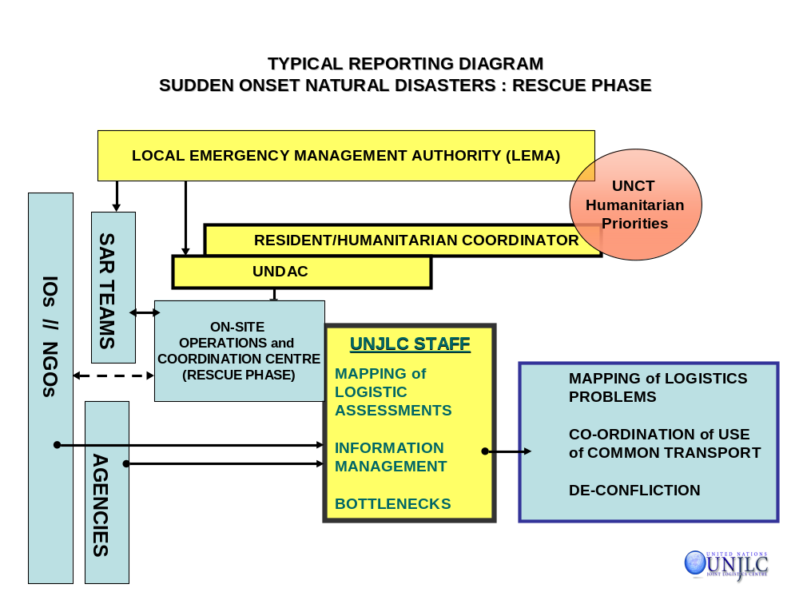

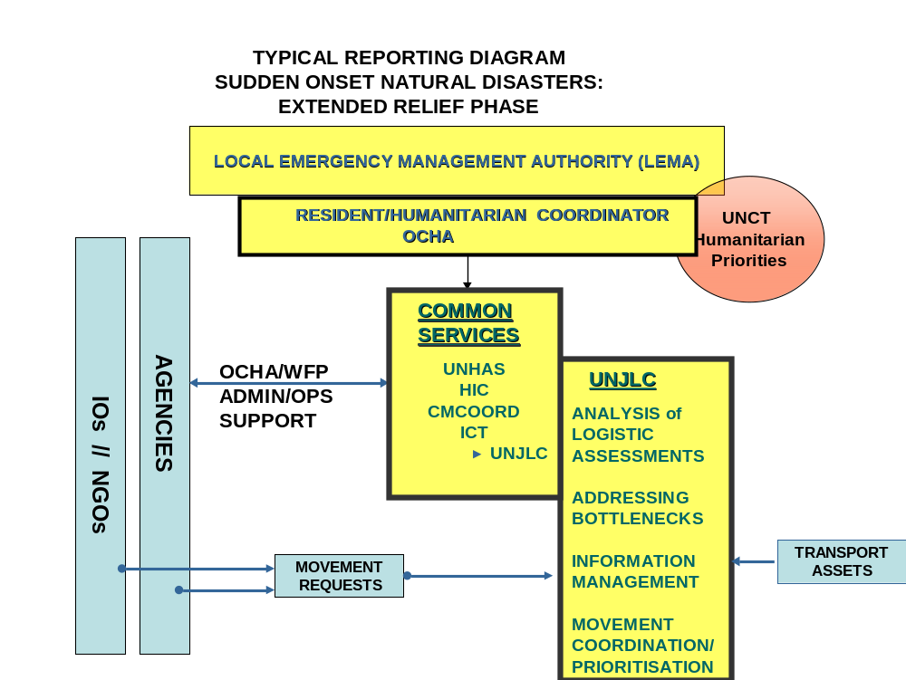
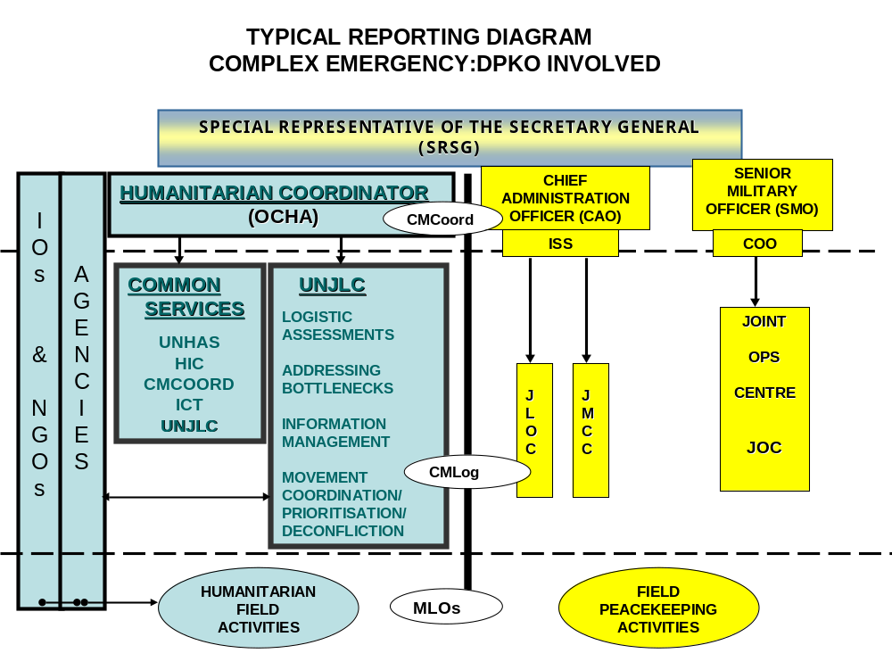
3.5. UNJLC STRUCTURE during operations
The UNJLC will normally be integrated in the existing or planned humanitarian coordination structure in a given emergency. The generic structure below is modular and will be adapted to the emergency environment. Structures will be adapted during the course of the emergency. A generic UNJLC structure is depicted below and more details on the specific functions are explained in the relevant sections of this handbook. (Sample UNJLC Mission Organizational Structures can be found in LOG 2 Section 3).
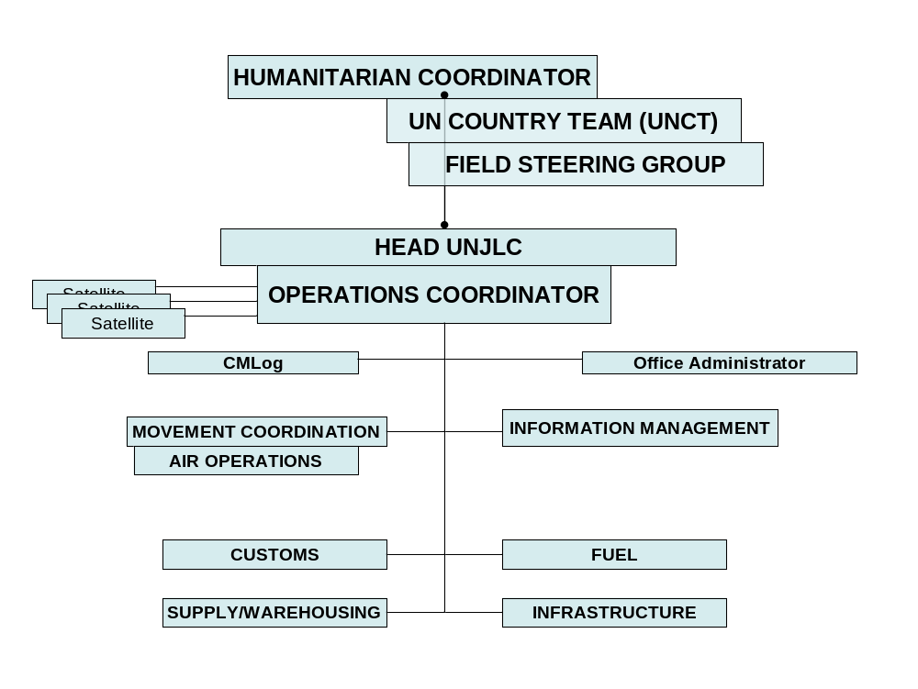

3.6. EXIT STRATEGY
UNJLCs are envisaged as a temporary bolster during the response phase of an emergency. As such, no UNJLC is activated without a clearly defined exit strategy. Prior to demobilization, the UNJLC ensures appropriate inter-agency logistics Information Coordination mechanisms are in place. Similarly, the UNJLC aims to improve Agency and government logistics management capability through selective logistics capacity-building activities. Each function within a UNJLC mission will have its own handover checklist. Some of these are included in the text of the sections of LOG 1. (See LOG 3 Section 1 for sample phase-out/exit strategy/handover timeline for all functions.)
LOG 1 - SECTION 4: COORDINATION & COORDINATING BODIES DURING EMERGENCIES
4.1. INTRODUCTION
The purpose of this section is to provide a short overview of the principles of Coordination and the structures and responsibilities of the coordinating bodies and mechanisms during emergencies. Its aim is to inform UNJLC staff officers of the responsibilities and mandates of these different actors in the various Coordination functions: enabling them to have a better understanding of the role that UNJLC plays in these processes.
This section discusses Coordination activities in both natural disasters and complex emergencies and highlights the differences between these two types of emergencies. Full details of Coordination Structures etc. can be found in the LOG 2 Section 4.
4.2. COORDINATION
Coordination can be defined as ''the harmonious and effective working together of people and organizations towards a common goal.’’ Coordination is not free, it has costs in terms of time and other resources needed to make it work. Coordination is also vital because of the complexity of modern emergency response operations.
Coordination is not telling others how to do their work. “Coordination is the management of interdependencies between activities.” (Malone & Crowston1992). In the humanitarian world, Coordination is a result of intentional actions to harmonize individual responses to maximize humanitarian assistance and achieve synergy.
Good coordination should result in:
- Maximum impact for a given level of resources;
- Elimination of gaps and overlaps in services;
- Appropriate division of responsibilities;
- Uniform standards for all services;
Effective coordination is the result of sound management. Coordination mechanisms set up without the establishment of clear objectives and assignment of responsibilities and authority will be ineffective. Coordination must be based on good information exchange; otherwise, it may be counter productive.
4.2.1. Mechanism/Tools for Coordination in Emergencies
Coordination of humanitarian response by multiple parties in a complex operation is one of the key elements of emergency management. Since the success of coordination will necessarily be based on the trust built between organizations and individuals, the role of external relations with those organizations, bodies and agencies involved in overall coordination is vital.
Coordination mechanisms should be based on sound management principles such as the establishment of clear objectives and assignment of appropriate responsibilities and authority.
Some mechanisms which support coordination are:
- International and Regional instruments and agreements which define responsibilities and roles at the global (and sometimes regional or country) level;
- Memoranda of Understanding and exchange of letters with other agencies, and agreements with implementing partners and host governments, defining responsibilities and roles at the situational level;
- A coordinating body;
- Sectoral committees as necessary;
- Regular meetings;
- Reporting and information sharing;
- Joint services and facilities, e.g. vehicle repair services, communications.
- Code of conduct for organizations working in humanitarian emergencies;
In large-scale emergencies, the coordinating body will also likely require sectoral sub-committees (water, sanitation, health, food and nutrition, education etc). Such sub-committees will be responsible for coordinating implementation in each sector and representing the status and needs of each sector in relation to the overall operation. In such cases, coordination may be facilitated by the adoption of operation-wide standards of assistance for each sector.
UN Coordination mechanisms at field level also include a standing UN Disaster Management Team (DMT) or a UN Country Team (UNCT) in disaster/emergency prone countries. The DMT or UNCT may include staff from FAO, UNDP, UNICEF, WFP, WHO and UNHCR. The DMT/UNCT is the main mechanism by which UN agencies coordinate policies and programs.
In most emergencies, in country staff supporting the Resident/Humanitarian Coordinator is organized into a Field Coordination Unit (FCU). This unit may be organized in different ways and under different names; it may contain non-UN members similar to the make-up of the Inter Agency Standing Committee (IASC) and may be supplemented by other special units such as de-mining. In Afghanistan, for example, the FCU meets chaired by the Head of the UN Office for the Coordination of Humanitarian Assistance in Afghanistan (UNOCHA) and is known as the Inter-Agency Humanitarian Coordination Committee. In some emergencies, the Office for the Coordination of Humanitarian Affairs (OCHA) to support the Field Coordination Unit, recruits a UN Disaster Assessment and Coordination Team (UNDAC).
During emergencies, there are two aspects of humanitarian Coordination, the first referring to requirements at the strategic or policy level, and the second, those at the operational or field level. The two are interlinked with one other.
4.2.2. Coordination at Strategic or Policy Level
At the policy level, coordination takes place through specification of the overall approach, strategy or tactics to be used rather than on the detailed actions to be taken. Here the actors all work towards the common objective.
At this level, those coordinating concentrate on defining the overall approach and strategy. Once initiated however, it may be difficult to control what is happening in terms of action, budget and there may be inconsistency in the way different partners deal with the same problem.
The mix of strategic coordination coupled with detailed specification of repetitive tasks to be undertaken is probably the best approach to coordinating emergency response. This mix maintains the flexibility of the response and at the same time ensures a controlled and uniform approach.
Although agencies and other humanitarian organisations are planning their operations at both strategic and operational level, strategic Coordination is the responsibility of OCHA.
The composite functions of strategic Coordination could include:
- Setting the overall direction and goals of the UN humanitarian programme;
- Allocating tasks and responsibilities within that programme and ensuring that they are reflected in a strategic plan;
- Advocacy for humanitarian principles;
- Negotiating access to affected populations;
- Ensuring correspondence between resources mobilized and established priorities;
- Monitoring and evaluating the overall implementation of the programme; and
- Liaising with military and political actors from the international community, including those of the UN.
4.2.3. Coordination at the Field Level
At the field level, coordination takes place through specification of the detailed actions to be taken. Field coordination focuses on the actions to be taken rather than on the underlying strategy. Although actors should be aware of the strategy and the overall purpose of the coordinated effort, this is not always the case.
“Operational or Field Coordination” is concerned with two requirements.
- The first is the need for substantive Coordination in relation to specific sectors or clusters, with regard to geographical areas or beneficiary groups. This is to ensure that, within each sector or cluster, the activities of different actors are conducted in a complimentary manner.
- The second requirement is for common services to support humanitarian actors. Thus, operational Coordination ensures that matters such as Logistics, Air Services, Communications and Information Technology, Civil and Military Coordination and provision of Information are provided to the humanitarian actors in a coordinated, systematic and structured manner, best calculated to respond to operational needs.
Being one of the common services (see further), the UNJLC has an important role to play in support of the Logistics Coordination. Its overall and individual Coordination functions are reflected in the different functions that are described in this handbook. Good Coordination should result in:
- Maximum impact for a given level of available resources;
- Elimination of gaps and overlaps in logistics services;
- Appropriate division of responsibilities;
- Uniform treatment and for all the beneficiaries.
- Reporting and information sharing;
- Preparedness to share services and capabilities.
4.2.4 Effective Coordination of Emergency Response.
To coordinate an emergency response in an effective manner, consensus needs to be established among the responders on the following 3 points:
- The present situation;
- The goal(s) and objective(s);
- The activities and inputs needed to achieve the common goal(s).
It is important to understand that relief agencies partly function within a framework of self-interest. While their first objective is to assist their targeted beneficiaries, they prefer to assist these beneficiaries in such a way that their contribution is seen and valued by the donor community with the intention to enhance the “profile” of their agency. Sometimes agencies have problems recognizing the contributions of others or to admit that someone else can do a particular job better than they can. As a result, Coordination is not always an agency’s first priority.
The person or organization charged with promoting and ensuring cooperation has to overcome Coordination barriers that may be encountered. Agencies and individuals participating in the Coordination process must be convinced that the benefits outweigh the costs and that it provides added value to their operations.
Coordination requires time and resources and to achieve the best possible results, the process should be anticipatory, impartial and transparent.
- The tasks of Coordination must occur within a structure and process that has been established and agreed before the emergency. Organizations need to participate in deciding the policies, procedures, strategies and plans, which will affect them during the emergency Coordination process. The coordinators must secure and maintain the confidence of the other actors, engendering an atmosphere of respect and good will.
- The Coordination process should not be seen to favour one organization over another but rather to identify the distinctive competencies and capabilities of the various actors. Coordination should advocate the principles of humanitarian priorities and impartiality, i.e., the provision and prioritization of relief should be based solely on need (irrespective of race, religion, political affiliation, gender, or age).
- Coordination requires trust and trust requires transparency; the spontaneous flow and exchange of information, open decision-making processes, sincere, and honest rationales for decisions.
4.2.5. Cluster Approach
Strengthening humanitarian action is a responsibility shared by all members of the Inter-Agency Standing Committee (IASC). The Humanitarian Response Review (HRR), issued in August 2005, assessed existing humanitarian response capacity and identified gaps. The review recommended: mapping the response capacities of national, regional, and international actors; strengthening response capacities, in particular human resources; applying benchmarks to measure performance; improving coordination; and filling gaps in water and sanitation, shelter, camp management, and protection.

The cluster approach aims to improve the predictability, timeliness, and effectiveness of humanitarian response, and pave the way for recovery. The approach also aims to strengthen leadership and accountability in key sectors, not replace sectors per se.

Cluster functions at the global level include:
a) Up-to-date assessments of the overall needs for human, financial, and institutional capacity;
b) Reviews of currently available capacities and means for their utilization;
c) Links with other clusters, including preparedness measures and long-term planning, standards, best practice, advocacy, and resource mobilization;
d) Taking action to ensure that required capacities and mechanisms, including rosters for surge capacity, exist; and,
e) Training and system development at the local, national, regional, and international levels.

Accountability is a key feature of the cluster approach: cluster leads are responsible for:
a) Predictable action within the cluster for analysis of needs, addressing priorities, and identifying gaps in the cluster area;
b) Securing and following-up on commitments from the cluster to contribute to responding to needs and filling the gaps;
c) Provider of last resort; and,
d) Sustaining mechanisms through which the cluster as a whole, and individual participants, assesses its performance.

In addition, cluster leads have mutual obligations to interact with each other, and are accountable to the Emergency Relief Coordinator globally and to Humanitarian Coordinators locally.

The following list of Clusters was subsequently established:
- Camp Coordination and Management Cluster;
- Early Recovery Cluster;
- Health Cluster;
- Logistics Cluster;
- Nutrition Cluster;
- Protection Cluster;
- Shelter Cluster
- Telecommunications Cluster;
- Water, Sanitation and Hygiene (wash) Cluster;
More details on the Logistics Cluster approach can be found in LOG 2 Section 4.2.5).

Variations between Natural Disasters and Complex Emergencies
While each emergency is unique, many aspects of the emergency environment and response management are similar in natural disasters and complex emergencies. Nevertheless, significant variations exist and are summarised below.
4.3.1. Complex Emergencies
A complex emergency is also referred to as a man-made emergency. It is defined by the Inter-Agency Standing Committee (IASC) as, “a humanitarian crisis in a country, region or society where there is total or considerable breakdown of authority resulting from internal or external conflict and which requires an international response that goes beyond the mandate or capacity of any single and/or ongoing UN country programme.”
Likely characteristics of a complex emergency include:
- A large number of civilian victims, populations who are besieged or displaced, human suffering on a major scale;
- Substantial international assistance is needed and the response goes beyond the mandate or capacity of any one agency;
- Delivery of humanitarian assistance is impeded or prevented by parties to the conflict;
- High security risks for relief workers providing humanitarian assistance;
- Relief workers targeted by parties to the conflict;
In these situations, there are typically four model structures or options for the coordination of the emergency response. These are generally referred to as:
- Resident Coordinator Model
(The Resident Coordinator is the leader of the United Nations Country Team and is normally the Head of UNDP in a particular country. In a complex emergency, the Resident Coordinator may also be designated as the Humanitarian Coordinator).
- Humanitarian Coordinator Model
(If the emergency is of considerable size a Humanitarian Coordinator may be appointed distinct from the Office of the Resident Coordinator and lead agency. The Humanitarian Coordinator normally phases out once the emergency reaches the recovery phase and any residual tasks are returned to the Resident Coordinator).
- Regional Humanitarian Coordinator Model
(If the emergency affects more than one country a Humanitarian Coordinator having regional responsibilities may be appointed). See Annex 9 and 10, MEDEVAC & Moss Compliance.
4.3.2. Natural Disasters
a. Natural disasters, also referred to as sudden Onset Disasters are emergencies caused by natural, technological and environmental calamities. The actions and activities described below will only relate to natural disasters but the UNJLC will have similar functions in technological and environmental disasters.
Sudden onset/Natural disasters are increasing in terms of frequency, complexity, scope and destructive capacity. During the past two decades, natural disasters have killed millions of people, adversely affected the life of at least one billion more people and resulted in enormous economic damages. Natural disasters include earthquakes, windstorms, tsunamis, floods, landslides, volcanic eruptions, wildfires, etc.
The risk of natural disasters is increasing because of population growth, urbanization, and alteration of the natural environment, substandard dwellings and public buildings and inadequate infrastructure maintenance.
b. The Role of the National Government/State
The sovereignty, territorial integrity and national unity of States must be fully respected in accordance with the Charter of the United Nations. In this context, humanitarian assistance should be provided with the consent of the affected country and in principle based on an appeal by the affected country. First and foremost, each State has the responsibility to take care of the victims of natural disasters and other emergencies occurring on its territory. Hence, the affected State has the primary role in the initiation, organization, coordination, and implementation of humanitarian assistance within its territory.
While for most natural disasters, the State is a willing and legitimate partner and must request international assistance; in complex emergencies, the legitimacy and territory of the State is under, often violent, dispute. In some situations a State, per se, may not exist and even if it does exist, it may have limited authority and capability. This situation makes the adherence to the above principles problematic in complex emergencies. In these cases, the commitment to the victims may supersede the commitment to the State. More likely, however, UN Coordination efforts will need to acknowledge the legitimacy of competing authorities. Thus, the UN may need to develop and maintain effective relationships not only with the State but also with the antagonists and political opposition.
4.3.3. Guiding Principles

- Humanitarian assistance is of cardinal importance for the victims of natural disasters and other emergencies.
- Humanitarian assistance must be provided in accordance with the principles of humanity, neutrality and impartiality.
- The sovereignty, territorial integrity and national unity of States must be fully respected in accordance with the Charter of the United Nations. In this context, humanitarian assistance should be provided with the consent of the affected country and in principle on the basis of an appeal by the affected country.
- Each State has the responsibility first and foremost to take care of the victims of natural disasters and other emergencies occurring on its territory. Hence, the affected State has the primary role in the initiation, organization, coordination, and implementation of humanitarian assistance within its territory.
- The magnitude and duration of many emergencies may be beyond the response capacity of many affected countries. International cooperation to address emergencies and to strengthen the response capacity of affected countries is thus of great importance. Such cooperation should be provided in accordance with international law and national laws. Intergovernmental and non- governmental organizations working impartially and with strictly humanitarian motives should continue to make a significant contribution in supplementing national efforts.
- States whose populations are in need of humanitarian assistance are called upon to facilitate the work of these organizations in implementing humanitarian assistance, in particular the supply of food, medicines, shelter and health care, for which access to victims is essential.
- States in proximity to emergencies are urged to participate closely with the affected countries in international efforts, with a view to facilitating, to the extent possible, the transit of humanitarian assistance.
- Special attention should be given to disaster prevention and preparedness by the Governments concerned, as well as by the international community.
- There is a clear relationship between emergency, rehabilitation and development. In order to ensure a smooth transition from relief to rehabilitation and development, emergency assistance should be provided in ways that will be supportive of recovery and long-term development. Thus, emergency measures should be seen as a step towards long-term development.
- Economic growth and sustainable development are essential for prevention of and preparedness against natural disasters and other emergencies. Many emergencies reflect the underlying crisis in development facing developing countries. Humanitarian assistance should therefore be accompanied by a renewal of commitment to economic growth and sustainable development of developing countries. In this context, adequate resources must be made available to address their development problems.
- Contributions for humanitarian assistance ion an emergency should not be to the detriment of resources made available for international cooperation / development programs.
- The United Nations has a central and unique role to play in providing leadership and coordinating the efforts of the international community to support the affected countries. The United Nations system needs to be adapted and strengthened to meet present and future challenges in an effective and coherent manner. It should be provided with resources commensurate with future requirements. The inadequacy of such resources has been one of the major constraints in the effective response of the United Nations to emergencies.
4.3.4. Time Frame
While the basic human needs for security, food, water, shelter and medical treatment are the same for beneficiaries in natural disasters and complex emergencies, the role of a Coordination mechanism in a natural disaster will be more limited in time. In a natural disaster, speed of response is critical and is measured in hours and days. This is especially so in an earthquake situation and flooding where trapped people are unlikely to survive more than 3-4 days unless rescued. Therefore, during the first phase of deployment, the UN efforts will concentrate on assisting the affected state in the Coordination of the SAR activities. Nevertheless, the rescued people have to be kept alive and, in particular large-scale disasters, anticipation and early planning of relief activities are paramount. While the Coordination activities at strategic level may be short-lived, operational Coordination may be required throughout the relief phase, until the start of the rehabilitation phase.
For most complex emergencies, the UN disaster relief activities and Coordination mandates will need to be sustained over a longer period of time and humanitarian needs created by the emergency may become chronic. This will inevitably affect the Coordination approach.
4.4. HQ Management Coordination MECHANISMS
4.4.1. OCHA
UN OCHA is responsible for Coordination in a disaster or emergency. This responsibility has been historically determined and mandated. OCHA’s mandate is to ensure that the relief provided is effective, not to provide effective relief.
Such as mandated by the United Nations General Assembly resolution 46/l 82 the Secretary-General designated an Emergency Relief Coordinator (ERC), at the level of Under-Secretary General for Humanitarian Affairs, and established a secretariat to support the ERC. This secretariat is OCHA. The responsibilities assigned to the Emergency Relief Coordinator and his /her secretariats are essentially the following:
- Coordinating, facilitating, and mobilizing the humanitarian assistance of the United Nations system in those emergencies that require a coordinated response;
- Providing services that maximize the efficient use of resources for humanitarian assistance, such as consolidating, managing and disseminating information including situation reports, early warning data and needs assessments;
- Mobilizing resources through the preparation of interagency appeals, management of revolving funds, and financial tracking of donor responses;
4.4.2. IASC
- The Inter-Agency Standing Committee (IASC) serves as the primary UN mechanism for inter-Agency Coordination relating to humanitarian assistance in response to complex and major emergencies. The IASC is chaired by the Emergency Relief Coordinator (ERC) and consists of the Heads (or designated representatives) of the UN operational Agencies, i.e. FAO, UNDP, UNHCR, UNICEF, WFP and WHO. At the heads of agency level, the IASC meets formally at least twice a year and deliberates on issues brought to its attention by the ERC and by the IASC Working Group (IASC-WG).
- The IASC-WG, chaired by the Director, OCHA Geneva, is formed by senior representatives of the same agencies and meets four to six times a year. Its responsibilities include formulating the agenda for IASC meetings; making non-strategic policy and operational decisions; endorsing the yearly work plan; and preparing options and recommendations for the IASC on strategic policy and major operational issues.
- It is the IASC-WG, which decides on the activation of the UNJLC. At the onset of a large-scale emergency with multi-sectoral involvement, the IASC-WG will designate a core group of Agency decision-makers, which will consult and decide on the possible activation of the UNJLC. Consultation will take place as expeditiously as possible (e.g. teleconference in the case of sudden onset emergencies and as part of the contingency planning.
4.5. Field Management Coordination MECHANISMS
4.5.1. SRSG
A Special Representative of the Secretary-General (SRSG) is sometimes appointed by the UN Secretary-General to act on his behalf in emergencies which are "complex or of exceptional magnitude". In practice, the appointment of an SRSG is normally reserved for those complex emergencies which require UN involvement in major political negotiations and/ or when UN peacekeeping forces are deployed.
When a SRSG is appointed, he/she is recognized as having overall authority with regard to UN operations in the designated country. If heading a peacekeeping operation, the SRSG reports to the Secretary-General through the USG for Peacekeeping Operations, or if heading a political mission, is through the USG for Political Affairs. Normally, the SRSG will have two deputies, the first coordinating humanitarian operations and the second heading the peacekeeping operations. The Humanitarian Coordinator (HC) is recognized as having the sole mandate for Coordination of humanitarian assessment/ response, under the SRSG’s strategic lead. The SRSG recognizes that mandate by ensuring that all concerned agencies and NGOs deal with his office through the HC. The latter, reports in parallel to the SRSG and the ERC: in particular to the SRSG on the day-to-day functioning of operational Coordination while remaining accountable to the ERC for Coordination, programming and policy in relation to humanitarian assistance.
4.5.2. Resident Representative/Coordinator
In response to natural disasters in countries where the UN system is present, overall Coordination of UN activities falls primarily to the Resident Coordinator, in consultation with the relevant UN agencies. In most cases, the Resident Representative of the United Nations Development Programme (UNDP) is designated as the Resident Coordinator (RC). The Resident Coordinator is responsible for coordinating UN humanitarian assistance. In the period before a natural or man-made disaster occurs, the Resident Coordinator coordinates preparedness and mitigation activities; monitors and provides early warning of potential emergency situations; leads contingency planning based on early warning monitoring; and chairs the UN Country Team (UNCT) or Disaster Management Team (DMT). Unless otherwise designated, once an emergency occurs, the Resident Coordinator will continue to lead and coordinate the UN interagency response. For the duration of the emergency, he/she reports to the ERC.
4.5.3. Humanitarian Coordinator
If an emergency becomes significant in size and/or complexity, the Emergency Relief Coordinator, in consultation with the UN agencies, may appoint a Humanitarian Coordinator. If the Resident Coordinator has the necessary skills, he/she will normally be designated the Humanitarian Coordinator. If not, either a new Resident Coordinator will be appointed to serve in both functions, or a separate Humanitarian Coordinator will be appointed. In countries where there is a significant risk of the occurrence of a complex or major emergency efforts will be made by the Administrator, UNDP, whether through specific training or accelerated rotation, to find a Resident Coordinator with an appropriate humanitarian profile. Once Coordination structures are activated and in place, the HC begins coordinating humanitarian response on the ground using a combination of rapid-response tools, information services and consultative forums.
In the immediate aftermath of a sudden-onset disaster, the ERC, in consultation with the RC, may field a rapid-response team to support on-site Coordination, to manage first-hand information and to advocate among donors. Known as United Nations Disaster Assessment and Coordination (UNDAC), these teams work under the HC’s authority to reinforce the UNCT/DMT and, when requested, the affected government. UNDAC teams typically remain deployed for two to three weeks.
After an earthquake, flooding or Tsunami, the RC also assists the national authorities in organizing the international SAR teams, dispatched by governments to support the search and rescue efforts of the affected country. In such cases, UNDAC may establish and manage an On-Site Operations Coordination Centre (OSOCC) to coordinate the international search and rescue teams.
Once a complex emergency occurs, the HC coordinates humanitarian response by chairing the regular UN Country Team (UNCT) meetings in order to share information and consult on issues of common concern. It is here that the HC and agencies aim to address areas of common concern, such as humanitarian access, security and the interplay between the peacekeeping, political, humanitarian, human rights and development components of the mission.
The RC/HC may also convene and oversee broader Coordination meetings designed solely to address humanitarian concerns. These forums include NGOs, the Red Cross movement, donors and international organizations, which often establish sub-committees to help coordinate humanitarian relief in a particular sector or region.
4.5.4 LOCAL EMERGENCY MANAGEMENT AUTHORITY (LEMA)
UN studies have long emphasised the desirability of encouraging governments to "designate a single national agency or organisation to conduct and coordinate emergency relief measures”. The establishment of a LEMA to coordinate domestic relief activities recognises the central role and responsibility of the stricken government in disaster relief operations. If a LEMA is established to coordinate the ongoing humanitarian relief operation, the UNJLC may be part of this organisation. Reporting structures will be agreed between the LEMA and the Humanitarian Coordinator.

When such a government coordination structure exists, this will be an important counterpart for UN humanitarian coordination staff. Other government ministries that the UN may liaise with include Foreign Affairs, Interior (normally encompassing the police and border control functions), Defence, and Civil Defence. The UNDAC team may at times be tasked to strengthen this capacity of the national Government.

The question is more complicated in man-made conflict situations when circumstances require the Coordination of relief activities through different authorities. At the field level, it is not unusual for local authorities, such as Regional Governors or local military commanders, to have considerable authority and some degree of independence from the capital. An important task of UN field level staff is to ensure that such authorities are well informed concerning the objectives, principles, and implementation of humanitarian assistance, both of the UN as well as the larger international system.

In complex emergencies, UN assistance may need to be provided to persons living in areas outside of the control of the national government, i.e., under the control of the opposition groups. Opposition groups may have established their own coordination mechanisms and field staff must be able to work effectively with them. Policies regarding relationships with such groups will be established by OCHA.
4.5.5. United Nations Country Team (UNCT)/Disaster Management Team (DMT)
The UN General Assembly has mandated that a standing UN Country Team or a Disaster Management Team (DMT) be formed in every disaster/emergency-prone country. The Resident Coordinator chairs the UNCT. Its composition is unique to each country depending on its special circumstances and normally includes representatives, if present in the country, from FAO, UNDP, UNICEF, WFP, WHO, and UNHCR. IOs and NGOs may also be invited to the meetings of the UNCT, which may then be called Country Team (CT).
The primary purpose of the UNCT is to prepare and ensure a prompt, effective, and concerted response and promote coordinated UN assistance to the Government for post emergency recovery. This does not supersede the mandates of its members. During an emergency, the CT is the main in country mechanism by which UN agencies coordinate policies and programmes of humanitarian assistance.
4.5.6. OCHA and the UNDAC Team
In response to natural disasters, OCHA can dispatch a United Nations Disaster Assessment and Coordination (UNDAC) Team, and establish an On-Site Operations Coordination Centre (OSOCC) or other unit to assist in emergency assessment, rescue operations and Coordination during the initial relief phase. Working under the authority of the Resident/Humanitarian Coordinator, the UNDAC team cooperates with the Local Emergency Management Authorities (LEMA) in carrying out assessment and Coordination tasks at the disaster site. The UNDAC team will assist in the assessment of international relief requirements during the first phase of the emergency and, when necessary, in the Coordination of international rescue operations at the site of the emergency. It is capable of deploying at very short notice (12-24 hours) anywhere in the world and is provided free of charge to the disaster affected country. Its activities also include strengthening national and regional disaster response capacity on request. The UNDAC system is managed by the Field Coordination Support Section (FCSS) in the Emergency Services Branch at OCHA Geneva.
The mission of the UNDAC Team is further described in LOG 1 Section 5.
4.5.7. Humanitarian Common Services (HCS)
A Humanitarian Common Service is a support function, administered by one agency/organization or a group of agencies/organizations and authorized by an established interagency process, to facilitate the work of the humanitarian community in emergency response operating at the request of the HC/Country Team.
The IASC WG identified five HCS entities: The United Nations Joint Logistics Centre (UNJLC), the United Nations Humanitarian Air Service (UNHAS). Civil/Military Coordination (CMCoord), the Humanitarian Information Centre (HIC) and the Inter Agency Emergency Telecommunications (IAET). Both UNJLC and UNHAS are administered by WFP, CMCoord, HIC and IAET are administered by OCHA. While Humanitarian Common Services have different custodians whose overall individual management of each service will continue, in an emergency the UNCT, through the HC is responsible for facilitating the provision of key support services for the larger relief community. Thus, a distinction should be made between policy and leadership in emergency and executive/administrative management by the implementing agency. The reporting lines will be determined in consultation/agreement with HC in each emergency. Nevertheless, it is recommended that in an emergency situation, the HCS be co-located, preferably in the office of the HC/RC, to ensure a more effective collaboration, uniformity, compatibility of equipment and security considerations A co-location also offers additional benefits of appearing under one UN flag and having the same visibility vis-à-vis NGOs, the Red Cross or the military.
When deployed, the activities of the UNJLC will be overseen by the UNJLC Field Steering Group (FSG). This FSG is an inter agency Coordination body, made up of UNCT or DMT members or their delegated staff. The FSG approves the TOR of the UNJLC and determines the scope of work. It also decides on specific, gap filling functions of operational nature, which do not fall within the responsibility of other agencies. The FSG meets separately, or can be integrated in other UNCT (or DMT) meetings as a separate agenda item.
4.5.8. Department of Peacekeeping Operations (DPKO)
The DPKO is a UN body that is tasked by the Security Council to undertake Peacekeeping Operations in specific areas of recent or potential conflict. A Special Representative of the Secretary General (SRSG) is usually appointed to head each Peacekeeping Operation. Reporting to DPKO HQ in New York, the SRSG exercises authority over all UN entities in the emergency area. The Peacekeeping contingent has two main components, a civilian structure headed by the Chief Administration Officer (CAO) and a military structure headed by the Senior Military Officer (SMO).
Typically, a Peacekeeping Operation encompasses a broad range of tasks and responsibilities. For example, DPKO staff deployed into an emergency area may include military components in the security or observation role, civilian police elements and mine action teams as well as specialists in Political Affairs and Human Rights. Recent peacekeeping mandates have also included tasks such as “Coordination with humanitarian agencies” or “support to humanitarian action.”
Logistics support for Peacekeeping Operations is provided by the UN’s Integrated Support Service (ISS). Its civilian head, Chief ISS (CISS) manages all UN owned/contracted/ leased logistics support assets. The ISS includes units for engineering, transport, logistics, materials and contracts management, aviation, telecommunications, information technology and medical services. Many of these components are integrated, that is to say they have a civilian chief and military deputy chief. The structure of ISS is similar in some respects to the UNJLC organization. The Head UNJLC is in effect the counterpart of CISS.
An ISS assigned to a DPKO operation will usually have specialized logistics liaison officers who report to the unit within the ISS known as the “Joint Logistics Operations Centre” (JLOC). UNJLC staff should normally coordinate with the JLOC and the Joint Movement Coordination Centre (JMCC) both of which are part of the DPKO’s civilian component. The Joint Operations Centre (JOC), which is part of DPKO’s military structure, will be able to provide UNJLC with security information regarding logistics movements.
4.5.9. Civil/Military Coordination
Using military assets for humanitarian needs in a complex emergency is a very political decision and has been opposed in the past in recipient countries e.g. Afghanistan, Iraq. In a natural disaster, it is far easier to use military assets for relief, as there are fewer political implications to such use.
During emergencies requiring or involving a military presence in the crisis area, the military authorities may be able and willing to offer direct or indirect assistance to the humanitarian relief effort. The decision to use military assets for supporting humanitarian operations in an emergency affects all of the actors, has political consequences, and will impact upon perceived neutrality and impartiality of the assistance effort. Although such perceptions may not be important in natural sudden onset disasters, it will become predominant in complex emergencies.
Cooperation between civilian and military bodies can take many forms, and can be initiated by either side. From a humanitarian perspective, Civil/Military Coordination is defined as CMCoord and is considered as a staff/advisory function integrated into the HC staff. CMCoord staff is provided by OCHA, reports to the Humanitarian Coordinator and acts in accordance with the CMCoord Concept, which is available in LOG 2 Section 17. The UNJLC may be involved in this civil/military Coordination process, by integrating Civil/Military Logistics (CMLog) experts into its structures. These CMLog staff will coordinate Civil/Military activities with military entities at operational level – further details are in Section 17 of this LOG 1. In addition, agencies may assign Military Liaison Officers (MLOs) to perform Coordination functions with the military during the execution process of humanitarian operations.
Military authorities may also appoint staff officers for liaison duties with the humanitarian community. The generic military term for liaison between humanitarian and military bodies is Civil/Military Cooperation (CIMIC). During Sudden Onset Disasters, it is not unusual that donor governments activate a Civil/Military Operations Centre (CIMOC). During complex emergencies, larger military formations (e.g. multi-national coalitions) may even establish a Humanitarian Operations Centre (HOC), as was the case during the Afghan and Iraq emergencies. CIMOCs, HOCs, etc. will not be submitted to the authority and responsibility of the Humanitarian Coordinator. Nevertheless, during sudden onset disasters, CIMIC or CIMOC staff of nations providing MCDA support may be made available to assist UNJLC. In such a case, this staff will be integrated in the UNJLC structure, report to the Head UNJLC or his/her delegate and will function as Liaison Officers (LNOs, see LOG 1 - Section 17)
Whatever the name used for these structures/functions, the objective is essentially the same: namely, to ensure that any military assistance is effectively coordinated with civilian humanitarian activity in line with the “Guidelines on Use of Military and Civil Defence Assets in Disaster Relief, both for Natural disasters and Complex Emergencies, available in LOG 2, Sections 17.1 and 17.2.
LOG 1 - SECTION 5: ASSISTING THE UNDAC TEAM
5.1. The UNDAC Mission
In response to natural disasters, OCHA can dispatch a United Nations Disaster Assessment and Coordination (UNDAC) Team, and establish an On-Site Operations Coordination Centre (OSOCC) or other unit to assist in emergency assessment, rescue operations and Coordination during the initial relief phase. Working under the authority of the Resident/Humanitarian Coordinator, the UNDAC team cooperates with the Local Emergency Management Authorities (LEMA) in carrying out assessment and Coordination tasks at the disaster site. The UNDAC team will assist in the assessment of international relief requirements during the first phase of the emergency and, when necessary, in the Coordination of international relief operations at the site of the emergency.
The UNDAC team will assist the Resident/Humanitarian Coordinator in ensuring that regular reporting on the situation, needs and relief efforts is made to the ERC. The UNDAC team is mobilised for a particular emergency primarily by utilising specialised emergency managers made temporarily available by member states of the UN. It is thus a temporary entity that formed for the emergency phase of a disaster, generally only lasting for a brief period.
The UNJLC has an agreement with UNDAC to integrate logistics experts into the Team during large-scale sudden onset disasters. These experts will assist in logistics assessments and identifying /solving logistics bottlenecks.
5.2. ASSISTING THE UNDAC TEAM
UNJLC is on the alert list of UNDAC and deployment is decided after mutual consultation. The aim is to deploy UNJLC experts as part of the UNDAC Team in potentially large-scale emergencies. In case of an extended relief operation with multi-sectoral involvement, the IASC/WG may decide to activate a fully-fledged UNJLC. Due to early established relations with national/local authorities and international responders, the immediate presence of UNJLC experts in the UNDAC Team will contribute to greater efficiency of the subsequent UNJLC deployment. On the other hand, if the experts identify that there is no need for UNJLC involvement, they will terminate their mission with the withdrawal of the UNDAC Team.
The UNJLC experts will assist the UNDAC Team in two major areas, Logistics Information Management and Movement Coordination
5.2.1. Logistics Information Management
Information Management (IM) may include two pillars, Commodity Tracking and Logistics Movement Support information. At the onset of the emergency, the IM officer will:
- Before deploying, go to the checklist in LOG 1 Section 6. Particular attention should be paid to the ICT equipment (LOG 3 Section 2), including availability of electronic maps of the area. Make sure to have the most recent copy of the LOG, which is electronically available on www.unjlc.org
- Once deployed, the IM officer will be integrated in the OSOCC. Specific IM/OSOCC/VOSSOC functions are described in the UNDAC Handbook, LOG 2 Section 5.
- Oversee the logistics assessments: assessment guidelines are described in LOG 1 Annex 4.
- Compile and analyze logistics information and provide inputs to the GIS Mapping element of the OSOCC. If the latter is not available, the Core UNJLC GIS officer in Rome may provide mapping assistance. See LOG 1 Section 10.
- Publish/distribute formats to the humanitarian relief agencies for inventorying/tracking essential relief items and unsolicited commodities using Logistics Support System (LSS). Refer to LOG 3 Section 5 Software.
- Publish logistics information on www.reliefweb.int, Virtual OSOCC and/or on the relevant page of www.unjlc.org.
5.2.2. Movement Coordination
The UNJLC Logistics officer or a Logistics Cluster officer should be the focal point within the OSOCC to coordinate logistics movements during the early stages of the relief phase. The Logistics Movement Coordinator will:
      - Before deploying, go to the checklist in LOG 1 Section 6. Particular attention should be paid to the ICT equipment, including availability of electronic maps of the area. Make sure to have the most recent copy of the LOG CD ROM.
      - Upon arrival in the disaster area, establish logistics cell within the OSOCC
      - Obtain an overview of the logistics situation through the various available national, UN and NGO sources. Determine entry points, airfields, bottlenecks, road/railroad conditions, transport requirements, warehouse capacity, etc. Request logistics assessments as described in paragraph
      - Advise on the most cost-effective mode of transport.
      - Acquire and provide information to avoid inflation of commercial transport rates.
      - Inquire on procedures to use MCDA, such as outlined in LOG 1 & 2, Section 17
      - Inquire on border crossing procedures and facilitation measures as outlined in LOG 1 Section 13.
      - Inquire on availability of gas oil, gasoline and Jet 1 aviation fuel. If required, propose actions to re-establish fuel provision for humanitarian assistance. (LOG 1 Section 12 and LOG 2 Section 12.)
      - If required, establish system to allocate trucks that are made available by the government and/or donors for common use.
      - In case of flooding, establish system to allocate boats that are made available by the government and/or donors for common use.
      - Assist in CMCoord (CMLog) Activities at operational level as described in LOG 1 Section 17
      - Organize logistics coordination meetings with the operational humanitarian organisations.
      - In case of intensive air operations, recommend the establishment of a dedicated Airport de-Congestion unit. Depending on the intensity of the air operations, this unit may be put in charge of both, de-congestion at the airport of entry and management of air assets for regional/local flights.
        - The de-confliction function may include the establishment of an Air Coordination Cell (ACC) for allocating slot times at the airport of entry and calling upon technical teams to assist in downloading and dispatching of aircraft.
        - The Air Coordination Cell (ACC) will act as described in LOG 1 Section 9 and will inform all organisations which are planning flights into the airport of entry of the procedures to request slot times. A sample of such request form is in LOG 2 Section 9.
        - The ACC will make a summary of all requests on a daily basis, prioritise the requests and forward to the slot allocation authority. A sample of such summary sheet is in LOG 2 Section 9. The slot allocation authority will be assigned by the LEMA and might be the CAA and/or local ATC. After approval, the ACC will inform all concerned of the slot designation. If necessary, instructions will be drafted to impose specific procedures for arrival/departure at the relevant airport(s).
        - In case of substantial regional airlift, the LEMA may appoint the UNJLC to manage the assets that are appointed for common use.
LOG 1 -SECTION 6: STAFF OFFICERS GUIDELINES BEFORE DEPARTURE
6.1. CONTRACTUAL AND ADMINISTRATION ISSUES
PRE-DEPARTURE CHECKLIST
All staff assigned to UNJLC should go through the checklist below and take action as required. Locally recruited staff should refer to their parent Agency or Organisation for obtaining the necessary documentation and equipment.

In order to recruit local staff at least three potential candidates must be interviewed; remember to keep an interview-rating sheet for submission to WFP HR Officer for contract issuance. The following documents are also required.

- CV
- TOR
- Medical Certificate
- Copy of ID
6.2. ITEMS TO CARRY
6.2.1. Personal Items
- • Valid passport and at least 6 passport photos. If possible, obtain UN Laissez-Passer (UNLP). In some countries, the yellow booklet (immunisation record) may be required. Ensure that this booklet includes your blood group.
- • Adequate amount of relevant currency and/or travel cheques. Also, take at least one credit card.
- • Food and water for 36 hours, four changes of clothing appropriate for the location, toilet articles, flashlight with spare batteries, alarm clock, pocketknife, earplugs and business cards.
- • Sleeping bag, mosquito net (if required).
Optional items (brought at own risk): Pocketsize binoculars, electrical adapters for appliances, pocket calculator, personal digital camera, condoms, swapping items (pins, buttons, pencils, stickers, etc.)
6.2.2. Health Items and Medical Tips
- • Prescription medicine for expected length of stay; medication for colds, allergies, diarrhoea, athlete's foot, menstrual cramps, haemorrhoids, constipation and headaches.
- • Sunscreen, insect repellent, antiseptic ointment, lip salve, vitamins, small scissors, tweezers, soap, isopropyl alcohol, water-purification tablets, one packet of oral re-hydration salts, baseball cap or hat for sun and rain, extra pair of spectacles or contacts (plus copy of your optician's prescription).
6.2.3. Items provided by UNJLC
- • UNJLC Laptop Computer with accessories for e-mail.
- • Most recent version of UNJLC Field Operations Manual on CD ROM, including an electronic map of the region.
- • Specific items related to the task such as mobile phone, satellite phone, PDA, GPS, digital camera (flyaway kit)...
- • Country clearances for affected country and visa if required.
6.3. ITEMS to READ and to STUDY
All of these documents can be found in LOG 2 Section 6 & LOG 3 Section 2.

- USE OF GPS
- USE OF SATELLITE PHONE
- USE OF VHF RADIO, CALL SIGNS ETC
- REPLICATING YOUR EMAIL
- LOTUS NOTES
- SENDING ATTACHMENTS
- USB PORTS and FLASH DRIVES

LOG 1 - SECTION 7: HEAD UNJLC & OPERATIONS COORDINATOR
7.1. RESPONSIBILITIES
Once deployed, the Head will be responsible for the management and efficient functioning of UNJLC. He/she will ensure that all UNJLC activities are performed in accordance with the policy guidelines and priorities established by the Humanitarian Coordinator, UN Country Team, Cluster and/or Local Emergency Management Authorities (LEMA). In return, he/she will provide the necessary logistics information for establishing the humanitarian relief policy and prioritisation process. During large-scale emergencies, an Operations Coordinator may be appointed who will also be the Deputy Head UNJLC. Some of the responsibilities and actions below may be assigned to the Operations Coordinator. (LOG 3 Section 1 for sample TORs for these positions and for all other officers within a UNJLC Mission).
7.2. PRE-DEPARTURE ACTIONS
Depending on the scenario, Head UNJLC should report to the Country Representative WFP and Resident/Humanitarian Coordinator (and/or the Logistics Cluster lead should the cluster approach be in operation) in the crisis area. In any case, before assuming his / her duties the following activities will need to be addressed:
- Go through pre-departure checklist;
- Obtain copies of UNJLC Logistics Operations Guide (LOG) and CD ROM of the LOG;
- Obtain information on other international responses to the disaster (e.g. Countries, UN Agencies, NGOs and IOs with programmes in the affected country);
- Discuss UNJLC objectives and functions with Chief UNJLC Core Unit in Rome and representatives of agencies deployed in the crisis area;
- Take appropriate actions for mobilising the necessary resources to support the UNJLC operations (LOG 3 Section 1)
- Obtain an overview of the emergency, available capabilities, organisational structure and in-country support needed by the UNJLC. Useful websites can be found in LOG 1 Annex 7,
- Decide upon the components of the UNJLC Organizational Structure: whether to establish Satellite JLCs. (Sample UNJLC Organizational Structures can be found in (LOG 2 Section 3).
- In consultation with UNJLC Core Unit, identify and select staff for the UNJLC operation: modifying TOR in accordance with selected staff’s skills and experience. (See LOG 3 Section 1 for a range of TORs).
- Discuss reporting requirements, including daily telephone calls, data collection, situation reporting, and final report (in consultation with Information management and Communications (INFOCOMMS) in Rome.
- Obtain information on status of affected country's response to the disaster and local logistics disaster-response capability. [Refer to WFP's Logistics Capacity Assessment (LCA) data bank, accessible via the UNJLC Core Unit].
- Obtain details of important points of contact (POC) in the affected country (UN, Government, etc): refer to useful websites in LOG 1Annex 7; consult with UNJLC Core Unit, UN Resident Coordinator and the WFP CD in affected country.
- Discuss deployment timeframe with UNJLC Core Unit.
- Verify acquisition, preparation and shipment of UNJLC flyaway packages. (See LOG 2 Section 3)
- Ensure that adequate communications equipment is ordered for all envisaged UNJLC tasks. Coordinate with UNJLC Core Unit, WFP CO and Fittest: obtain waivers if necessary or draw from stockpiles – e.g. UNHRD Brindisi, Fittest Dubai.
- Ensure that expertise is available for installation of ICT equipment: consult UNJLC Core Unit, WFP CO, Telecommunications Cluster lead (OCHA / WFP).
- Ensure that the UNJLC has access to funds in the country of the emergency. Discuss operational financial/HR/administration arrangements with UNJLC Core Unit: POCs – WFP Rome, UNJLC Core Unit and WFP Country Office; any accounting restrictions; delegated signing rights; and administrative/financial reporting within the affected country. (See LOG 3 Section 1)
- Take actions for acquiring all necessary maps; consult UNJLC Core Unit, FAO Geo network and UNOSAT. (See LOG 1 - Annex 7 for Acronyms, Terms and Useful Websites).
7.3. SUMMARY OF KEY ACTIONS IN THE FIRST 72 HOURS
NB: It is unlikely that the Head of the UNJLC will be the only staff member executing these actions; it is intended as an overall operational start-up checklist for the Head of Mission.

- Check relevant points in pre-departure checklist.
- Report to the Humanitarian Co-coordinator and WFP Country Director and agree on UNJLC functions to be fulfilled during the initial phase of the crisis.
- Obtain information on political sensitivities relating to the affected country, security situation and any potential evacuation strategy.
- Brief the Humanitarian Coordinator's staff on UNJLC requirements: personnel, in-country support, and special travel needs. Obtain clearance for travel to, and within, restricted areas. Organise meeting to discuss UNJLC’s TOR and modus operandi and discuss exit strategy.
- Conduct initial UNJLC briefing with available staff members.
- Establish contacts with LEMA, OSOCC/UNDAC (if deployed) and military actors.
- Verify whether UNJLC Terms of Reference (TOR) have been drafted. Establish/modify the TOR in accordance with LEMA, Humanitarian Coordinator, Country Team (UNCT), Logistics Cluster (as appropriate) and Field Steering Group (FSG). See Figure 1, below.

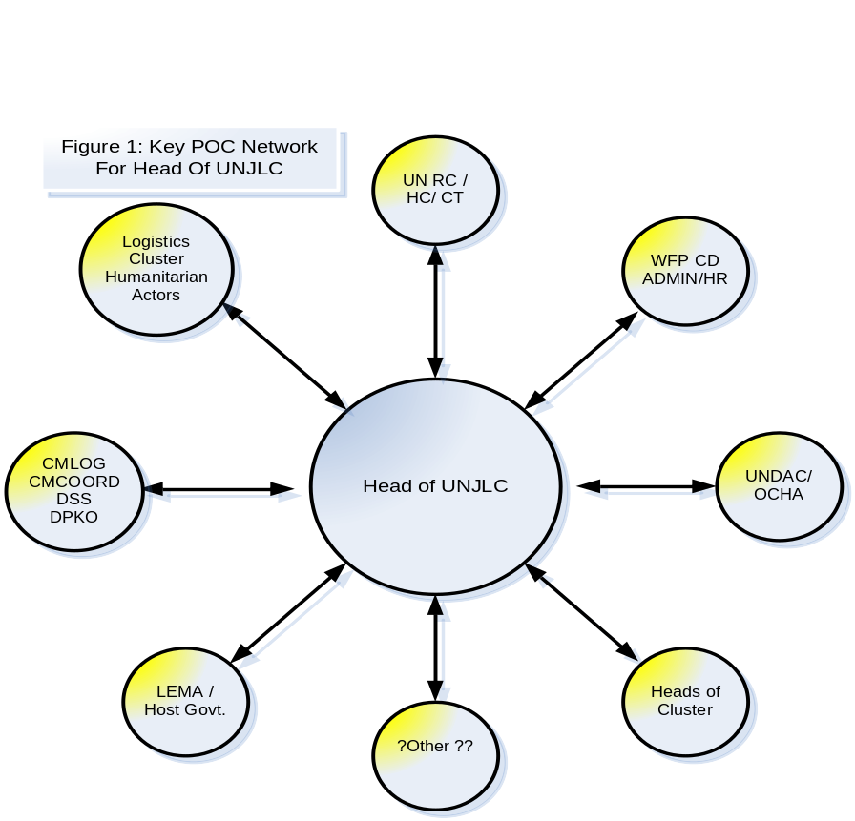
- Establish location for UNJLC HQ and oversee its set up. Ideally, the HQ should be close to the office of the Humanitarian Coordinator or LEMA. Verify shipment/delivery of UNJLC flyaway package and arrival of staff officers.
- Ensure ICT equipment is available and monitor its installation.
- If necessary, forward requirements for staffing and equipping the UNJLC to Lead Co-coordinating Agency and/or the Humanitarian Co-coordinator.
- Ensure acquisition of vehicles and drivers for UNJLC staff members.
- Finalise structure of UNJLC. Appoint and brief available staff officers on their respective functions and responsibilities.
- Determine locations and staffing of satellite JLCs (if required). Once deployed, establish communications with - and provide guidance to - the JLCs.
- Participate in inter-agency and/or national Coordination meetings.
- Oversee or perform an immediate initial evaluation of the common transport situation.
- Establish contacts with donors who might be offering common transport assets.
- Establish contacts with relevant national and/or international authorities in order to be kept informed on all security issues related to logistics.
- Establish links with DSS; subscribe to regular security updates (email, meetings, radio).
- In complex emergencies, liaise with DPKO or relevant military authorities including the Civil Military Coordination (CMCOORD/CIMIC) component - in the event that such an entity is deployed in the crisis area - and establish modus operandi. See also LOG 1 Section 17.
- Establish procedures for coordination of movement of humanitarian relief commodities, including security aspects.
- Establish Coordination procedures for obtaining humanitarian movement priorities and monitoring the application of these priorities during the execution phase.
7.4. ONGOING OPERATIONS
- Perform logistics information coordination function with Agencies and other humanitarian organisations to facilitate operational logistics actors:
- Monitor activities of all UNJLC sections, including satellite JLCs.
- Supervise application of priorities;
- Organise and chair internal planning and participate to coordination meetings.
- Review and clear - Situation and Mission reports (Sitreps, Misreps).
- Maintain close contact with and inform Humanitarian Co-coordinator and Custodian Agency on current logistics situation (Logistics cluster if present), work in progress, problems, planned actions, effectiveness of support, etc. ;
- Assist and provide logistical advice to inter-agency and multi-sectoral policy-making and strategic Coordination meetings.
- Organise, or participate, to regular meetings with beneficiary organisations to discuss logistics planning issues. Ensure regular attendance and effective contributions from all UNJLC members to the operational planning process.
- Coordinate continuously with affected country representatives (LEMA) and beneficiary organisations.
- Conduct, as needed, a critique of all functions for effectiveness, validity of priorities, soundness of objectives and ability of UNJLC staff members to carry out functions. Institute changes as necessary.
- In consultation with the UN HC, UN DMT, Logistics Cluster (as appropriate), the Head of UNJLC reviews the need for continued UNJLC services beyond initial Special Operation tasks and timeline.
- Depending on the severity / longevity of the emergency and the operating context, the UNHC and UN CT may request that UNJLC‘s mission be extended. This will normally entail providing a concrete log frame showing outputs and the levels of financial/personnel resources that is required. (See LOG 3 Section 1).
- Alternatively, the detailing of UNJLC outputs also assists in determining an exit strategy and identifying handover partners. (See LOG 2 Section 10, LOG 3 Section 1)
- Oversee the development of situation reporting, operational planning, resource tracking, documentation, and commodity consignment systems.
7.5. OPERATIONS COORDINATOR (Deputy Head UNJLC)
NB: The tasks denoted below may be delegated to other personnel within the operation according to the areas of expertise /experience / competence of the mission team.
If appointed, the Operations Coordinator will report to the Head UNJLC, direct and monitor the activities of all UNJLC sections, particularly satellite JLCs. In this capacity, he/she will take some of the responsibilities of the Head UNJLC described in 7.2, 7.3 and 7.4 above with emphasis on the following functions:
- Contribute to the formulation and the implementation of the overall UNJLC work plan.
- Perform operational Coordination functions with Agencies and other humanitarian organisations to facilitate logistics support.
- Ensure proper functioning of the UNJLC office.
- Oversee the Finance/Administration Officer and actively assist in resource mobilisation efforts.
- Monitor the activities and backstop the JLC satellite Offices.
- Assist in the planning of timely opening and closing the JLC satellite offices.
- Develop a staff work schedule. Brief the available staff on their functions and responsibilities;
- Organise and chair internal planning and coordination meetings.
- Organise, or participate to, regular meetings at operational level with beneficiary organisations to discuss logistics planning cycle. Ensure regular attendance and effective contributions from all UNJLC members to the operational planning process.
- Establish procedures for inter-agency Coordination for the movement of humanitarian relief commodities, including security aspects. Establish Coordination procedures for obtaining movement priorities and monitoring the application of these priorities during the execution phase.
- Supervise the information management process for the logistical aspects of the emergency (Refer to LOG 1 Section 10). Oversee the processing of situation reports, operational planning, resource tracking, documentation, and commodity consignment systems. Review and clear - Bulletins, Mission Reports (Misreps) and Situation Reports (Sitreps).
- Act as Head UNJLC as and when required.
7.6. EXIT STRATEGY – Key actions within the last month of the mission
- The Exit Strategy will be determined by the Humanitarian Coordinator as outlined in paragraph 7 of the IASC Exit Strategy in LOG 2 Section 4.
- Brief all actors regarding UNJLC’s exit: when, why, product and service cessation/transition partners identified. (See LOG 3 Section 1 and LOG 2 Sections 10).
- Identify best practises of the mission, review all documentation and accumulated data, such as Bulletins, videotapes, photographs, logs, Misreps, Sitreps, faxes and electronic messages, personnel end of mission reports.
- Identify additional requirements for final reports.
- Ensure that all financial obligations / procedures are properly concluded, administrative tasks completed, HR matters cleared, inventory of capital and sundry items reconciled, packed and returned to UNJLC Core Unit. (See LOG 3 Section 1)
- Debrief LEMA (if applicable), UN Resident/Humanitarian Coordinator and Custodian Agency.
- Refer to LOG 3 Section 1 for Micro Issues Phase Out / Shutdown Timeline.
LOG 1 - SECTION 8: MOVEMENT COORDINATION
8.1. INTRODUCTION
With the cluster approach, the Movement Coordination activities may be divided into an operational coordination, for which the Logistics Cluster will lead, and an information on movement and transport resources, for which the UNJLC will be responsible.
The Movement Coordination Section (Movcoord) - headed by the Senior Movement Coordination Officer - is responsible for the efficient monitoring of transportation resources and movement operations. If no Logistics Cluster is deployed, he may be responsible for the coordinated planning of transport resources. Movement Coordination may include, air, ground (truck, rail), coastal and shipping operations. Besides the generic functions that are described in 8.3 below, the Movcoord Section will be an information platform for determining the most efficient mode of transportation. This will be done in conjunction with other UNJLC components including Information Management & Communications (INFOCOMMS) and Field Logistics Staff (as well as partners form other humanitarian, military and host government if present) to identify possibilities and limitations of road, rail and waterway networks and provide information on the capabilities and options for use of air transport. The respective inputs and outputs to and from the Movcoord Section are depicted in Figure 1 below.
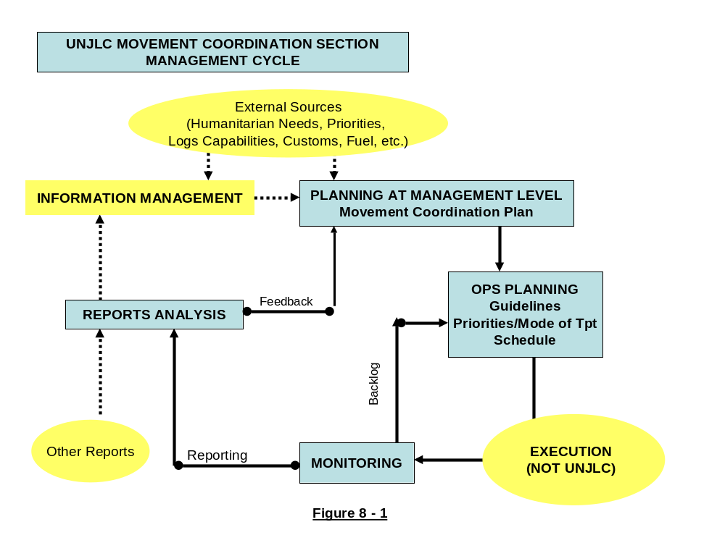
The Movement Coordination Section will normally consist of two to three Cells, respectively Planning, Monitoring and, in some cases, Report Compilation and Analysis. See LOG 1 Section 10, LOG 2 Section 8 for models / software for each of these functions within movement coordination. Generic and previous model TOR for the various roles can be found in LOG 3 Section 1. In case of intensive air operations, an Air Coordination Cell may function either separately or be integrated in the Movement Coordination Section. The UNJLC responsibilities in the different scenarios of air operations are described in LOG 1 Section 9. A Sample Movement Coordination structure can be found below in Figure 8.2. Other samples of Movement Coordination from previous operations can be found in LOG 2 Section 8.
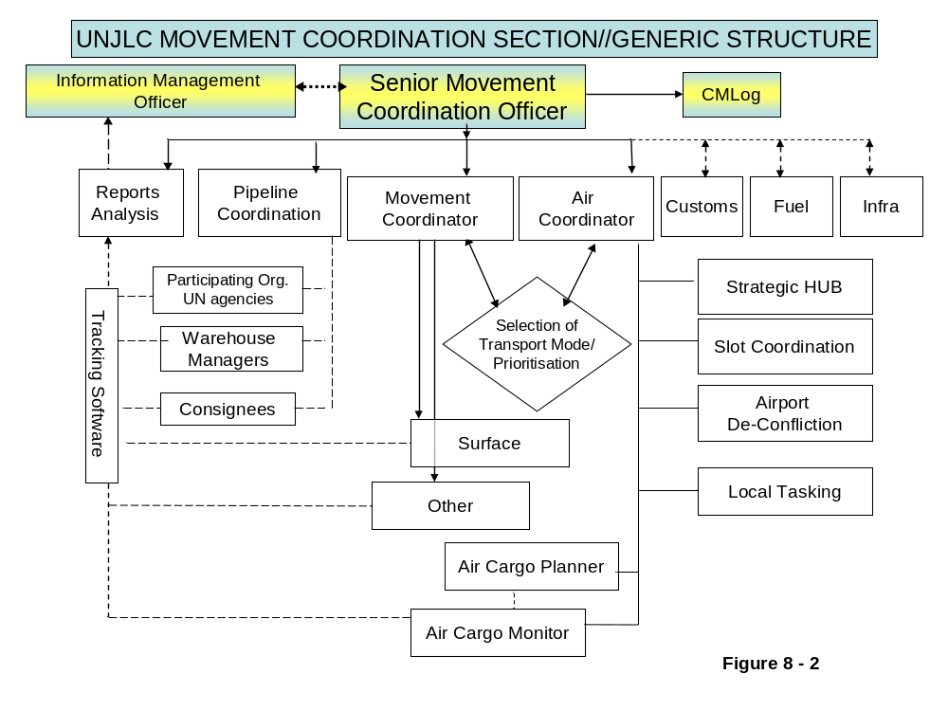
8.2. CONSIDERATIONS on MEANS of TRANSPORT
8.2.1. Internal Water transport – boats and barges.
Boats are slow but economical and can carry large tonnage and cargo that may be too bulky for other means of transportation. River or tidal currents will affect their speed. In view of the UNJLC/Logistics Cluster's mission to react quickly in large-scale emergencies, it will be rare for boats to be recommended for common transport during the initial relief phase. On the other hand, small boats and barges may be the only means of moving relief commodities in flooded areas or remote coastal areas.
Normally, the Movcoord Section will not be involved in detailed scheduling of commonly available boats and barges. In cases where such assets are made available by Donors, they will be directly allocated for a pre-determined period to beneficiary organisations, which will be responsible for the detailed scheduling. (See LOG 2 Section 8 for templates and samples from previous missions.) Nevertheless, the UNJLC will maintain an inventory of the allocated assets and may require regular reports on their availability and status. In Coordination with Donors, the UNJLC, or Logistics Cluster, should have the right to re-allocate boats and barges in case of overriding priorities.
In special circumstances, boats or barges may be an important link in a movement plan using different modes of transportation. In such cases, responsibilities for coordinated scheduling may be delegated to the UNJLC.
8.2.2. Rail
Railways continue to be outstanding in their ability to move large quantities of cargo and passengers over long distances at minimal cost. The degree of UNJLC involvement in rail transport will depend on the circumstances. If available, rail transport, because of its large capacity, should normally be shared by all participating Agencies and organisations. However, rail scheduling will require thorough planning well in advance of execution and may not be the best mode of transport in urgent humanitarian relief situations. See LOG 2 Section 8 for sample assessments. (See LOG 1 Section 11 and LOG 1 Annex 4.)
8.2.3. Road
Road transport plays a major part in the movement of humanitarian relief commodities. In principle, it will be the primary mode of transportation whenever possible. Normally, Agencies and other humanitarian organisations will manage their own fleets of trucks and the UNJLC or the Logistics Cluster, will not be involved in detailed loading and movement planning. Nevertheless, Donors or other benevolent organisations may decide to allocate a number of trucks for humanitarian use. In such cases, UNJLC or the Logistics Cluster will allocate these trucks for a certain period or task. Furthermore, the UNJLC will be the focal point on road conditions and transport availability. In that context UNJLC may, for example, advise on avoiding choke points and bottlenecks and recommend alternative options. See LOG 2 Section 10 for samples of previous road updates, data capture templates and GIS map products.
8.2.4. Air
Airlift enables the rapid delivery of significant quantities of cargo over long ranges. However, it is the most expensive mode of transportation and should be used only if no other alternatives are available. That said, due account must be taken of such important factors as accessibility of the victims and the urgency of the humanitarian crisis. At the onset of an emergency, the use of air transport is very often the only way to reach the victims in a timely manner.
Because of their high cost, airlift assets (fixed-wing aircraft and helicopters) should wherever possible be shared or made available for common use. When significant air assets are deployed to a crisis region, the UNJLC should be structured to include an Air Operations Cell, distinct from and in addition to the Movement Planning Cell (MPC) (which would then handle only the Coordination of surface and river transportation).
The UNJLC Air Operations Cell will be manned by one or more staff with appropriate professional experience and qualifications. Its primary role will be to coordinate the utilisation of all air assets made available for the common use of UN Agencies, IOs, NGOs and other humanitarian organisations. These air assets could include both regional and strategic aircraft.
Because of the complexity of this function, a special section in this LOG has been dedicated to air operations. (LOG 1 Section 9).
8.2.5. Maritime
The UNJLC will normally not be involved in shipping and will refer to WFP shipping section (OTS) for expert advice. Nevertheless, during large-scale emergencies, the UNJLC could be involved in compiling the requirements of humanitarian organisations for transporting heavy and bulky cargo. Some of these requirements may be combined and, in some cases, shipping services may be shared. In addition, while the urgency might be the deciding factor to use aircraft for flying the commodities into the crisis area, it might be useful to consider shipping, in particular if multiple flights would be required to transport heavy and bulky cargo. Furthermore, the costs of air transport may be such that shipping provides the only way to efficiently transport commodities over long distances.
A quick reference checklist with the average days that ships require to reach their destination is in LOG 2 Section 8. In addition to the on-route time, the charter time and preparation of Bill of Lading should be included. In some urgent cases, it may be more efficient to request governments for assistance with military vessels. Refer to LOG 1 Section 17.
8.2.6. Advantages and Limitations of Different Modes of Transport
The following table summarises the advantages and limitations of the different modes of transportation. See LOG 1 Annex 5.

Mode | Characteristics | Advantages | Limitations
INTERNAL  WATER TRANSPORT | Can be used to supply riverside communities or during floods (barges, small boats). | Capacity  Specificity | Speed  Flexibility
RAIL | Can be useful if tracks and equipment are in good condition | High Capacity  Low Cost  Range and Speed | Inflexible  Needs additional means to load/offload and to transport cargo to warehouses  Long planning time
ROAD | Depends on safety conditions and access routes to delivery points | Flexibility  Cost | Road Conditions  Bottlenecks  Vehicle Maintenance  Fuel Availability  Vulnerability
AIR  (Fixed Wing) | Usually employed when supplies are needed urgently or when there is no other way to reach the affected area | Speed  Range  Flexibility | High Cost  Small Payload  Weather  Airfield availability  Aircraft maintenance  crews
AIR  (Helicopters) | To be employed to deliver staff and commodities at places which cannot be reached by other means | More versatile than Fixed Wing (can land at small sites) | Very small Payload  More expensive than Fixed Wing  Limited Range
MARITIME | Used for transporting bulky and heavy commodities | Enormous cargo capacity  Economical | Slow  Follow-on transport needed  Offloading and Customs processing can be time consuming

8.2.7 The MOVCOORD Cell in the first phase of an emergency response.
Figure 8.3 illustrates the functional operations of UNJLC Movement Coordination Cell during the initial stages of an emergency deployment. The UNCT / RC / HC or the Logistics Cluster will consider the mission context, identify priorities and request a UNJLC mission. The derived mission staffing and tasking of personnel will determine the range of services / activities undertaken by the Movement Coordination Cell.
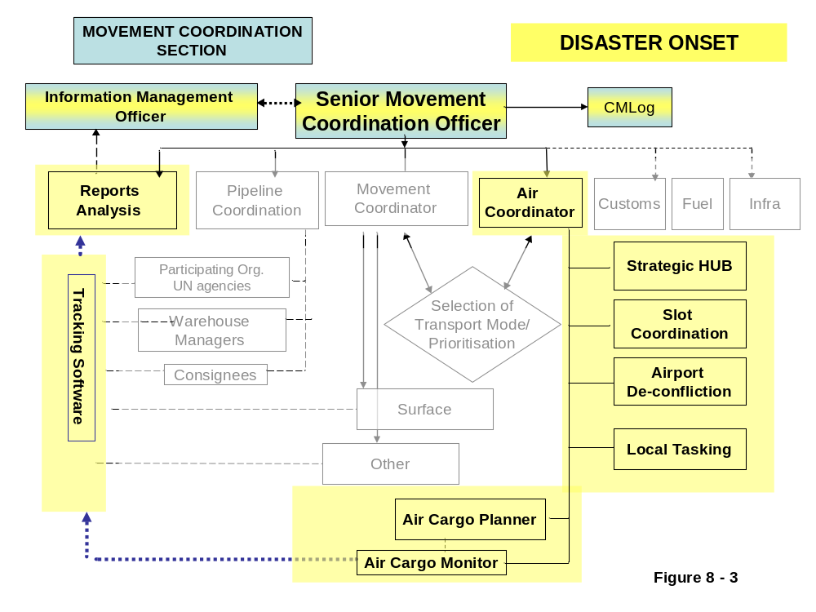

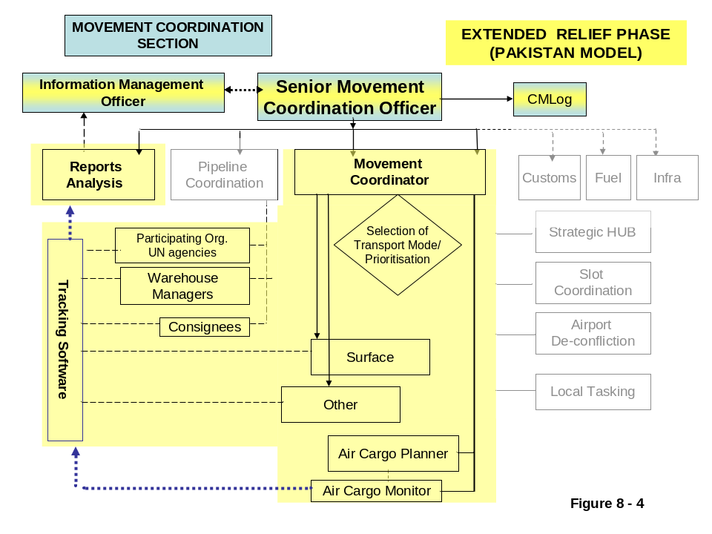
Following the initial surge associated with the emergency response, the UNJLC mission will transform in accordance with the evolving requirements of the relief phase. The model in Figures 4 & 5 are taken form the experiences of Pakistan (a sudden-onset emergency) and Sudan (a complex emergency).
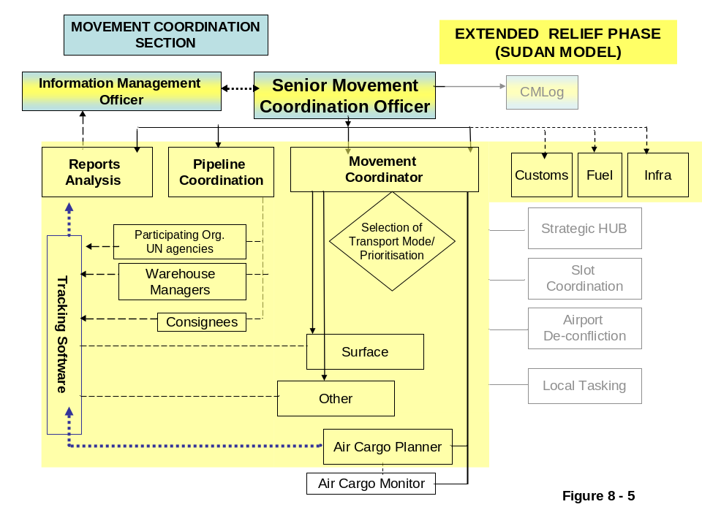
The key actions to be taken by the UNJLC Movement Coordination Personnel in the First 72 Hours of deployment are covered in the following ‘’Responsibilities and Actions of Key Movement Coordination Personnel’’. Remembering that the order of deployment may not always be in order of seniority, the first deployed in the Movement Coordination role can draw guidance from both generic TORs outlined below.
8.3. SENIOR MOVEMENT COORDINATION OFFICER (SMCO)
a. Responsibilities
The Senior Movement Coordination Officer (SMCO) may also act as Deputy Chief UNJLC or Deputy Operations Coordinator, if appointed. SMCO will keep himself/herself informed on all activities within the UNJLC and will substitute for Head of UNJLC or Operations Coordinator, whenever required. He/she has a major Coordination role within the UNJLC and, besides being responsible for the Planning and Monitoring functions, will:
- Provide information on interruptions to road and railway networks, including congestion points and any other logistical bottlenecks. Act as focal point for the resolution of such problems.
- In conjunction with UNJLC air operations staff (if present) provide an information platform on the operational status, capabilities and limitations of all airfields in the crisis area and recommend strategy for use of these airfields.
- In conjunction with UNJLC air operations staff (if present) provide an information platform on use of common air assets for transport of humanitarian cargo and passengers.
- Identify possibilities and limitations for using inland waterways and recommend use of suitable boats and/or barges.
- Provide an information platform to facilitate operational decision-making on all logistics matters, including identification of most efficient transport method (possibly a combination of water/road/air).
- Acquire information about, and disseminate information to all actors, to alleviate undue influence on the pricing and availability of local commercial fleets that ply the commercial transport routes.
- Act as focal point for UNJLC Field Coordinators deployed at satellite JLCs.
- Direct and supervise the Movement Planning Cell (MPC), Movement Monitoring Cell (MMC), Movement Execution Cell (MEC) and Air Operations Cell (AOC), depending on which of these Cells are established. Issue specific TOR for MMC and MEC as required: see examples LOG 2 Section 8 & LOG 3 Section 1.
- Be the focal point for integrating CMCoord / CM Log / CIMIC staff and their support into the UNJLC movement control function.
- In a complex environment, be the focal point for coordinating logistics movements with DPKO (MOVCON) and/or other relevant military entities.
b. Immediate Actions after UNJLC Activation
- Read the Deployment Requirements Assessment (DRA) and obtain all relevant information on logistics movement issues.
- If DRA report is not available, read the checklist at LOG 1 Section 6 and see LOG 1 Section 9 (obtain information from sources identified in the checklists).
- Obtain information on availability of common transport assets. Establish the UNJLC "Transport Support Request" process.
- In a scenario involving UNJLC Coordination of airlift operations, request the establishment of an Air Operations Cell to undertake the air functions of movement planning, monitoring and execution (as applicable). In conjunction with the UNJLC Senior Air Operations Officer, draw up and publish procedures and guidelines for coordinating use of common air assets. (See LOG 2 Section 8.)
- Discuss approach to be adopted for use of MCDA logistics support. Establish integration of CMCoord staff into the Movement Control function.
- Agree and establish general coordination guidelines for streamlining and de-conflicting logistics movements.
- If operating in a complex environment, establish procedures with DPKO and/or relevant military entities for coordinating movement of humanitarian relief commodities, including security aspects.
- Establish coordination procedures with DPKO for determining humanitarian priorities and monitoring application of these priorities during execution phase.
c. Ongoing Operations
- Confirm humanitarian priorities as and when up-dated by relevant humanitarian authorities and monitor application of these priorities during the movement-planning phase.
- Undertake logistics Coordination function on behalf of Agencies and other humanitarian organisations to facilitate logistics operational decision-making and avoid inflation of commercial transport rates.
- Depending on the scenario and structural arrangements for Coordination of common transport assets, call and chair regular meetings of users and operators to receive and prioritise bids and formulate the transport plan. Such meetings could be held daily (to discuss the following day's plan) or at less frequent intervals as required. In the case of airlift Coordination, this task should be delegated to the UNJLC senior air operations officer.
- Continuously supervise Movement Planning, Monitoring and Execution activities as applicable.
- Analyse reports and modify Movement Planning schedule as required.
- Coordinate summary reports with Reports Analysis and Statistics section.
- In a complex environment, continuously coordinate logistics movement activities with DPKO or other relevant military entities.

8.4. MOVEMENT PLANNING OFFICER (MPO)
a. Responsibilities
The Movement Planning Officer (MPO) will be responsible for the detailed Coordination, planning and scheduling of common transport assets. Besides these planning functions, he/she will also be responsible for recommending the most efficient modes of transportation. In so doing, the MPO will consider the following planning considerations:
b. Actions by Movement Planning Officer (MPO)
Road Transport
Obtain information on:
- General road conditions.
- Locations of hazardous or impassable areas.
- Fuel availability.
- Availability of local drivers.
- List of reliable local common carriers and rates.
- Availability of local maintenance facilities.
- Local insurance requirements.
- Local driving laws and requirements.
- Ensure an adequate fuel supply system.
- Obtain information on local Customs formalities/procedures (see LOG 1 Section 13).
- Obtain relevant information on local laws, procedures, forms, costs and hours of operation at points of entry.
- Brief beneficiary Agencies and organisations on process for submitting road transport bids, publish these procedures on UNJLC website and send electronic copies to all concerned.
- Receive requests for road transport from Agencies, IOs, NGOs and other humanitarian organisations.
- Evaluate and prioritise requests in line with priorities established by Humanitarian Coordinator.
- Prepare and submit a road transportation plan, including routes of travel, ETDs/ETAs, precise location of departure and pickup points, and assignments of vehicle and driver. Include maps for drivers.
- Monitor execution of road transport plan, receive and analyse reports and, if required, monitor the fuel/oil consumption and vehicle cost.
- Produce regular, timely and accurate narrative and financial reports for the head UNJLC and for donors as required.
Multi-lateral relationships:
- Ensure effective working relationships with logistics planners of UN Agencies and other humanitarian organisations.
- Ensure effective working relationships with technical and service departments of transport operators.
8.5 EXIT STRATEGY: KEY ACTIONS IN THE LAST MONTH OF AN OPERATION
- Establish timeline for handover and an end of mission date in consultation with UNCT/RC/HC/ Logistics Cluster and publicise imminent closure of UNJLC.
- Identify appropriate hand-over partners for services provided by the Movcoord Section, e.g. UNHAS (for air coordination), Logistics Cluster members (for road, inland waterways, etc) with the capacity to continue the services.
- Notify UNJLC Core Unit of handover partners and the contact details.
- Archive all mission data and file with both INFOCOMMS in the mission and the Core Unit in Rome. (See LOG 1 Section 10.)
- Compile mission report for Movement Coordination including input from the relevant cells. This report should highlight the deployment timeline, achievements, milestones, shortcomings and conclude with recommendations. Submit MOVCOORD Report to Head of UNJLC and INFOCOMMS mission staff for consolidation into the UNJLC End of Mission Report.
- Complete a personal end of mission report: indicating personal successes and failures within the operation.

LOG 1 - SECTION 9: AIR OPERATIONS
9.1. INTRODUCTION
- In the first stage of a disaster, airlift may be the only tool of the humanitarian organizations to answer the requirement of speed, flexibility and mobility for providing humanitarian assistance. In most emergencies, especially in the early phases, transport aircraft are used to send urgent commodities to the crisis region. This creates an overwhelming flow of aircraft, which often surpasses the handling capacity at the destination airfields and causes congestion. In addition, regional and local air support may be required for assessment missions and distribution of relief items. This will generate an increased demand of available assets. To reduce competition and to achieve economies of scale, the UN may decide on the activation of a common humanitarian air service. Therefore, it has been recommended to:
- Centralise the planning of humanitarian aircraft proceeding to the airfields in the crisis area and, in Coordination with the authorities who have control over the airspace and airfields, establish a system and procedures to avoid congestion.
- Combine and consolidate the requirements for regional and local air assets and centralize their chartering and use.
- The UN High Level Committee on Management agreed in 2003 that the World Food Programme (WFP) would be the lead agency for conducting air operations. WFP established the Humanitarian Air Service (HAS) system to comply with this new role and to provide common air services in case of emergency. As a result, several humanitarian actors will be active in the crisis area i.e.
- Humanitarian Air Services (HAS), operated by WFP Aviation, supporting a variety of humanitarian organizations;
- NGO’s chartering their own assets;
- Donor countries flying commodities into the crisis area to support the local authorities and/or NGOs.
- International organizations such as ICRC, IFRC and IOM.
- Generally, in large-scale emergencies with multi-sectoral involvement and intensive humanitarian airlift operations the United Nations Humanitarian Coordinator will assign the United Nations Joint Logistics Centre (UNJLC) to schedule and prioritise Humanitarian Air Service cargo flights.
- The layout of this section is as follows:
9.1. Introduction
9.2. UNJLC/HAS Relationship
9.3. Context
9.3.1. Regional versus Strategic Air Operations
9.3.2. Decongestion of Airfields
9.3.3. Staging areas or Strategic Hubs
9.4. Scenario-related Coordination Options
9.4.1. Scenario 1: Management of Aircraft Flow (Slot Time Allocation)
9.4.2. Scenario 2: Coordination of Strategic Airlift
9.4.3. Scenario 3: Coordination of Regional Airlift
9.5. Required Infrastructure and ICT
Supporting documents, airfield assessment forms and TOR of the individual staff officers are in LOG 2, Section 9
9.2. UNJLC/HAS Relationship
In particular during the early stages of a large scale emergency, the management of air assets will be closely coordinated between UNJLC and HAS; the first, handling the interagency Coordination and prioritisation aspects, the second, contracting, flight planning and execution. The smooth interface between these two bodies should ensure an unprejudiced and cost-effective use of all available air assets. Oversight structures under the cluster approach have yet to be defined. (Refer to LOG 2, Section 4)
In principle, at the onset of a large-scale emergency, the Humanitarian Coordinator will establish a Field Steering Group (FSG) to oversee the UNJLC activities and a Users Group Committee (UGC) to oversee the HAS activities. These Groups will consist of representatives of Agencies and relevant IOs and NGOs and other beneficiaries. One of the responsibilities of the UGC is to approve the Standard Administrative and Operations Procedures (SAOPs), which lay down the rules and regulations to use the air assets.
- The UNJLC role in passengers air transport will be limited to obtain facilitation measures regarding over flights and landings but HAS will be fully in charge for passengers booking and handling.
- The UNJLC/HAS interface with regard to cargo flights is depicted in Figure 9.1.

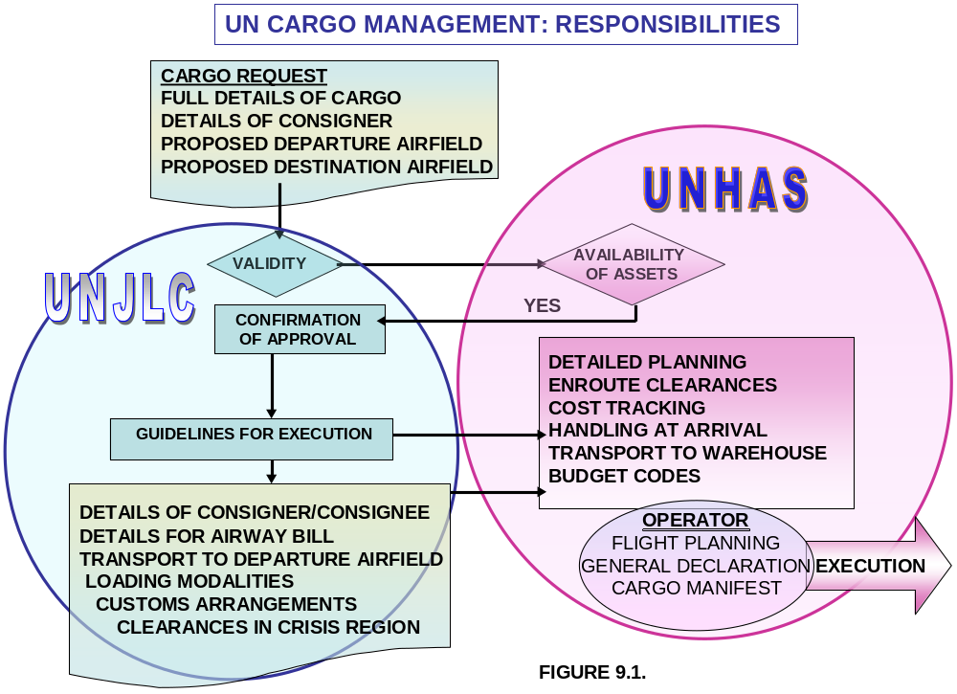
9.3. CONTEXT
9.3.1. Regional versus Strategic Air Operations
- Regional Air Operations are air activities within the crisis region, which include operations departing from neighbouring countries that are close to the affected country/area. Generally, departure bases for regional air operations should not be further away than 1000 Km from the destination airfields, which is the approximate radius of action of a C 130 with full payload without requirement to refuel in the crisis area. Regional Air Operations may include passenger services and possibly helicopter operations, the latter normally deployed in the crisis area.
- Strategic Air Operations are departing from outside the area that is defined above and will be limited to humanitarian cargo transport. These flights can land at regional hubs or directly at destination airfields within the crisis area as illustrated in Figure 9.2.

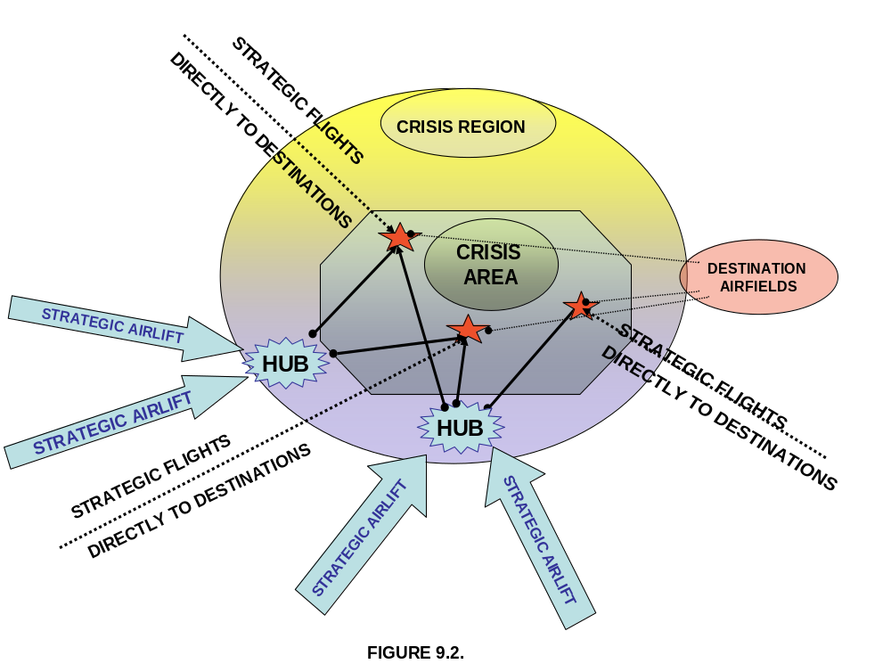
9.3.2 Decongestion of Airfields
(1) Overview

Such as mentioned in the introduction, it is common that the airfields in the crisis area are congested and that aircraft with rescue teams and relief commodities cannot be accepted or are forced to land at diversion airfields, which are at considerable distance from the crisis area. This is causing significant delays in Rescue and Relief operations, resulting in losses of lives and wastage of resources. The problems are caused by the overwhelming influx of aircraft, which often surpasses the handling capacity of the airports and is emphasised by the lack, in some cases absence, of an overarching management authority. In addition, the congestion at destination airfields is often caused by shortage of ground handling/dispatch equipment and expertise.

The management and handling problem should be considered in different modules such as depicted in Figure 9.3.

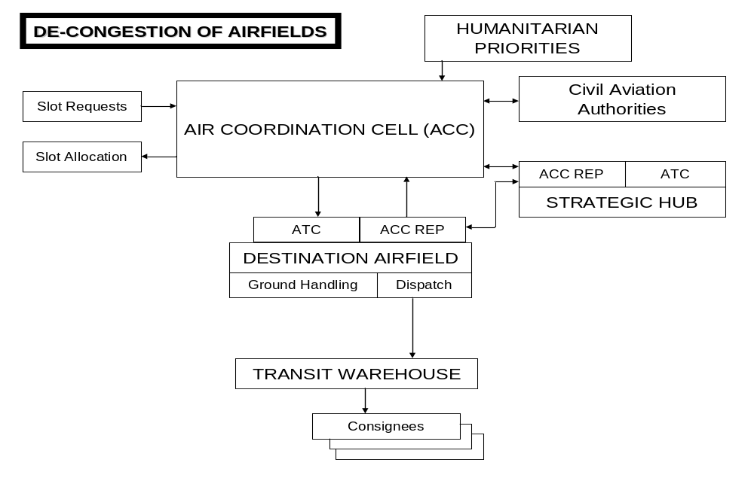Figure 9.3

(2) Management of aircraft flow

The management of the aircraft flow should be closely coordinated between the Civil Aviation Authorities, the Air Traffic Control (ATC) at the destination airfields and the UN air coordination structure. The relevant national authorities should agree with the establishment of an Air Coordination Cell (ACC) to centralise the request/approval procedures of humanitarian aircraft into the crisis area. Slot request/approval procedures should be established and enforced by CAA, ATC and ACC. Unsolicited commodities should not be accepted. Humanitarian priorities should be established by the appropriate authorities and enforced by the ACC. Detailed ACC procedures are outlined in Section 9.4 below.

If it is anticipated that the capacity at the destination airfield(s) will be insufficient, a staging point strategic hub should be established. Procedures for establishing such staging point are in Section 9.3.3 below.

(3) Ground handling at destination base

In principle, ground handling should be done by the local ground handling agencies. If these prove to be unreliable or if insufficient capacity is available, external ground handling teams will be required. Three options are available:

- Call upon private initiatives
- Deploy a HAS ground handling team
- Call upon MCDA support

A combination of these 3 options is possible. In cases where capabilities are made available for common use UNJLC or HAVE staff will coordinate the use of these capabilities. If necessary, priority will be based on humanitarian priorities.

(4) Dispatching to transit warehouses

A major problem remains the clearance of the ramps after downloading the aircraft. Commodities have to be transported to a nearby transit warehouse and an entity should be in charge of transporting, registering and storing all arriving commodities. (See LOG 1, Sections 8, 10 and 14). Meanwhile the consignees have to be advised to pick-up their cargo at the transit warehouse within a set timeframe. Three options are available to handle this task.

- Call upon private initiatives
- Call upon support of the local authorities
- Call upon an NGO such as CARE or World Vision

A combination of these 3 options is possible. Procedures for accepting, temporary storing and dispatching commodities are in LOG 1, Section 14 of this handbook.

9.3.3. Staging Areas or Strategic Hubs
- Staging areas or Strategic Hubs are logistics facilities, located in airports or ports, pre-identified, and rendered operational upon short notice.

- Staging areas are used to decongest the airports and ports of countries stricken by natural disasters or complex emergencies where large-scale humanitarian activities are necessary, by creating an integrated system of receiving, storage and dispatch of relief items and equipment.

- In these staging areas, relief items and equipment are on-forwarded to the affected areas, by prioritising deliveries and rationalising the use of the means of transport (cargo aircraft, speedboats, etc.) See Annex 5 of this LOG. Potential staging areas should have the following fundamental characteristics:

- Airports: military or civilian, should have the capacity to handle a wide range of cargo aircraft, with adequate aircraft parking space. The airport should be close to seaports and with good access to road and rail networks.
- Ports, with the capacity to handle both large and small-scale shipments, should be close to airports, and have good access to road and rail networks.
- Availability of warehouse space, office space and offices for staff.
- Easy and unrestricted access to worldwide telecommunications and email.
- Able to be activated upon short notice.
- Government agreement. This is needed to simplify transit customs procedures and to operate exempt from any fees, taxes and royalties, for the duration of the emergency.
- Standard immunities and privileges as applicable to UN staff and premises for the duration are required.
- If possible, access to MCDA military cargo aircraft for humanitarian emergency airlifts.
- Virtual locations, not holding any stock until activated.
- Operational on 24/7 basis.
- Government support and commitment, to be consolidated in a MOU. A sample of such MOU is in LOG 3, Section 3. LOG 1 Section 13.

As of today, UNJLC, UNHAS and UNHRD remain the main players of a staging area or a transhipment point, but the presence of the 3 actors is not necessarily required. These entities are administered by WFP and all admin/finance rules and regulations apply. For this reason, should the staging area (transhipment point), be located in a country where there is no WFP office, a WFP staff member should be immediately appointed and he/she should receive delegated authority to manage the staging area including authority for local procurement of NFI if needed.

A disbursing officer for a correct segregation of duties should also be identified as well as experienced local staff.

After arrival and transit storage at the Hub, the commodities remain to be shipped to their final destination for which the HAS could be in charge. In such a case, UNJLC will be responsible for the coordination and prioritisation process. Since the modalities can be directly negotiated between the UN and the local authorities, the UN should have a better grip on operations and slot allocation at the strategic hubs, but the mechanics have to be in place to negotiate slot times at the destination airfields. TORs for the UNJLC representative at the strategic hub are in LOG 2 Section 9 and in LOG 3 Section1.

The role of the different players is as follows:

- The Role of UNHRD is:
- To accept and dispatch the incoming and outgoing inter-agency cargo, including intermediate storage and handling.
- To provide a management and related procurement and administrative function.

- The Role of HAS is:

- To obtain, coordinate and manage, available air assets on behalf of all agencies.
- To ensure that the assets are available and scheduled for operations as and when required.

(3) Role of UNJLC is:
- To coordinate inter-agency requirements in terms of incoming and outgoing cargo.
- To coordinate slot times in consultation with local air traffic services and ground handling agents.
- To prioritize interagency cargo movements in consultation with HAS and available air assets.
- To coordinate as above with other available transport sea assets.
- To acquire and disseminate information on an Inter Agency basis.
- TORs for the UNJLC Staff Officer are in LOG 2 Section 9 and LOG 3 Section 1.

9.4. SCENARIO-RELATED COORDINATION OPTIONS
The UNJLC responsibilities will depend on the scenario and the presence of the Humanitarian Air Service (UNHAS). In certain scenarios, some of the functions outlined below will be carried out by UNHAS staff. Nevertheless, UNJLC’s role in air operations may extend to all humanitarian air activities while the UNHAS responsibilities will focus on the management and provision of services related to those air assets which are chartered or acquired by WFP. The UNJLC air Coordination process will follow the pattern, which is depicted in Figure 9.4 below.

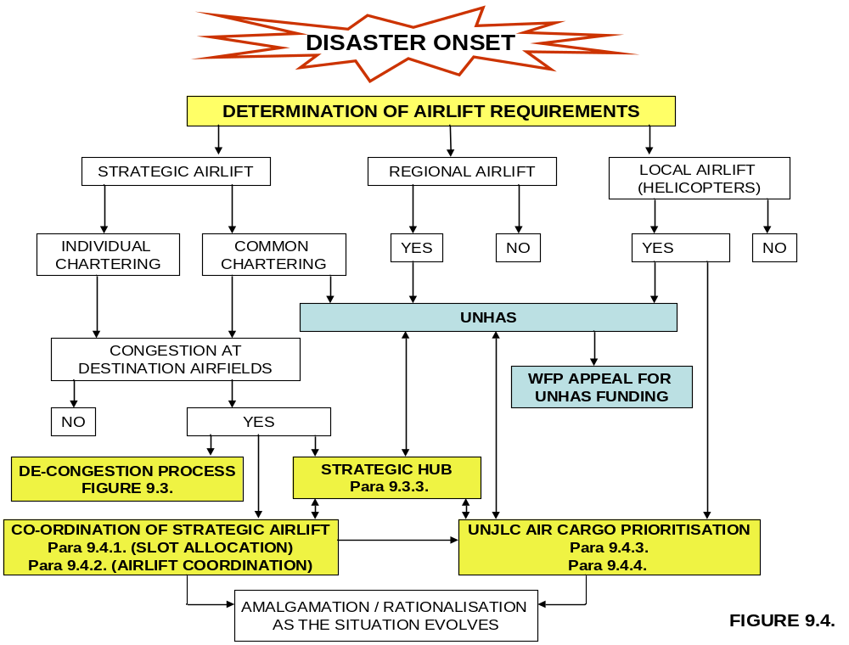
9.4.1. MANAGEMENT OF AIRCRAFT FLOW (SLOT TIME ALLOCATION)
At the onset of large-scale emergencies when the overwhelming flow of transport aircraft surpasses the handling capacity at the destination airfields and/or the security situation imposes specific restrictions it may be required to create a centralised system for slot allocation at the congested airfields. Examples of such a scenario are Bosnia 1991-1995, Rwanda 1994 and Kosovo 1999. Typical characteristics are a quick build-up of a massive number of refugees or IDPs requiring immediate relief assistance. Airlift will be required to airfields in the immediate vicinity of camps, creating bottlenecks. Typical destination airfields were Sarajevo during the Bosnia crisis, Goma and Bukavu during the Rwanda crisis and Tirana and Skopje during the Kosovo crisis. In addition, bottlenecks may occur at strategic hubs that do not have sufficient capacity to handle the massive influx of strategic transport aircraft.
Typical for such scenarios is that, at the onset, humanitarian airlift is arranged and managed individually by UN Agencies, IOs, NGOs, Donors and other bodies. In addition, since most of such emergencies will occur in a complex environment, military operations may use a major part of the handling capacity of staging areas and destination airfields. As a result, a central coordination mechanism will be required to negotiate space, slot times and handling capacity at the relevant airfields. The UNJLC may be assigned to coordinate the humanitarian airlift schedule with the relevant air space management authorities and, in case of bottlenecks, prioritise the flights in accordance with the humanitarian priorities. Nevertheless, taking into consideration the urgency and specificity, and awaiting the full deployment of the UNJLC, UN Agencies may decide to activate an Air Coordination Cell (ACC). Such ACC may be installed at any location outside the crisis area such as in the premises of the Lead Agency, such as assigned by the Emergency Relief Coordinator (ERC), or at strategic airfields such as Brindisi, Copenhagen, Dubai, etc.
- The Air Coordination Centre (ACC) will act as the focal point for compiling all humanitarian strategic airlift requests, produce a consolidated airlift schedule and negotiate slot times with the military authorities or the authorities which are in charge of airspace and airfield control in the crisis region.
- The UNJLC Air Movement Coordinator at the Hubs (or staging airfields) will be, together with UNHRD and HAS the focal point to assure smooth transition and handling of strategic humanitarian aircraft. While keeping the ACC informed, she/he will be the coordinating element between local authorities, ATC, commercial handling agencies, HAS, UNHRD and representatives of UN agencies. In some cases, the Air Movement Coordinator may assume the responsibility for coordinating the ground handling capabilities.
- The Air Movement Coordinator at the Destination Airfields (or Airheads) will have similar functions as at the hubs but will have to pay more attention to the local security situation. In addition, he/she may be involved in obtaining local facilitation measures, including customs and immigration procedures. (See LOG 1, Section 13).
- Planning of strategic airlift slot allocation should start at least 3 days before execution, but should be sufficiently flexible to permit last-minute changes. The latter is to allow immediate rescheduling, should an aircraft be unable to meet the allocated slot times or is not allowed to land at the intended destination. It is recommended to anticipate spare slot times for such unexpected changes and/or delays. The ACC will publish a form to request slot times which will allow prioritisation and coordination with the military authorities. The format is available in LOG 2, Section 9. Requests will be summarised, put in the appropriate priority and forwarded to the relevant authorities for approval. An example of such summary form is in LOG 2, Section 9. A typical planning cycle is illustrated in Figure 9.5 below.

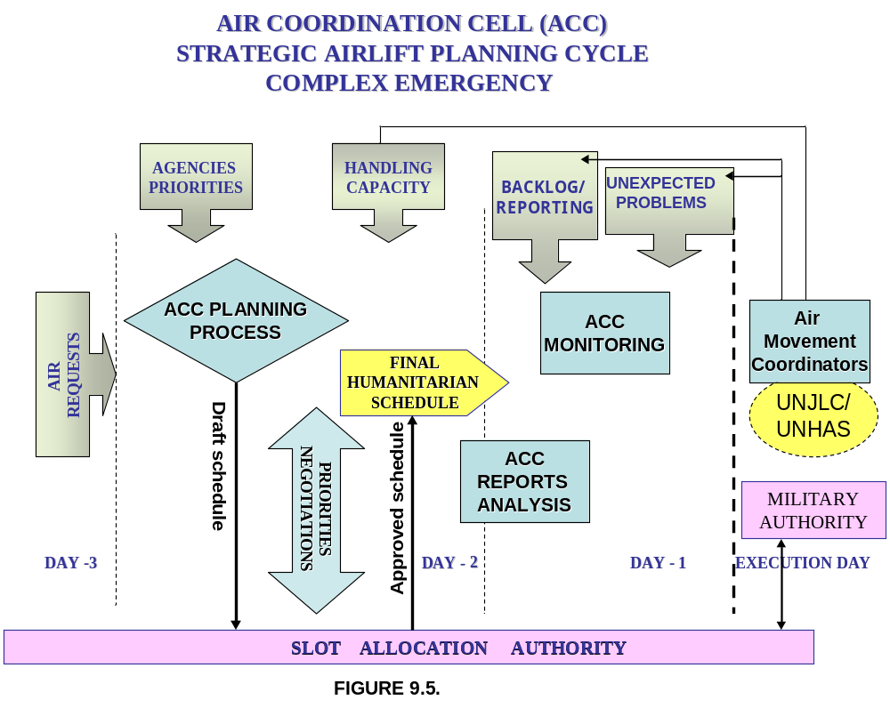9.4.
9.4.2. COORDINATION of STRATEGIC AIRLIFT
a. Scenario
Under its mandate, the UNJLC will only be involved in the early stages of large-scale complex emergencies but, as such, may be implicated in different types of air services as mentioned above. UNJLC involvement may occur modularly, in accordance with the following scenario.
- At the start of the crisis, a sudden influx of strategic aircraft may occur in which case it may be necessary to create immediately an Air Coordination Cell (ACC) as described in paragraph 9.4.1 above.
- Following the decision to deploy the UNJLC, an air structure will be created in the crisis region and air coordination officers will be deployed to those airfields, which are used by the humanitarian airlift. The ACC may remain at its original location, but may become a satellite of the UNJLC.
- Besides the UNJLC, the HAS system will be activated to manage the air assets which are available for common use.
- As such, the UNJLC/ACC may be charged with both strategic airlift scheduling of HAS chartered aircraft and slot coordination of other humanitarian aircraft. Regional airlift prioritisation would be done within the air component of the UNJLC. Nevertheless, as the situation evolves and strategic airlift requirements are decreasing, ACC responsibilities may be transferred to one central common location within the UNJLC structure.
- To a certain extent, the latter has been the case during the crises in both Afghanistan and Iraq. During the first crisis, strategic airlift was initially coordinated by the Core UNJLC in Rome but shifted to the UNJLC respectively in Islamabad and Amman, once fully established. The Afghanistan crisis did not require intensive coordination of strategic airlift, but during the Iraq crisis, UNJLC became involved in both strategic and regional air operations. Nevertheless, since the influx of strategic airlift was limited, it was not necessary to create a strategic planning structure separate from the regional air functions. Furthermore, as from the start of the operation, the execution of the air operations was managed by UNHAS, while UNJLC remained in charge of the compilation and prioritisation of the cargo needs, both strategic and regional. Both UNJLC and UNHAS were collocated and, although the air activities were limited to a few aircraft, the formula to manage the assets from a central location proved to be successful.
b. Structure and Responsibilities
- During large-scale complex emergencies, the Secretary General may appoint a Special Representative (SRSG) who will be overseeing both UN humanitarian and peacekeeping activities, if the latter are undertaken under UN mandate The Humanitarian Coordinator reports to the Emergency Relief Coordinator (ERC) or to the SRSG, if appointed, and chairs, inter alia, the (UN) Country Team (LOG 1 Section 4). The UNJLC will report to the HC or to his/her Deputy for Operations. The (UN) Country Team (UNCT) and/or the Field Steering Group (FSG) will provide the overall directives on the management of the ongoing emergency. These include the establishment of humanitarian priorities. A diagram of the reporting lines is in Figure 9.6.

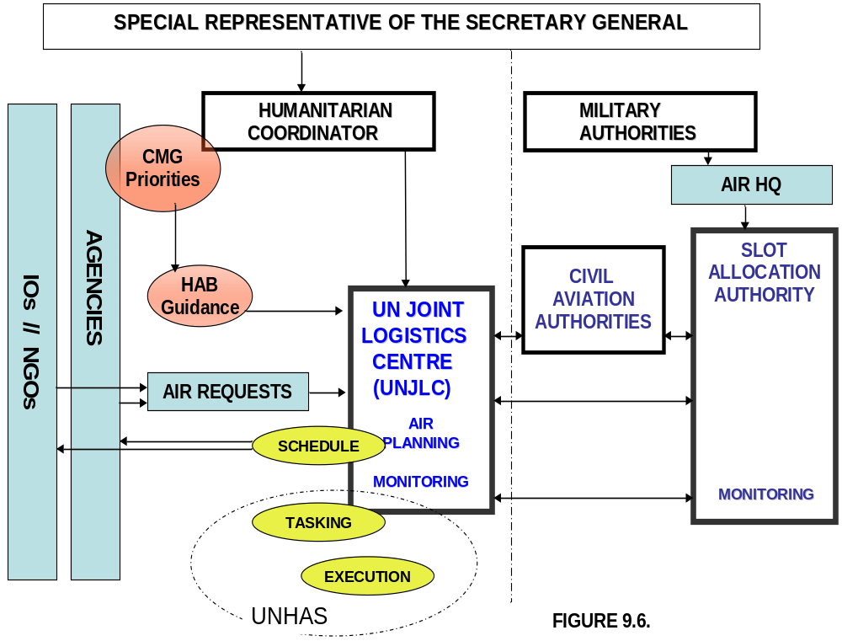
- In case of intensive humanitarian air operations, the HC may decide to create a Users Group Committee (UGC), which, however will not be directly involved in the management process of the air assets. The UGC provides administrative direction and guidance for the utilization of the common air transport resources. It is composed of all the Agencies, IOs, NGO representatives and Donors, which are active in the crisis area. One of the important tasks is to establish a list of beneficiary organisations having access to UNJLC/UNHAS air resources, but also establishing more detailed priorities for passengers and cargo transport. Sample TORs of such UGC are in LOG 2 Section 9.
- The UNJLC will act as the expert adviser to both the CMG/UNCT and the UGC on the interagency air requirements to support the relief phase of the ongoing emergency. In case of HAS activation and involvement, responsibilities for scheduling passenger and cargo flights will be as described in paragraph 9.2 above.
c. Planning Cycle
- Separate requests should be made for passengers and both regional and strategic cargo transport at least 3 days before execution. In some cases, the UNJLC may also be in charge for slot assignment for other humanitarian missions than those managed by UNJLC/HAS. In such a case, separate request forms will be needed and an additional officer may be assigned for this function. The flow of activities is depicted in Figure 9.7.

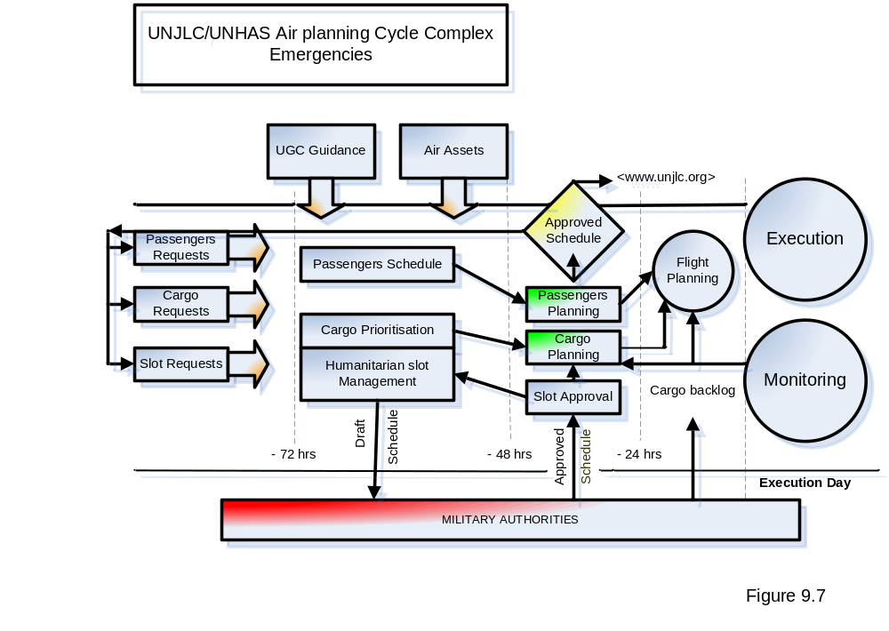
- During the initial phase of the emergency, passengers transport may be ad hoc, using all available means, but once established, the HAS passenger service will aim for a regular schedule and publish the booking procedures on the UNJLC and UNHAS websites.
- Depending on the scenario and the number of assets involved, cargo planning may be split into two separate entities, strategic and regional.
d. Functions
Staffing and individual functions will depend on the mandate of the UNJLC Air Component. The TOR of the individual staff officers are described in LOG 2 Section 9 and in LOG 3 Section 1.
Following options are possible:
- The UNJLC is only involved in cargo prioritisation and requests for slot allocation of those aircraft that are chartered for common humanitarian use;
- In addition to the above, UNJLC is also in charge for compiling all humanitarian slot requests and for proposing a consolidated schedule to the slot allocation authorities. In such a case, a Humanitarian Air Liaison Officer will be appointed to the UNJLC.
9.4.3 COORDINATION OF REGIONAL AIRLIFT
a. Scenario
- A typical scenario for managing regional air operations occurred during the floods in Mozambique (2000), the Tsunami (2004/5) in Indonesia and the earthquake in Pakistan (2005). During large-scale sudden-onset disasters, the tendency is that donors offer assets spontaneously and the humanitarian authorities should endeavour to negotiate a formula to centralise the management of these assets. This approach was successful in Mozambique but in both Indonesia and Pakistan, the national authorities decided to keep the mission assignment of the donated assets at their level. Nevertheless, it should be anticipated that donated assets, which are mostly military, would phase out after the initial relief phase. UNJLC and HAS should be prepared to replace these military assets with commercially chartered aircraft and gradually take over the management of all available air capabilities (HAS as the operator and UNJLC as cargo movement coordination/control prioritization). Similar scenarios are possible in the future. UNJLC and HAS should be prepared to send air experts to the crisis area in the very early stages of a disaster and set-up a structure for centralised management. Office and communication equipment should be readily available and installed to operate efficiently. Subsequently, the national authorities will be invited to centralise the air management task under the UNJLC/HAS umbrella, while donors would be encouraged to make their assets available for management by UNJLC/HAS.
- In a scenario with fixed wing and helicopter aircraft, it may be required to operate at one or two operations bases, preferably international airports with customs and immigration facilities, and deploy helicopters to designated pick up points. These points should be as close as possible to the disaster area and easily accessible by trucks, carrying the necessary relief commodities and logistics support for the helicopters, including fuel. These pick-up points can also be small airfields, which permit landings of C 130, C 160 or Buffalo type of aircraft, which can carry fuel for the helicopter operation. Also, a fuel storage capacity should be anticipated, reviewed and implemented if deemed necessary.
b. Structure and Responsibilities
- Normally, the Local (National) Emergency Management Authority (LEMA) is in charge for management of the rescue and relief operations and the UNJLC may be integrated into the national disaster management system.
- If UNJLC is integrated into the LEMA, the activities will be coordinated with the UN Resident Representative who will normally be appointed as the Humanitarian Coordinator.
- Administrative and office support will be provided by WFP, the custodian of UNJLC. See LOG 1 Section 15 and LOG 3 Section 1.
- The LEMA will provide the overall directives on the management of the ongoing emergency. In this function, it may be supported by the United Nations Disaster Assessment and Coordination (UNDAC) Team, which, in turn may establish the On Site Operations and Coordination Centre (OSOCC) and the online forum for info- sharing.
- The TORs of the UNDAC Team are in LOG 2 Section 5. UNDAC provides technical services, principally in the field of on-site coordination and information collection and dissemination. UNJLC logistics assessment experts may be part of the UNDAC Team for analysing and mapping the status of the logistics infrastructure. UNJLC information management and/or GIS personnel may also be deployed within the UNDAC team.
- The OSOCC, if deployed, will mainly be in charge for coordinating the activities of the international rescue teams. The latter will act in accordance with the INSARAG guidelines, which are in LOG 2 Section 5.
- Humanitarian priorities will be established by the LEMA, in close consultation with the UN Country Team (CT), which is chaired by the Resident Representative (Humanitarian Coordinator). The UNJLC reporting lines are depicted in Figure 9.8.

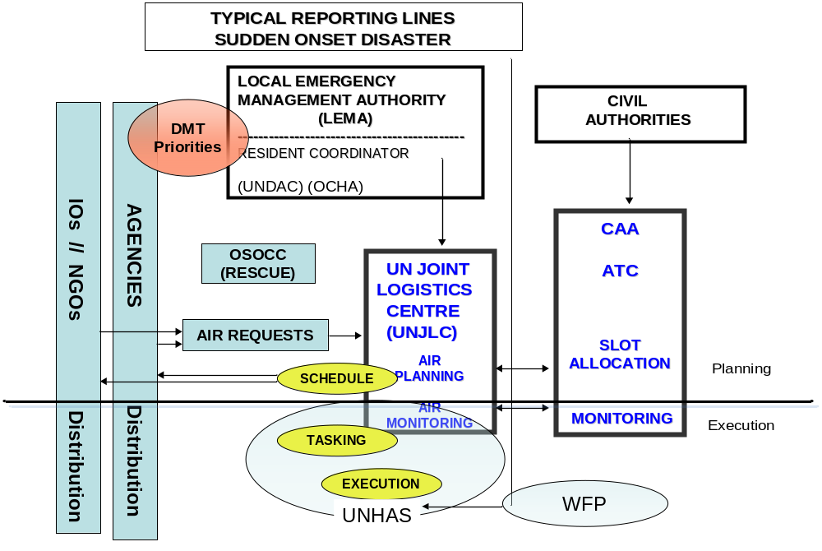
Figure 9.8
- Besides a possible logistics infrastructure analysis and mapping function, the UNJLC will act as the expert adviser on the use of all available air assets to support the rescue and relief phase of the ongoing emergency. It will act as the focal point for compiling all air requests, prioritise these requests and produce a consolidated airlift schedule in close coordination with CAA/ATC authorities and relevant air operators. As soon as HAS is deploying its assets, the scheduling functions will be taken over by the HAS staff.
- As a result, in particular during the initial phase, the UNJLC will have coordination, planning and monitoring functions. In principle, directing and monitoring of the execution will be delegated to HAS (if deployed) or to the staff of countries which provide MCDA assistance.
c. Planning Cycle
- Considering the nature of a sudden onset disaster and the related need to deliver the requested relief commodities very urgently, the UNJLC will aim for a very short planning cycle as shown on the diagram below. Large-scale helicopter operations, i.e. the handling of considerable cargo at the helicopter pick up points should be announced at least one day in advance but other flights may be requested until 11.00 AM on the day preceding the flight. In case of helicopter operations, cargo may be mixed with passengers on condition that the aircraft has adequate licenses and that the passengers are properly manifested.
- The UNJLC Movement Officer will make a draft schedule, taking into account the requests for airlift, the available assets and the humanitarian priorities. The draft schedule will be discussed at a coordination meeting. At that time, up-to-date information will be available on the number of serviceable air assets for the next day, the backlog of the ongoing operation and other factors such as crew availability, logistics support such as fuel at the pick-up points, etc.
- After the meeting, the approved schedule will be distributed to all concerned, allowing the requesting organisations to take the necessary actions for preparing the cargo.

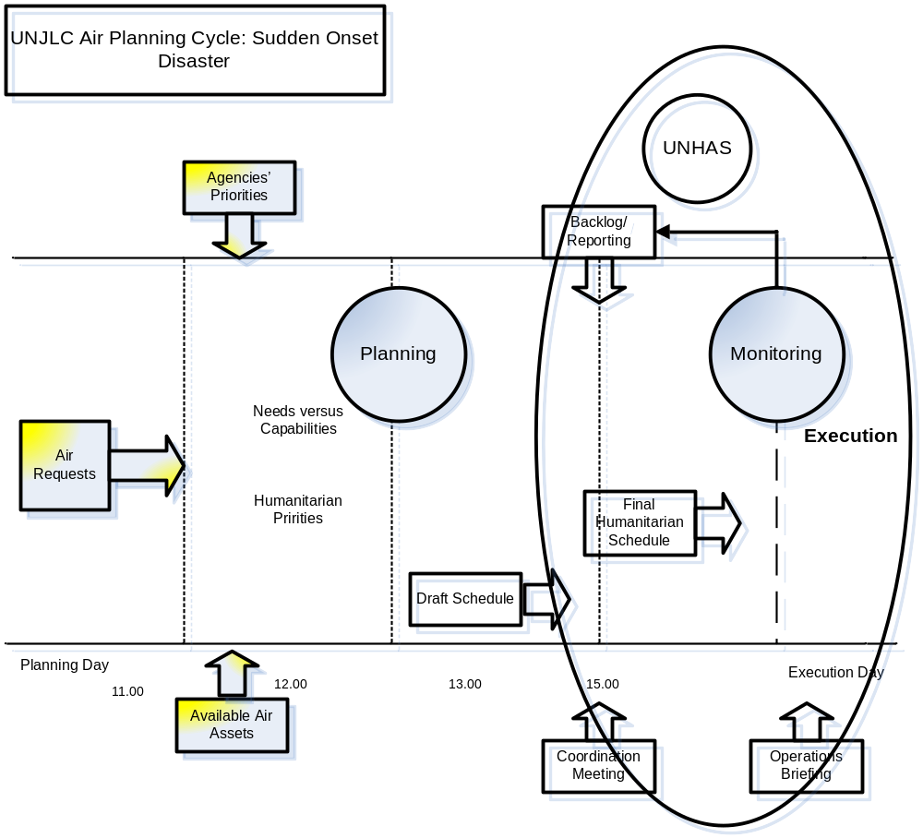Figure 9.9

- On the execution day, all participating crews will be briefed on the modalities to execute the flights. This briefing will be conducted by the authority which is in charge of flight monitoring, which could be either UNJLC, HAS or staff officers provided by countries which offer MCDA.
- In any case, UNJLC or HAS will keep at least one staff officer at the operations base for monitoring the execution of the flight schedule. Possible changes will be decided at flight monitor level.
- A flow chart is available in Figure 9.9

d. Individual Functions
The individual functions are described in LOG 2 Section 9.
9.5. REQUIRED INFRASTRUCTURE AND ICT
Anticipating that the air management function is fully integrated into the UNJLC structure, the Air Section infrastructure and ICT requirements are included in the UNJLC flyaway kit. Nevertheless, there might be conditions that the UNJLC is not (yet) deployed or that the air entity is functioning separately. If Agencies decide to deploy an ACC for coordinating strategic airlift or if a separate air management section has to deploy for managing the air assets during a sudden onset disaster, the following office space and basic equipment is needed to support an independent Air Coordination Cell (ACC):
a. Office
- One office, space 8 to 10 sq. meters per person and one meeting room
- One desk per person, size 2 by 1 metres minimum.
- One conference table, 2 by 1 metres (in meeting room).
- Three tables for faxes, printer, photocopier, scanner and miscellaneous matters
- Two filing cabinets;
- One television with satellite;
- Provision of wallboards to mount maps and plans.
- Briefing board/flip chart.
- All standard office stationary equipment, e.g. stapler, hole-puncher, pens, writing paper, note pads, ring-binder file covers, etc.
- One refrigerator.
- One coffee machine.
b. Communications
- One telephone with unlimited outside access for each individual;
- One mobile phone per staff officer;
- One Fax machine, programmable to send faxes to multiple addresses, with instruction manual, spare paper and spare toner or cartridges.
- Direct or remote access to long-range HF radio or VSAT communication systems.
- One mobile satellite terminal for voice/fax/data, as backup for all other links
- One Thuraya Satellite Phone
c. Information Technology for ACC members
- One laptop for each individual with DVD –RW, memory stick and the necessary connections for Email;
- At least three desktops. All computers should be in the LAN, have e-mail and DVD-RW capability and standardised software
- One Power Point Projector.
d. Aviation Documents
- Aircraft reference documents (Jane's).
- Access to Jeppesen Airport Directory (CDROM or on line).
- Access to Jeppesen FLITE STAR (Computer Programme)
- General Aeronautical publications such as:
- Airways charts (Jeppesen, RAF, USAF)
- Aeronautical charts topographical maps of relevant region(s).
NOTE: Air Movement Coordination Officers will be integrated into the JLC satellite offices, if deployed, and will basically need the same equipment as the JLC Field Coordinators.

LOG Part 1 – Section 10: INFORMATION & COMMUNICATIONS MANAGEMENT (INFOCOMMS)
10.1. INTRODUCTION
Logistics Information Management (and Communications) or INFOCOMMS is one of the most important UNJLC functions. In particular at the onset of large-scale emergencies, the UNJLC will distribute updated logistics information, including maps, to all humanitarian organizations that are active in the crisis area. Reciprocally, the organizations involved will be invited to share their own logistics information, which then can be consolidated and made available to the entire humanitarian community. Such spontaneous exchange of data is the cornerstone for the establishment of a common logistics information platform which ensures transparency and contributes to improvements in the efficiency of humanitarian logistics operations.

The INFOCOMMS aim is to ensure continuous improvement of UNJLC products / services and that the legacy of UNJLC is a worthy contribution to humanitarian relief, recovery and reconstruction.

The paragraphs below provide an overview of the Information Communications Management (INFOCOMMS) process within the UNJLC. They include the functioning of the system during emergencies and provide a checklist for staff officers which are appointed to fulfil field and INFOCOMMS functions. (See the checklist for the first few days of deployment on the last page of this Section.)

Sometimes the UNJLC collects data on commodities arriving into the crisis area. This allows the Humanitarian Coordinator, Agencies, IOs, NGOs, donors and logistics planners to obtain an overview of the support that is available for humanitarian assistance and, subsequently, adjust planning in accordance with needs. This function may be directly placed under the INFOCOMMS section or be a function embedded within the Cargo Movement Coordination Section.
10.2 CORE UNIT FUNCTIONS AND INTERFACE WITH FIELD ACTIVITIES
Particularly in the early stages of an emergency, the Core Unit INFOCOMMS will backstop the information management function in the field. The Core Unit will build up basic information regarding the logistics situation in the disaster region and will update this databank as soon as new information becomes available. It also has the necessary communications to distribute this data worldwide. The Core Unit support will gradually shift to field level as soon as more staff and better communications become available. Nevertheless, some basic functions, such as Web Management will remain with the Core Unit throughout the emergency.

The Information and Communications Management Unit or INFOCOMMS (Including GIS) within the UNJLC Core Unit in Rome generally performs the following functions:
- Providing normative guidance regarding the format, structure, timing of data collection (and collation) as well as most appropriate modes of delivery for information products,
- Web-design and overall generic standardization of products and structuring of the web based access platform (www.unjlc.org ),
- Structuring generic email lists and automated email forwarding, (both internal and external),
- Research and development of new product-interfaces on the web platform (such as interactive maps, discussion forums (blogs), etc.).

The Core Unit also attends to maintenance of the intranet (http://home.unjlc.org) which is accessible only for password-granted UNJLC staff. The intranet provides a basket of tools for use by staff in the field:
- LOG 1, 2 and 3 (i.e. both public and restricted access documents) and Logistics Capacity Assessments (LCAs) produced by WFP that are generally produced on a country-by-country basis.
- Intranet is a portal to access a range of useful software applications for field mission staff (photo-cataloguing tools, text-based cataloguing tools, photo re-sizing tools, Post-it, links to useful web-based software applications, latest relating to HR admin. and finance issues, etc. ). Contact info@unjlc.org

CORE UNIT INFOCOMMS INTERFACE WITH UNJLC FIELD UNIT

Mindful of the often poor connectivity in the field during emergencies, the Core Unit strives to ensure that electronic documents in a variety of formats can be accessed on-line with minimal connectivity. In parallel to this, the core unit promotes CD-based versions of the products and other electronic formats that are not dependent on internet connectivity.

It is the responsibility of the UNJLC mission field staff to provide hardcopy and electronic copy of the products directly to actors in the field and to make recommendations to the Core Unit on the appropriateness and timing of product dissemination for the mission. The Core Unit also plays a role in laying-out the INITIAL priorities and objectives for INFOCOMMS for the mission. As the mission evolves, field personnel are to adjust the priorities accordingly, but liaison with the Core Unit must be maintained for guidance and to ensure that field personnel comply with the UNJLC mandate.

The initial Situation Reports (Sitreps) from the field logistics officer will usually be very simple, possibly conveyed orally by radio or phone and circulated within the UNDAC team and to the UNCT/UNDMT: perhaps merely a list of numbers and contacts and place names. As the UNDAC team makes initial rapid assessments of the affected area and populace, the details in the reports increase. By this time, the recommendations should have been made to the UNCT and the IASC regarding the requirements for relief and the activation of an UNJLC.

Upon activation of a UNJLC Special Operation, members of the Core Unit will usually deploy as UNJLC Logistics Officers and begin establishing a UNJLC presence in formal terms. Information reporting structures then become a UNJLC format for the Situation Report (UNJLC Sitrep -See the format in LOG 2 Section 10). Ideally Sitreps are completed on a daily basis (for the first weeks of an emergency response): reverting to biweekly; and then weekly as the mission proceeds. In addition to field mission support, the UNJLC INFOCOMMS Core Unit is dedicated to identifying and institutionalizing the best practices of the previous UNJLC missions and incorporating new practices as and when developed. The INFOCOMMS unit in Rome also actively seeks cooperative partners in GIS, software tools, logistical analysis tools as well as collaborating on developing generic data/information standards with other humanitarian actors. (See samples of the tools in LOG 2 Section 10, LOG 3 Section 1).

Prior to establishment of formal INFOCOMMS structure, these reports are directed to the UNCT and UNJLC Core Unit. Subsequently, these reports are submitted to the UNJLC Chief of Mission and the Reports/Information Officer for the mission. These are internal documents sometimes containing sensitive information regarding the response, relief requirements, or the capacity of actors within the initial SAR/Relief phase to fulfil the relief needs, and as such may be politically sensitive. The process of ensuring that UNJLC INFOCOMMS products are politically and culturally sensitive is illustrated in Figure 1 (above) as well as in Figure 5 & 6 (below). As the mission INFOCOMMS unit is established, more formal protocols for reporting are designed based on whether reporting is to be based geographically (by town, region, area), functionally ( customs/borders, air, land, sea, etc.), or hierarchically (sub-office, field office, country office).

Figure 1. During an emergency response cycle, the purpose and sophistication of data flow, data volume, information products and the most effective modes of communications evolve: illustrated below on a linear time scale.

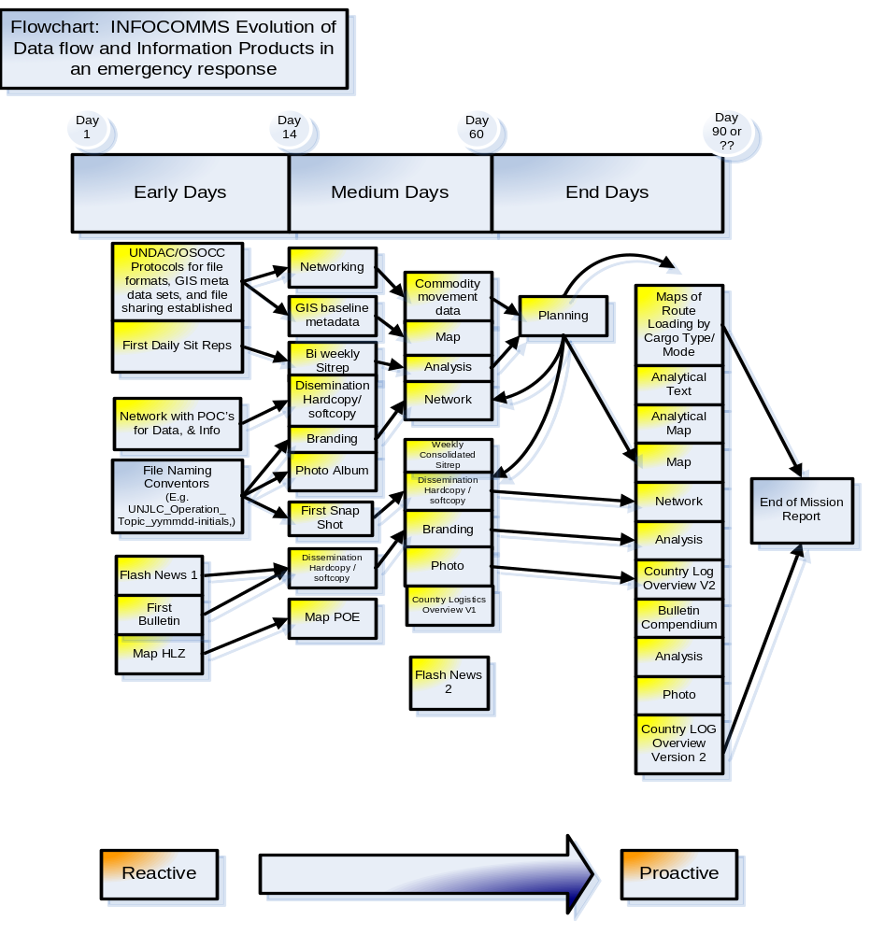
The INFOCOMMS aim is to ensure continuous improvement of UNJLC products / services and that the legacy of UNJLC is a worthy contribution to humanitarian relief, recovery and reconstruction.

CORE UNIT SUPPORT UPON ACTIVATION

Depending on the scale of the emergency, the Core Unit Information and Communications Unit may provide direct field support in the country of operations or, more likely, on-line support and secretariat services to bolster the initial stage of the INFOCOMMS function in the mission. (A comprehensive range of templates and examples of INFOCOMMS products from previous missions can be found on the website (www.unjlc.org) and in the LOG 2 Section 10.)

In any emergency response, one of the core services offered by the UNJLC to the humanitarian community is Information AND Communications Management (INFOCOMMS) for Logistics. The nature of the data, information and communications, is dynamic during the evolution of a humanitarian emergency response and as such the Figure 1 above, illustrates how reactive simple texts evolve into proactive analytical planning tools and tailor-made products.

The UNJLC Core INFOCOMMS Unit in Rome provides normative guidance, creative solutions, file protocols and general technical assistance. UNJLC personnel can obtain password access to the LOG 3 RESTRICTED PRIVATE Sections and the intranet by contacting info@unjlc.org.

Figure 2.

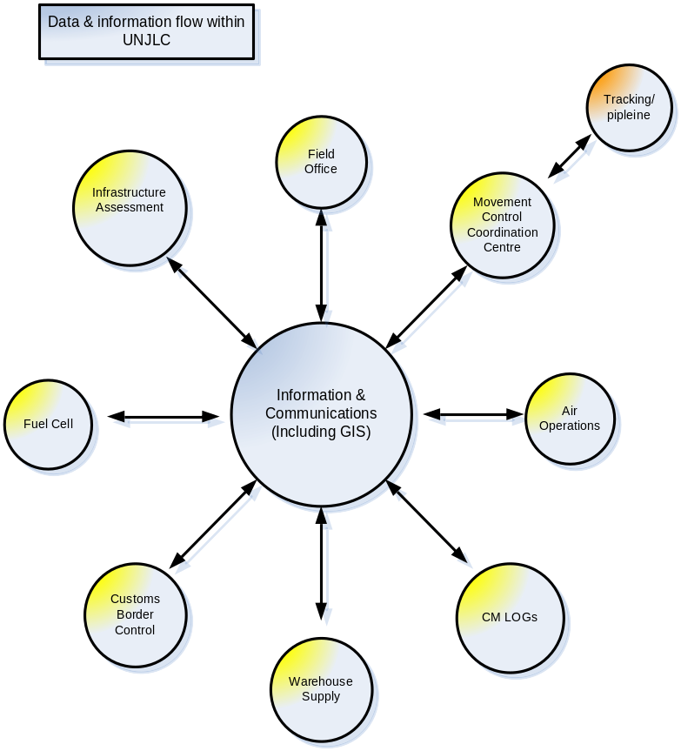

10.3 INFOCOMMS UNIT IN A MISSION

ORGANIZATIONAL STRUCTURE

The INFOCOMMS unit in a mission may consist of anywhere between one and ten personnel. However, in general several of the following roles are assumed by each of the UNJLC personnel in the mission;
- Information Manager,
- Reports Analysis Officer,
- Database Management Officer/Web Content Manager
- GIS Officer(s) - (GIS Cartographer, GIS Spatial Data Coordinator),
- Liaison Officer,
- Other junior national positions such as Reports Assistant, Communications Assistant may also be required for routine office duties, printing, publishing and/or front desk support roles,
- Generic TOR for INFOCOMMS personnel can be found in LOG 2 Section 10 and LOG 3 Section 1).

Figure 3: Sample INFOCOMMS Organizational Structure for a mission

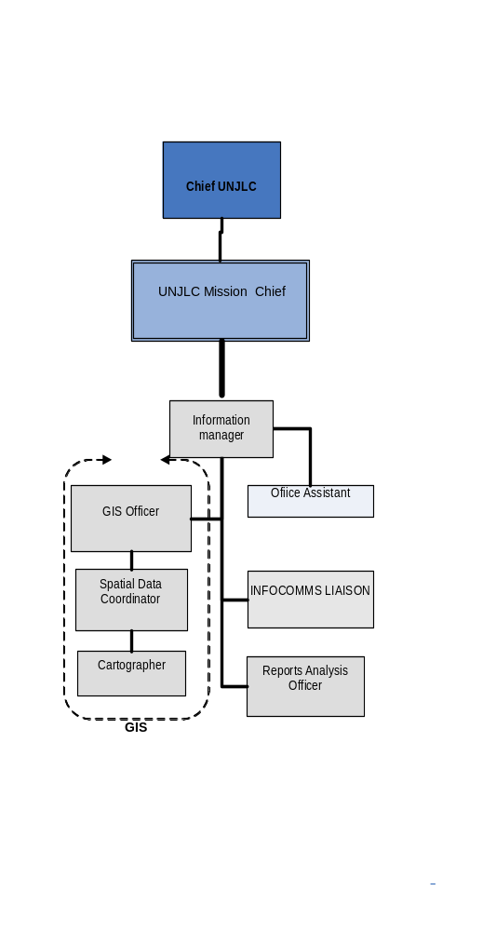

For TORs, refer to the LOG 3 Section 1 where a range of INFOCOMMS TORs is available.

FUNCTIONS OF INFOCOMMS PERSONNEL

The unit (or person) functions as the corporate memory, as well as the central collection point and repository for all mission-specific data from all available sources on all aspects of the mission. The INFOCOMMS unit is a repository for data and information in the broader sense of the humanitarian response. In addition to which the INFOCOMMS Unit is a service for UNJLC personnel as well as its clients and customers that specifically targets information regarding the logistical aspects of the humanitarian response. For generic mission tasks and timeline see LOG 2 Section 10 – INFOCOMMS.
The INFOCOMMS unit (or person) aims to:
- Establish the immediate logistics-related information needs,
- Capture logistics data,
- Process the data,
- Provide analysis of the logistics trends,
- Disseminate information products.

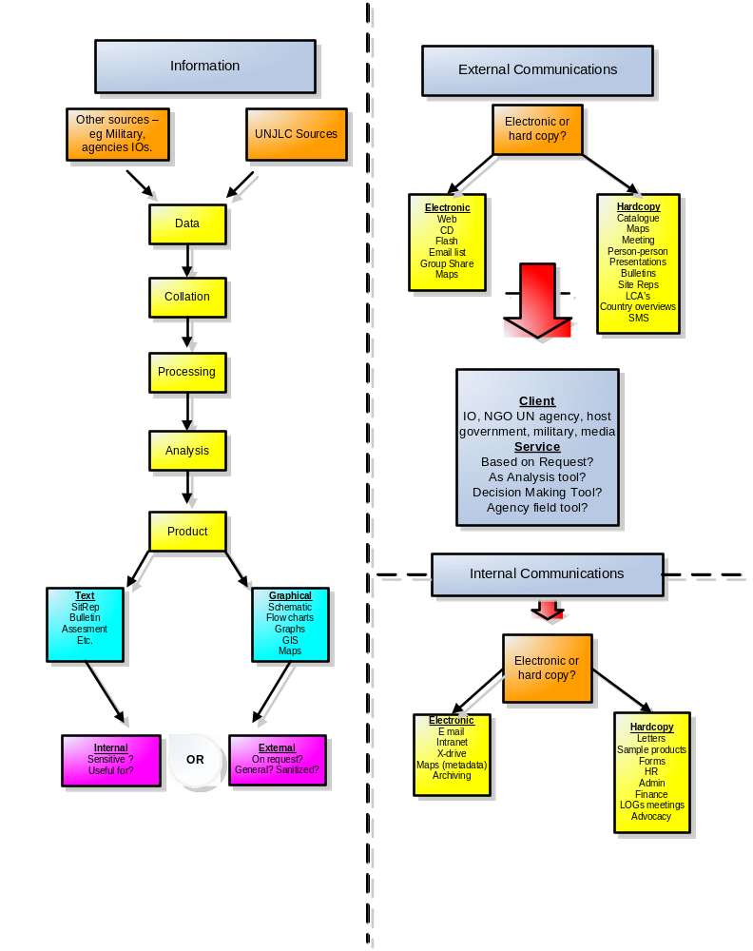Figure 5. Illustrates how data flow, information, analysis, communication and audiences/networks (internal and external to UNJLC) fit into the INFOCOMMS in UNJLC.
DATA FLOW

The data flow and information product development process (illustrated in the Figures 1& above) can be explained as below:
- Establishing a network of data and information sources
  - The collection phase is characterized by the establishment of a network of key focal points within the humanitarian / civilian and military actors at the data, information and reporting levels. The diagram below, figure 6, anecdotally illustrates the ’circle of friends’ likely to be of principal importance to a UNJLC staff person when seeking data. (The network is indicative, NOT exhaustive.)
  - Essential to an effective information network is the establishment of clear data flow paths VERY early in the mission: this may have been started by the UNJLC Logistics Officer deployed at the onset within the UNDAC.
  - Marketing and promoting the UNJLC facility, its services, and its products to the wider humanitarian circle of actors involved in the humanitarian response.
  - Generic Presentations, flyers etc. on the Role and Function of UNJLC are available in the LOG 2 Section 10.

Figure 6.

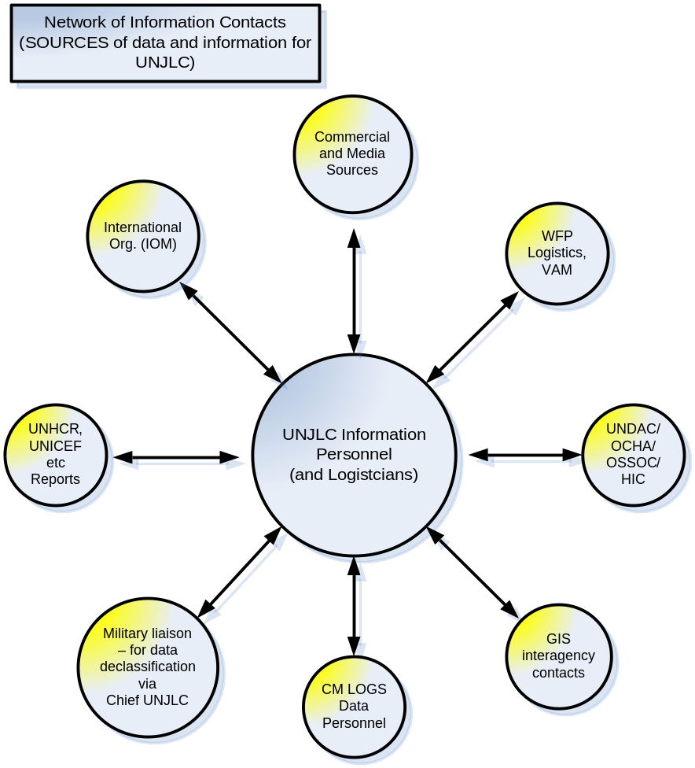
- Sourcing and filing protocols are generically provided by the Core Unit (see LOG 2 Section 10),
- Data collection,
- Data processing,
- Data analysis,
- Information product generation: refer to LOG 2 Section 10 – INFOCOMMS for product samples and templates),
- Liaison with UNJLC Core Unit Rome
- Defining the audience: internal or external UNJLC. Subsequently, developing products that are accurate, sensitive, relevant and timely. This is often conducted in consultation with the UNJLC Chief of Mission and the Core Unit INFOCOMMS (as and when necessary).
- Product dissemination (communication):
  - Communication of the information produced has two generic audiences: external to UNJLC and internal UNJLC
  - Communications are achieved through various modes but can be grouped into:
    - person-to-person (meetings / phone calls / teleconferences);
    - hardcopy (situation reports, bulletins, logistics capacities, bottleneck reports, maps etc.); and,
    - softcopy (web-based access, emails circulation, humanitarian groups on web based platforms such as UNJLC generic mailing lists and moderated mailing lists). See Figure 5 (above) as well as Figure 7 for a suggested generic product type and mode of delivery of products. The standard email lists and moderated UNJLC mailing lists are available from info@unjlc.org in the initial stages of an emergency and subsequently at www.unjlc.org.
- On-going liaison with network regarding product requirements, the usefulness and timeliness of products as well as the preferred dissemination methods.
- Production of catalogues of current products,
- Providing examples of other types of INFOCOMMS products that have been produced in previous missions,
- Evaluation of effectiveness of products and communications modes
- Archiving all data and products (and backup)
- Compilation of mission reports as and when required.

10.4 GENERAL LOGISTICAL DATA

In an emergency UNJLC typically collects data/information regarding:

- Total volume and types of materials moved,
- Operational status of transport infrastructure & modes of transport,
- Assessments conducted in relation of the emergency response,
- Geographic accessibility,
- Seasonal variations that impact upon logistics,
- Points of entry (POE),
- Customs procedures and waivers,
- Bottlenecks,
- Storage capacity,
- Warehouse locations,
- Warehouse utilization,
- Variation in route status,
- Price fluctuations for logistically significant commodities (e.g. fuel)
- Commercial logistics capacity within the affected area.

From data gathered UNJLC can analyze and provide guidance to the UNCT, the host government and other actors regarding aspects such as route optimization, evolving trends, route deterioration etc.

Subject to a directive from the IASC, the UNCT (and the host government if applicable), these areas of coverage may be expanded or reduced. It should be stressed that UNJLC’s INFOCOMMS role is dependent upon compliance and cooperation of all responding actors to ensure the free exchange of data and information both within UNJLC itself and within its core network of interlocutors.

10.5 LOGISTICS ASSESSMENTS
Logistics assessments are carried out during a mission to establish the capacity of the major (and minor) supply routes in the wake of the emergency and the subsequent surge in cargo for Search & Rescue (SAR), relief, recovery and reconstruction. UNJLC often takes a lead role in coordinating the logistics infrastructure assessment either during the SAR period (within an UNDAC team) or in the subsequent relief period.
The UNDAC deployed UNJLC logistician should develop a simple framework and schedule for a logistics assessment plan: hence providing a basis for subsequent UNJLC personnel to build on the foundation of coordinated and compatible logistics assessments. Close liaison with Core Unit INFOCOMMS regarding data collection and information management is required at this stage: refer also to the assessment templates in LOG 1 Annex 4 and sample products/templates in LOG 2 Section 10.

10.6 UNJLC INFOCOMMS LIAISON WITH DATA SOURCES & STANDARDISED DATA FORMATS
The INFOCOMMS role is to manage the data collection and processing stage so that:
- information products communicate effectively to the humanitarian actors about the current and future logistics challenges;
- other actors are then able to determine route prioritization, route maintenance/repair scheduling;
- Relief actors initiate call forward (or divert incoming relief) to other destinations using other transport modes; and therefore, effecting economies of scale and avoiding duplication.

Commonality of information formats across the humanitarian actors is always elusive. However, early intervention by INFOCOMMS personnel in the provision of the appropriate data capture tools and assessment forms can create some commonality. Such data capture forms can enhance the effectiveness of the UNJLC information outputs and hence also the response by all humanitarian actors. See LOG 2 Section 10.

Most importantly for the INFOCOMMS unit is the methodology used to collect the data/information and the format of the data/information. UNJLC has developed standard forms for this purpose (mindful of the realities of the dynamic situation as indicated by the Flow chart above): short (quick), and long (descriptive and more detailed) assessment templates.

Guidelines and short formats for logistics assessments are in LOG 1 Annex 4; electronic version of the forms can be found in LOG 2 Section 5. The Logistics Assessment Templates in Annex 4 include:
- Warehouse,
- Fuel,
- Road Route,
- Rail,
- Port,
- River,
- Airfield,
- Airport,
- Customs / Border Crossings, etc.

The templates in LOG 2 Section 5 have been revised to capture spatial data (GIS coordinates etc.) more effectively for map production. Two core challenges for UNJLC INFOCOMMS are:
- Ensuring a comprehensive assessment plan using common standards for data capture is one of the principal challenges for UNJLC personnel (whether Logistics Officers or INFOCOMMS staff).
- Ensuring that other actors are willing to provide data in a timely fashion AND actively engage with UNJLC regarding product design (both textual and map products). Other actors need to be aware of, and appreciate the added-value of the INFOCOMMS products and that those products are derived from data provided by THEM.

DATA AND INFORMATION EXCHANGE WITH THE MILITARY

When large-scale emergencies occur, it is likely that military partners will be involved in the response. Details on the protocols for this have been formalized by the UN system and military bodies (see LOG 1 and 2, Section 17). Data and information exchange with military actors carries many obvious mutual benefits and presents new challenges. CMLOG officer(s) within UNJLC or CMCOORD Officer(s) within the UN system form the bridge between the humanitarian community and the military actors. Networks of multi-level bridges are necessary to access the data person as well as the officer who is authorized to declassify the data/information. If it is evident that the military have information which is useful for humanitarian logistics, the CMLog officer can ask formally for accessing this information by filing a Request for Information (RFI). The release of such information will depend on the decision of the military commander but, in some cases, a de-classified version can be made available.

Risk Awareness in an Emergency (See Contingency Planning in LOG 1 - Section 3). In an emergency response (such as after an earthquake), the affected area is often prone to continuing significant aftershocks etc. This means that INFOCOMMS will collect data and information that may not seem to be relevant, but may for example become vital, should key supply routes be blocked. This task should be carried out in parallel with routine logistics data collection. Data should be centrally housed and backed-up at another site (e.g. Core Unit Rome) or different physical location.
10.7 INFOCOMMS PRODUCTS
Standard Products for a UNJLC mission include:
- “Bulletin”,
- “Commercial Providers - Yellow pages”,
- “Affected Area Rough Guides”,
- “Staff Accommodation” ,
- “Daily/Periodical/Weekly Consolidated Sitrep” (private UNJLC documents that CAN be refined for public circulation).

In thematic terms, the coverage of INFOCOMMS products is illustrated in Figure 7. The prioritization of these areas will be determined by the UNJLC Mission Chief in consultation with the designated operational reporting line (Heads of Cluster, Logistics Cluster Head, HC/RC, CT). The priority for coverage is based on the overall mission objectives and the logistics concept of operations. (See following Figure 7 and refer to LOG 2 Section 10).

Another task that is undertaken by the INFOCOMMS unit is product dissemination tracking (who receives what product in what format): an important step in monitoring and evaluating UNJLC effectiveness and added value. This is conducted both in the field unit (for hardcopy and local softcopy distribution) and in the Core Unit through web statistics: both should be synchronized and reported monthly.

A format for tracking the reports and product distribution can be found in LOG 2 Section 10. Whatever the methodology adopted for tracking product dissemination it should include: numbers of each product disseminated, numbers of requests for map products, the general target audience (internal/external – IO, UN, general, donor etc) and the mode of dissemination (softcopy- web-based, email distribution list, generic emailing list OR hardcopy – A4 colour, A3 BW etc.).

Figure 7: INFOCOMMS PRODUCTS AND THEMATIC COVERAGE GUIDE

Area of Coverage | Text Product / Potential Graphics/ Photos | Map Products | Priority
Fuel | Fuel Survey (by consultant)
Fuel | Fuel Distribution/Storage Survey
Fuel | Fuel Distribution Map
General Transport | Commercial Transporters Survey
General Transport | Transport Regulations Survey (axle loads/unions/etc)
General Transport | Key Route/MSR Maps (identifying key bottlenecks)
General Transport | LCA- Country Wide Review
General Transport | Countrywide Logistics Planning Map / Schematic
General Transport | State/Regional Logistics Maps (A-Z idea)
Road / Land Transport | Road Assessment MSRs
Road / Land Transport | Road Assessment Secondary Roads
Road / Land Transport | Bridge Locations & Assessments
Road / Land Transport | Accurate GIS Road Map Layer
Road / Land Transport | Road Blockages UPDATES
Road / Land Transport | Rehab needs and Repair schedule Roads and Bridges
Rail | Survey (rolling stock/track/stations)
Air | Airfield Assessments (JHAS/collection of forms)
Air | UNHAS Pax Procedures
Air | UNHAS/JLC Cargo Procedures
Air | Commercial Flight Schedules – destinations etc
Port/Rivers | Sea Ports Assessment (infrastructure and procedures)
Port/Rivers | River Ports Assessment (infrastructure and procedures)
Port/Rivers | Barge Assessment
Port/Rivers | Port Map or Diagram/Map of River with Ports Identified
Suppliers | List of Suppliers
Infrastructure | Construction Companies and Materials Survey
Infrastructure | Urban Power Source Survey
Town Overviews | Overviews of Primary Towns
Town Overviews | Overviews of Secondary Towns
Weather | Web links to 5 Day Forecasts
CMCoord/CMLogs | Concept of Operations (CONOPS)
CMCoord/CMLogs | Contacts
CMCoord/CMLogs | Rules of Engagement
Contacts | Humanitarian/ UNJLC Internal / UNJLC Pakistan (int/ext)/Logs contacts
Customs and Immigration | Procedures Guidelines / Policy Overview Report
Other Comms | National Radio/TV Services + Mobile/Land/Internet Coverage.
Other Comms | Guidelines for Media/Press Engagement

10.8 COMMODITY TRACKING AND CARGO MOVEMENT CONTROL / COORDINATION
Before the new system implemented during the Lebanon crisis (July-October 2006) the common recurrent tasks delegated to UNJLC have been to provide visibility over the relief aid pipeline for Non-food Items (NFIs) and Cargo Movement Coordination. UNJLC has been involved with the development of the Logistics Support System (LSS) which has been trialled in several emergency responses for commodity tracking (this free software is available at www.lssweb.net and further assistance can be obtained at info@unjlc.org ). UNJLC has developed its own systems for Cargo Movement Coordination, including a multimodal transport tasking Data Base (LOG 3 Section 5) and is available on the intranet (http://home.unjlc.org)). More information on the use of a variety of software is in Section 8 (Movement Coordination) and in LOG 3 Section 5. The data derived from such management tools is used by the INFOCOMMS unit to inform the humanitarian response actors of logistics related achievements, objectives and challenges.

For the UNJLC operation supporting the relief activities in Lebanon (July –October 2006) a new tracking system was develop the Joint Supply Tracker. (Please see detailed info o the following paragraph).

THE JOINT SUPPLY TRACKER (JST):

As established by the Interagency Transport and Logistics Standard Operating Procedures, UNJLC is responsible for the Supply Tracking and Prioritization of all food and non food items as part of the Special Operation 10534.0 to Lebanon. As a tool to reach such goal, UNJLC is using the Joint Supply Tracker (JST) system, developed in collaboration with UNICEF. Such system was created with the aims of giving a general overview of the pipeline flow in the country during the relief operation considering all the actors involved, mainly by:

- increasing the pipeline visibility and transparency;
- tracking NFI from Consolidation and Loading Points (CLPs) to Extended Delivery Point (EDP);
- Prioritizing supply movements in accordance to agencies needs.

The collection of data is realized at field level. It is then consolidated and analyzed and by the central team defined during an operation
UNJLC JST field teams based at each relevant CLPs are responsible for:

- Establishing clear mechanisms for retrieving, collecting and feeding back the information at the relevant CLP level from incoming/outgoing cargo movements;(please refers to LOG 2 Section 10 for Cargo Movement request form)
- Collecting necessary data from available shipment documentation;
- Inputting required data into the JST field template and verifying accuracy and consistency of information;
- Sending the saved file, on a daily basis;
- Distributing status reports and providing other feedback to NGOs/Agencies as required;

Once the JST files are sent to the central team, they are all used to generate the daily consolidated Cargo Movement (CCM) report. The report indicates which cargo have been requested for movement, which relief items have been actually received and those dispatched from the different Consolidation and Loading Points (CLPs).

The report provides the above information summarized by the following:

a) CLP: the Consolidation and Loading Point which is, has or will be moving the supplies
b) Organization: the organization which is sending the supplies
c) Category: this is the higher level grouping of items, for example, Shelter contains all shelter related items like blankets, tents, kitchen sets, etc
d) Item Description: this is the generic detail description of the item.

All the items are reported at the total weight in kilos. An important consideration should be done regarding the Category description. As the relief goods entering in the pipeline for Lebanon are not standardized, it is impossible to keep record of detailed goods for the different agencies operating in Lebanon. (See LOG 3 Section 2 for detailed info on JST).

10.9 UNJLC GUIDELINES REGARDING SPEAKING TO THE PRESS
In general UNJLC personnel are expected to decline approaches for interviews and defer to the anointed authority in the field/country: the Emergency Response Coordinator, Humanitarian Coordinator or the Resident Coordinator (or designate). IF questions warrant specialist logistics responses the direction should come from the appointed spokesperson.

Simple though this may seem, personnel will, from time to time, be placed in situations where misleading information has been conveyed to members of the press regarding the LOGISTICAL aspects of the humanitarian response and clarification may be an appropriate intervention for UNJLC personnel. Refer to the LOG 2 Section 18.

Some guidance regarding UNJLC’s interactions with the media can be based on (or derived from the OCHA guidelines). UNJLC, (or indeed any UN agency/facility) can be substituted for OCHA in the following extract.

From the OCHA Orientation Handbook (2002):

It is in UNJLC’s interest to provide the media with accurate and timely information. Slow or unhelpful response can be damaging to the organisation. While the R/HC OCHA is the principal spokesperson for the ERC in the field, all UNJLC field officers should be familiar with the UN policies and standard practice that guide OCHA’s dealings with the press, as follows.

Who should speak to the press?
> The principal voice in the field is the humanitarian coordinator based in the capital city or main duty station.
> Most OCHA field offices also have a designated information officer who speaks on behalf of the R/ HC.
> The HC may authorize other OCHA field officers to speak on his/ her behalf on specific issues.
> In high profile or sensitive scenarios, the R/HC may refer more sensitive questions to the Advocacy and External Relations Section at headquarters in New York or Geneva.
> Information regarding the safety of UN staff – for example in an emergency situation – should be handled by the UN Designated Official for Security. (UNDSS)

How should you speak to the press?
Those field staff authorized to speak to the press should:
> For UNJLC, make sure that it is agreed with the OCHA, or other recognised, spoke person.
> Speak only on logistics issues, not political or security issues;
> Speak only within their area of competence and responsibility;
> Provide facts, not opinions or comment; and
> Leave sensitive issues to officials who are specifically authorized to speak on them.

UNJLC field staff speaking to the press should not feel that they have to answer every question, in particular any hypothetical ones.

When UNJLC field staff do speak to journalists, it should normally be done on the record - that is, for attribution. Sometimes, though, officials specifically authorized to address sensitive issues can give a journalist a deeper understanding of an issue by speaking on background. However, it is very important that the journalist know the basis of the conversation.
> On the record: “everything I say can be attributed to me by name”
> On background: “don’t attribute this to me by name, but rather to a UN official”
> On deep background: “use my ideas but not my words; don’t attribute to anyone.

10.10 Exit strategy: UNJLC INFOCOMMS UNIT key actions in the last month of a mission.
- Collect and file electronically all Field Sitreps, Consolidated Sitreps, Bulletins, Flash News, Snapshots, Rough Guides, and Yellow Pages etc. according to the filing and naming structure in LOG 2 Section 10.
- Finalize reports tracking form: noting numbers of each product disseminated, numbers of request for map products, the general target audience (internal/external – IO, UN, general, donor etc) and the mode of dissemination (softcopy, hardcopy – A4 colour, A3 BW, web-based, email distribution list, generic emailing list.)
- Ensure that movement control and commodity tracking data is consolidated into backup database(s) for future reference / access
- Liaise with HIC, OCHA and UNDP, as a repository for all logistics data & information: specifically regarding which products cease and which could be continued by other party.
- The following activities / products may be continued by one of the remaining partners: Commodity Tracking Data/System, Yellow Pages, Road Updates, GIS activities –e.g. road maps.
- The following will normally cease at with the Exit of UNJLC: Bulletin, Sitreps, etc.
- Maintain links with agencies/organizations, convey exit strategy and arrange transition to partners WFP, OCHA, HIC, etc. and catalogue the contacts to UNJLC mission HQ and UNJLC Core Unit Rome
- Advise network of contacts of transitional arrangements and alternate sources of logistics information and assistance, ensuring that INFOCOMMS in the Core Unit Rome is informed of such transfer arrangements.
- Publicize catalogue of ALL available products – Maps, Text, Schematics, and Assessments etc. AND increasingly drive the UNJLC network and clients to the UNJLC website for information (weaning customers from the person-to-person relationship and maintaining the functionality of the information and products generated during the mission. (NB. Although the products will not be updated, much of the content will remain static and still be a valuable resource for the humanitarian community involved in the reconstruction period.)
- Record deployment timeline, achievements, best practices identified during the mission to be incorporated into future missions
- Ensure that the archive of all materials: hardcopy, electronic data, emails, information and communications and forwarded to UNJLC Core Unit Rome: best practice and audit preparation.
- Ensure that the records for Administration, HR, Finance and Security are similarly archived for UNJLC Core Unit. (NB. This is essentially the role of the Administration/Finance/HR personnel and ultimately the responsibility of the Head of the Operation.)
- Liaise with UNJLC Core Unit regarding the contacts in the country of the mission for the period after the UNJLC exit. Often enquiries are directed to the Core Unit and Rome has not been informed of the transfer contacts that have been established in the operation. Core Unit also needs to be consulted regarding the structuring of the generic email addresses – post UNJLC exit.
- Compile End of Mission Report based in the input from all sections within the UNJLC CRISIS NAME.
10.11 SUMMARY: STAFF OFFICERS’ CHECKLISTS
Key Action Points for UNJLC INFOCOMMS Staff the first 72 hours of a mission.

The INFOCOMMS aim is to ensure continuous improvement of UNJLC products / services and that the legacy of UNJLC is a worthy contribution to humanitarian relief, recovery and reconstruction.

- Collate contact list for the mission: identify key network of data/information contacts that includes the UN, Military, IO, NGO, and host government
- Convey phase-in strategy of UNJLC (generic guidelines can be found in LOG 2 Section 10 and LOG 3 Section 1); build links with contacts and educate them regarding the UNJLC mandate, services, products etc. (Generic PowerPoint presentation and the UNJLC Brief Pamphlet can be found in LOG 2 Section 10.)
- Establish a UNJLC crisis code for file naming in conjunction with UNJLC Core Unit
- Contact Core Unit Rome re: website, filing system, photo catalogue, etc.
- Distribute flyer – generic description of UNJLC CRISIS NAME. Generic and past mission examples can be found in LOG 2 Section 10.
- Establish INFOCOMMS data protocols (including GIS metadata) coordination with UNDAC, VVAF, Map Action, HIC, OCHA, WFP VAM etc.
- Ensure INFOCOMMS office requirements (stationary, computers, printers, etc) are available immediately through either core unit/or WFP CO loan arrangement.
- Collate field input for first Sitrep: write-up and submit Sitrep to UNJLC Head of Mission, UNJLC Chief Core Unit Rome, Core Unit INFOCOMMS
- Attend /chair / participate in meetings as required: distribute maps, Sitreps, bulletins, etc. (hardcopy as well as softcopy)
- Become familiar with the range of INFOCOMMS products and templates for assessments
- Develop product distribution time line i.e. daily Sitrep for two weeks, then biweekly for two weeks thereafter weekly, a monthly logistics info sheet, etc.
- Recruit national staff: e.g. reports assistant, data entry assistant, communications assistant etc.
- Review UNJLC protocols, templates, assessments, logs, letterheads, caveats, disclaimers, headers, footers etc.. See LOG 2 Section 10 and LOG 3 Section 1.
- Determine appropriate Sitrep/Bulletin structure and adjust the thematic products in-line with UN mission priorities
- Transfer private email address to wfp email (where feasible): also, establish generic email addresses in close liaison with the UNJLC Core Unit (e.g. maps.operation@unjlc.org)
- Initiate INFOCOMMS products catalogue and product request processes
- Initiate an internal file sharing mechanism/backup: dedicated high-RAM and high-speed laptop that is networked & establish Mission HQ to Mission field office file sharing mechanism
- As the SAR period transitions to the relief period, refine, update and review the product dissemination mechanisms in order to accommodate new humanitarian, commercial and government actors.
LOG 1- Section 11: INFRASTRUCTURE – Waterways, Roads, Rail and Bridging

11.1. INTRODUCTION
UNJLC, or the Logistics Cluster if present, can be tasked with evaluating logistical integrity of waterways, maritime routes, ports, bridges, road and railroad infrastructure. Qualified experts may be deployed in the respective areas to conduct short-term rapid missions that provide recommendations for rapid repairs/rehabilitation of the infrastructure. This means, for instance, identifying what is required to re-surface a dirt track so that it becomes passable, identifying/setting up the means to do so (funding and an implementer) and ensuring that, until a hardened road is built in its stead, the track is regularly maintained to permit continued traffic. All interventions will be emergency/short-term oriented and will be coordinated with the longer-term actors such as World Bank, UNDP, WFP etc. The relevant sectors are as follows:

- Land transport sector study/analysis

- Road conditions assessments

- Snow/Mud/Dune containment/control and removal

- Port/Rail/River capacity assessments and the vulnerability of routes to unforeseen closures

- Food and NFI Storage capacity assessments

- Customs modalities and structure review

Examples of previous mission reports/recommendations/assessment forms/templates can be found in LOG 2 Section 11 and in LOG 2 Section 10.
11.2. INFRASTRUCTURE OFFICER
11.2.1. RESPONSIBILITIES
In emergencies where the affected area is of larger geographical size and /or the complexities of the emergency require constant evaluation (security) and re adjustment, it may be necessary to appoint an infrastructure officer for coordinating the collection, distribution and mapping of all available road and railroad information. He/she will be a focal point on river, maritime, road and railroad interruptions and/or congestion and provide advice to the wider humanitarian community. In addition, the infrastructure officer may be appointed to oversee the work of dedicated engineers: hence assuming a coordinating role and prioritizing the assessments to be conducted. These engineers would conduct detailed assessments to identify urgent repair works required for improving accessibility.
11.2.2. KEY ACTIONS
- Determine reliable information sources such as National Authorities, Military Entities, Agencies and other Humanitarian organisations;
- Obtain information on available logistics capabilities and limitations in the relevant sector of the crisis area;
- Obtain information on the security situation in the relevant sector of the crisis area
- Maintain liaison with National Authorities and Military Entities to be kept informed on specific restrictions with regard to the use roads and railroad system;
- Oversee assessments and recommend the use of forms which are available in LOG 1 Annex 4 (samples of previous mission products & infrastructure reviews are in LOG 2 Section 11). Pay special attention to:
        - Accessibility of roads and railroads;
        - Restrictions and possible damage of roads and railroads;
        - Description of the general road conditions (i.e. mountainous, narrow, steep, etc.);
        - Classification of primary roads, secondary roads and village road/tracks;
        - Size of cargo transport passable for each of the mentioned conditions;
        - Potential weather constraints, (i.e. fog, snow rains);
        - Maps and/or sketches, indicating major routes, border point, railheads, town-names, bridge locations and capacities, tunnels, overhangs, steep hills (%), river crossing and/or ferries (w/ expected delays) tolls, etc;
        - Locations of hazardous or impassable areas;
        - Ongoing projects to improve road and railroad conditions.
- Survey the most practical and / or likely - primary, secondary and tertiary transport routes - detailing the present route capacities and potential constraints;
- Visit problem areas and make local assessment of the nature of the restrictions;
- Identify bottlenecks and inform humanitarian organisations;
- Identify possible enhancement projects, including cost estimates;
- Assess transit corridors for cargo discharged at ports or overland entry points;
- Assess the capacity of the existing rail transport and any potential bottlenecks in the network, and obtain current rail tariffs and permission to negotiate concessionaire rates based on the volume and the humanitarian nature of the operation.
- Provide all data / assessments etc. to the Head of UNJLC in the mission, the Information and Communications (INFOCOMMS) personnel in the crisis area and the UNJLC Core Unit Information and Communications personnel.

LOG 1 - SECTION 12: FUEL
12.1. INTRODUCTION

In any emergency fuel is critical to effectiveness of the relief effort.

At a strategic policy level UNJLC advocates rationalisation of fuel sourcing in emergencies across the humanitarian community so that undue influence is not brought to bear on the local fuel market: neither inflationary nor deflationary pressures impact prices; demand is in-line with available domestic capacity for the range of fuels necessary for the humanitarian and local civil requirements; and that the local fuel supply lines are sufficiently mature to cope with the surge in demand at the onset of a crisis. In addition links should be engaged with the petroleum and energy sectors for contingency planning purposes, developing linkages that enable cross-sourcing and multi-sourcing of bulk fuel in a variety of delivery modes during crises.
12.2 Strategic Analysis of Fuels Supply
More direct interventions, such as Country / Region –wide Comprehensive Fuels Surveys might be done. If requested, UNJLC conducts Comprehensive Country Fuel Surveys utilising specialist fuel experts. These reports cover upstream production capacity, mid-stream processing and distribution networks as well as downstream retail supply chain and fuel depot networks. A part of this research models supply-demand on the full fuel supply system and its surge capacity during heightened demand, government fuels and energy policy as well as alternative energy development and supplies both within the affected areas and that are available as potential alternate sources of supply.

Assessment would usually cover:
- Fuel production and processing capacity
- Fuel production surge capacity
- Fuel importation capacity via ship / pipeline / barrel
- Country – wide fuel storage capacity
- Country wide infrastructure – pipeline / road / rail
- Shipping/Docks/unloading
- Transport availability type etc
- Other means of transportation
- Seasonal effects on production and supply lines
- Policy issues related to fuel
- Socio-political issues related to fuel / energy
- Pricing and stability of fuel prices
- Geographic advantages and impediments to a sustainable fuel supply chain
- Security of fuel stocks (including both physical security of depots and the integrity of fuel)
- Accounting and matters associated with monitoring fuel stock levels (evaporation/loss)
- Fuel contingency planning: fire, evacuation (in association with designated DSS personnel)
- Fuel contingency planning: supply chain stocks at green (normal), yellow (21 days), orange (14 days) and red (7 days) and the appropriate measures from reducing fuel use through to fully restricted movement (Medevac/Medivac only).

Fuel experts may be deployed as part of a fuel cell or be a component within an infrastructure assessment team. See LOG 2 Section 12 for samples of previous Country Wide Surveys. These surveys are also of importance to the Information and Communications Unit (INFOCOMMS) both in the operation and in the Core Unit. See LOG 1 Section 10 for guidance on information management in UNJLC.

12.2.1 FUEL EXPERT – Country-wide Fuel Survey

Generic Job Function

- Outline the overall structure and shape of the fuel supply chain in the region relevant to humanitarian operations;
- Identify, if possible, practical ways in which capacity limitations and bottlenecks may be eliminated or ameliorated;
- Identify how the humanitarian community may be more effectively served for fuel logistics in the foreseeable future, including improving the effectiveness of commercial arrangements, enhancing the logistics planning process of agencies, and further assisting them to optimise their logistics capabilities;
- Estimate, if possible, the fuel dependencies (user requirements) for humanitarian operations in the crisis area;
- Evaluate and monitor the affected country government’s policies pertaining to fuel and energy issues that may impact the humanitarian response;
- Establish what impact the UN / humanitarian community has on the local economy, prices;
- Examine the real cost effectiveness of the UN fuel utilization;
- Identify the longer term future policy of fuel infrastructure expansion programmes being undertaken
- Identify how transport development plans may effect the UN activities and fuel dependencies;
- Advise on:
  - Historical context of the fuel industry including recurring concerns and historical solutions;
  - The availability of fuels, particularly as they affect the welfare of the populace and related humanitarian work;
  - Current fuel stocks and imports, as well as seasonal surge capacity / unplanned surge capacity;
  - Rationalization of fuel issues;
  - Government policy and strategy especially with regards to governmental oversight, refinery capacity, monopolies, pricing, free markets and transparency;
  - Supply and demand for LPG, aviation fuel, gasoline, diesel, aviation fuel and kerosene. In particular, analyse whether supply is sufficient to meet projected demand.
12.3 Fuel Planning Officers in Field Deployments
Deployments of fuel planning specialists that are tasked with a more direct role in coordinating the requirements of the humanitarian response, sourcing of fuels for multi agency use and monitoring price fluctuations. Fuel planning officers may be deployed as part of a fuel cell or be a component within an infrastructure assessment team. A Fuel Officer, during field deployment will make observations, calculations and monitor the fuels situation and subsequently make recommendations for additional capacity in particular geographical areas or for particular types of fuel (See Figure 12.1 and Figure 12.2 below). Additionally, the Fuel Officer may also be tasked with negotiating voucher systems or bulk purchase agreements with private sector suppliers. Vital to the Fuel Officers role will be extensive field experience in fuel transport security, fuel supply chain security and understanding of fuel integrity / purity testing. The Fuels Officer is expected to have knowledge of, and experience with, temporary supply systems (bladders etc) and fuels integrity testing experience (for aviation fuels in particular). See LOG 1 Section 10 and LOG 2 Section 10 for sample fuel information products and templates.
12.3.1 FUEL PLANNING OFFICER
The Fuel Planning Officer may report either directly to the Head UNJLC or be part of the Infrastructure Section. He/she shall analyse options for fuel provision in the crisis area, propose possible solutions and be part of possible implementation of management and monitoring structures. In this capacity, the incumbent will:
• Assess, and draft overview of, agencies estimated fuel requirements in the crisis (user requirements);
• Asses, and draft overview of; suppliers & supply lines to the crisis area; delivery locations, forwarding & handling entities and appropriate systems (supply requirements);
• Collect, analyse, structure and disseminate all relevant information with regards to supply of fuel to humanitarian organisations;
• Act as an interlocutor with civilian and military authorities with regards to matters relevant to the provision of fuel for humanitarian organisations (see Figure 12.1 below)
• Advise the Humanitarian Coordinator through the UNJLC on possible implementation and execution of fuel supply (systems) to agencies and agencies' projects in the crisis area;
• Head and manage a UNJLC fuel planning unit if and when required and assist in the setting up of such a unit;
• Set up a monitoring system to control activities of private entities working for the UN in the fuel sector in the crisis area;
• Manage a fuel supply monitoring team and assist in the fuel supply prioritisation process if and when necessary;
• He/she shall work in close collaboration with the other experts and Field officers in the UNJLC and assist them in their duties when and if required
• Travel extensively in the crisis area when and if required;
• Write weekly progress and assessment reports according to agreed upon formats.

The planning examples below are provided only as a guide to the Fuels Planning Officer and Fuel Expert (either or both may be involved in such situational analysis).

Planning Example – SUDAN 2005:

SUDAN:
Refinery: Output 30 / 35 million litre / Jet A1: 15 million litres Diesel per month
Countries needs: 30 million Jet A1 / 15 million diesel
Misc: Currently importing diesel and Jet A1 for national requirements esp. for the main electricity grid.

UNITED NATIONS:
DPKO: 15 million litres jet A1 / 8 million litres of Diesel
Humanitarian Community: (WFP in the main) 10 million litres Jet A1 / 10 million litres of diesel
Misc: The Minister of Energy has advised the DPKO to import fuel. WFP currently is receiving subsidised fuel but this will change soon.

CONCLUSION:
The above factors illustrate just how the UN can actually damage the economy of a country that it is intending to support. This can lead to prices rises damaging the aid packages as less money is available and damages the country as the poor cannot keep up with high fuel costs. This may lead to instability plus it is unsustainable growth for any country in the infrastructure and long term needs of that country. Therefore the arrangement is unsustainable.

Planning Example – KENYA 2006

KENYA:
Refinery Output: Jet A1 10M litre & Diesel 14 M litre per month
Pipeline: 92% working capability working 7 days per week 24 hours per day
Countries needs: 18 million litres Jet A1 & 15 million litres diesel per month

UNITED NATIONS:
MONUC: 10 million litre Jet A1 & 5 million litre diesel
UNMIS: 8 million litres Jet A1 & 5 million litres Diesel
Humanitarian Community South Sudan: 5 million litres Jet A1 & 6 million litres of diesel

CONCLUSION:
The UN requirement cannot be met from the local refinery: scheduled to closedown. UN requirements will impact upon the total local demand significantly: potentially damaging that fragile economy. Uganda / Rwanda and DRC received fuel supplies through the Kenya pipeline and rail net work. Any unsustainable UN fuel demand/supply could put these economies also at risk.

Figure 12.1: Schematic of Operational Fuel Positioning, Supply and Capacity for the UN relief operations in Sudan 2005-2006

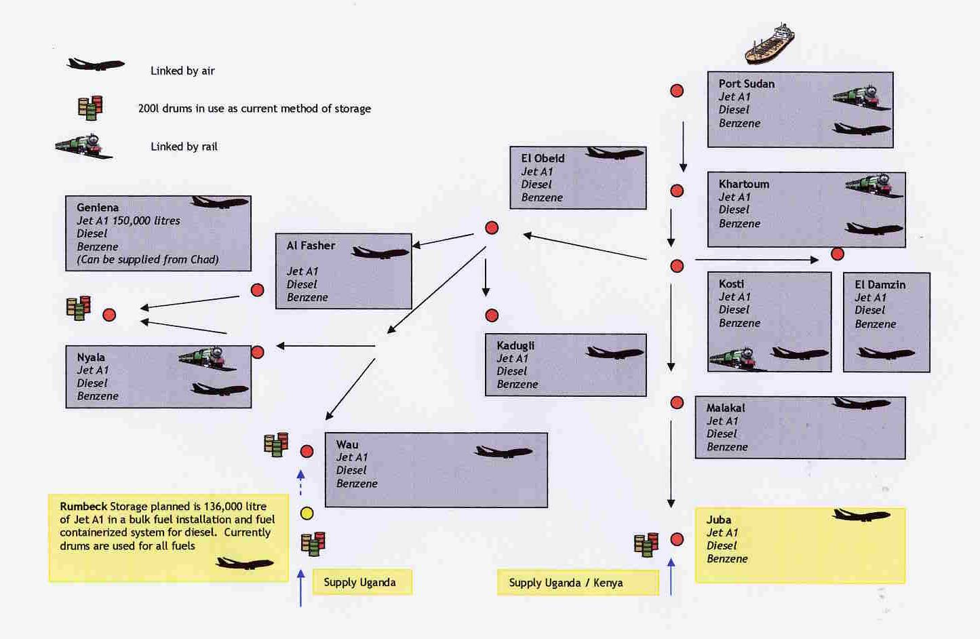

OTHER RATIONS
Figure 12.2: Table of estimated requirements for the relief operations of a multi-agency emergency response.

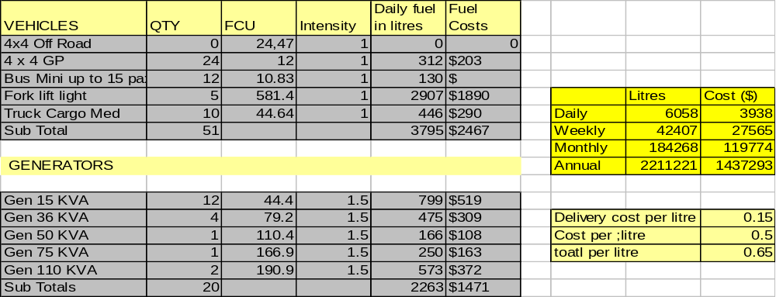

LOG 1 – Section 13: CUSTOMS
13.1 Introduction

In both sudden-onset and complex emergencies smooth border transit and customs processing/procedures often underpins the success of the humanitarian relief effort: host governments (if present) and neighbouring countries will normally play a pivotal role in facilitating this. (The dominant actors will include both civilian and military actors neighbouring countries as well as the Red Cross and Red Crescent movements, IOs, INGO, and NGOs.)

The United Nations often assumes the lead role in making appropriate arrangements with the governments regarding expeditious access to emergency relief stockpiles, strategic hubs for air bridges & reconfiguring relief supplies, as well as staging areas that provide best access for relief actors and the relief supplies. The logistics of emergency relief is contingent upon the above-mentioned arrangements and UNJLC plays a role in each of these. UNJLC is prominent in Customs and Border Crossings as related to emergency response because it acts for, and on behalf of, the UN Resident Coordinator (UNRC) / UN Country Team (UNCT) and the humanitarian relief effort.

13.2 Sudden-onset versus Complex Emergencies

Owing to the nature of the circumstances of a sudden onset emergency, the Customs Officers work will focus on the promotion of the application of streamlined procedures, for which the WCO-OCHA Agreement is the most convenient instrument to date. (See LOG 2 Section 13).

In Complex emergencies (and also after the initial phase of a relief response to a sudden onset emergency), the customs role can be more proactive: initiating Capacity Building with the Customs Authorities, enhancing the Customs Knowledge among the Humanitarian Community, Conducting Transit & Release Studies, etc..

Regardless of the type of emergency or the location, ‘’a tangible, measurable and effective improvement to the customs and border crossing operating environment for the humanitarian relief effort is the ultimate goal of the Customs officer(s)”. His/her negotiations need to be focussed on achieving the following four key elements.

Four key elements for the Customs Officer within UNJLC are:
1. Obtain customs ‘paperwork simplification’
2. Arrange for pre-arrival clearances.
3. Arrange for customs services outside of normal office hours and offsite customs services (at POE/EP for example).
4. Minimise physical inspections of the shipments.
This is in line with the intent of Standard 3, of Annex J, Chapter 5 of Kyoto Convention, “Relief Consignments.” A Model Agreement can be found in LOG 2- Section 13.

13.3 Functions and Duties of the UNJLC CUSTOMS OFFICER

The UNJLC Customs Officer reports to the UNJLC Head of Office or the UNJLC Operations Coordinator depending on the type of crisis and the size of the UNJLC mission team. This context will impose different constrains: availability of time, nature of the political situation, economic conditions & customs policies. Expected outputs and timeframes will be determined based on the context of each mission and are further explained below. (See also LOG 1 – Section 10 INFOCOMMS regarding the information management aspects of the Customs function.)

The Humanitarian Coordinator (HC) and the UN Country Team (UNCT), and / or the Logistics Cluster will coordinate UNJLC activation and deployment (if the cluster system is being utilised in the emergency response). For this reason, any approach to the Customs Authorities must be agreed upon by all actors and be based on a common stance in negotiations. The Customs Officer should develop linkages with Points of Contact as per those functionaries noted in Figure 1 below.

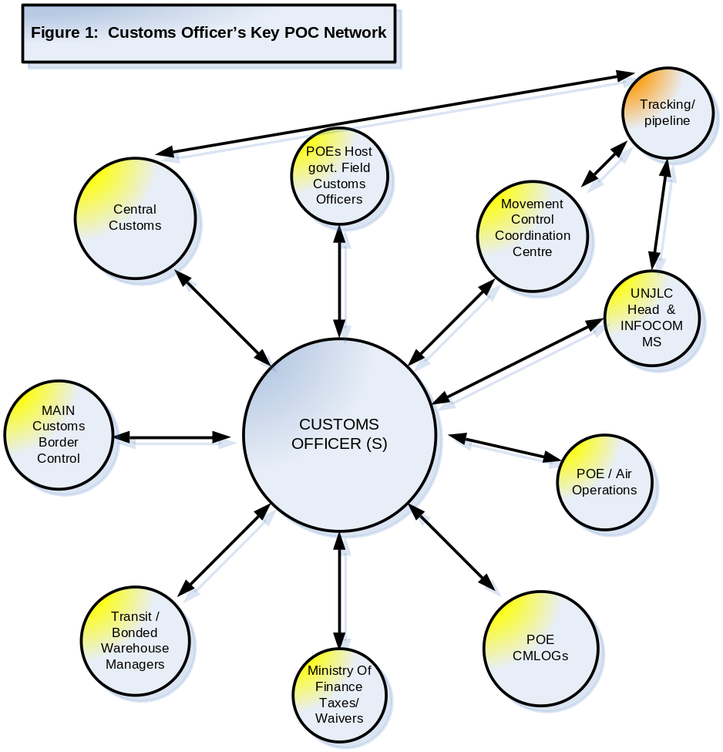

The objectives of the Customs Officer are best summarised in the extract from the Kyoto Convention, Chapter 5, Annex J, dedicated to Relief Consignments (International Convention on the Simplification and Harmonization of Customs Procedures). See LOG 2 – Section 13 for the full Chapter.

Kyoto Convention, Chapter 5, Annex J “Relief Consignments”
Standard 3 establishes:

“In case of relief consignments Customs shall provide for:
-lodging of a simplified Goods declaration or of a provisional or incomplete Goods declaration subject to completion of the declaration within a specified period;
-lodging and registering or checking of the Goods declaration and supporting documents prior to the arrival of the goods, and their release upon arrival;
-clearance outside the designated hours of business or away from Customs offices and the waiver of any charges in this respect; and
-examination, and/or sampling, of goods in only exceptional circumstances”.

Large-scale Sudden Onset Disaster

During the Search and Rescue (SAR) and emergency relief phase, time will limit every UNJLC Customs Officer’s activities. Nevertheless, the Customs Officer’s primary tasks should be to:
- Analyze import/transit processes both for the affected country and for the bordering countries. See Figure 2 below.
- Advise on main Customs issues affecting Humanitarian Cargo operations.
- Determine shortcomings and bottlenecks and indicate if these delays are the result of a) inappropriate, cumbersome or inadequate Customs Procedures; or, b) inadequate adherence to procedures on the part of the humanitarian relief actors.

Figure 2. SAMPLE Importation and Customs Clearance Process

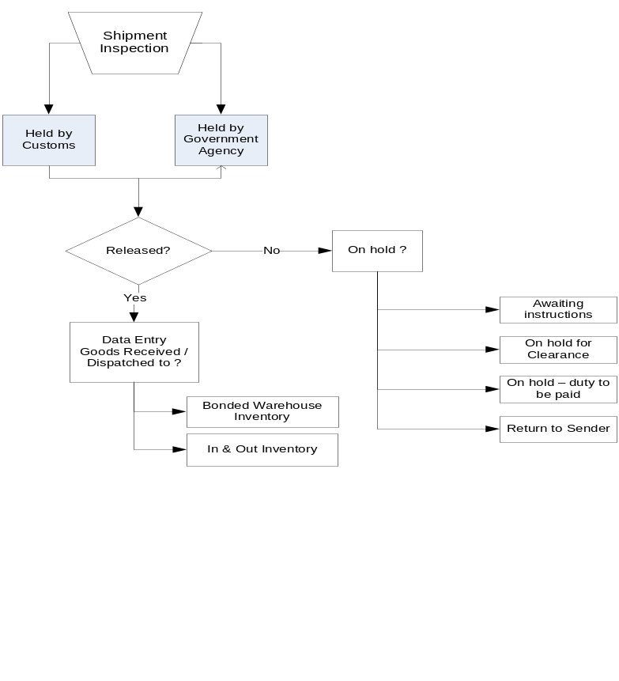
- Collate importation/transit requirements for Humanitarian Actors, to be published and disseminated. See Figure 3 below.

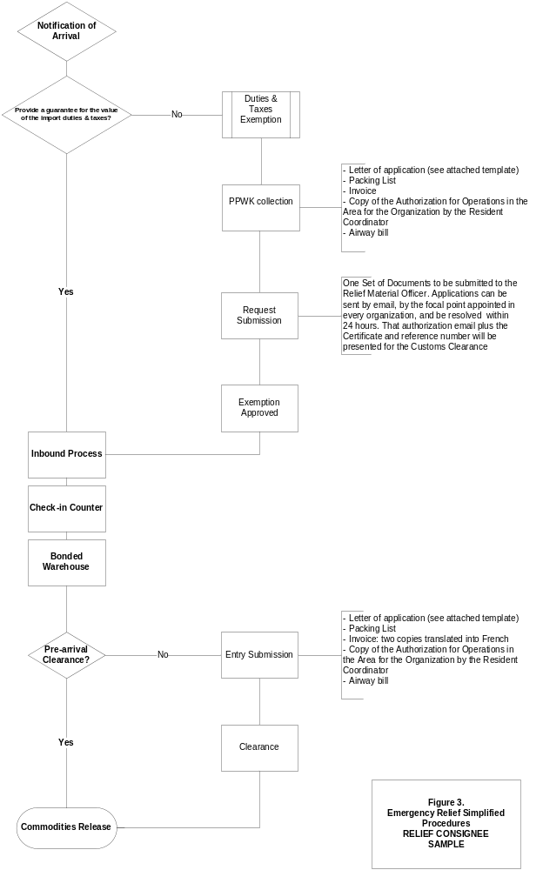

- Negotiate facilitation measures with national and local Customs Authorities:
  - Promoting the OCHA-WCO Model Agreement (See LOG 2 Section 13)
  - Seeking the implementation of existing regional agreements (See LOG 2 Section 13) or sectoral conventions applicable to the affected country (See LOG 2 Section 13)
  - Liaising with Customs authorities and providing templates of the most frequently used documents for Humanitarian Cargo (See LOG 2 Section 13)
  - Provide basic instructions on how to recognize Relief Consignments: the timing of the goods arrival, the types of goods, and the consignee(s).
  - Ensure that negotiations for waivers, fast-tracking, pre-arrival or pre-shipment clearance etc. are made on behalf of all actors involved in the Relief Operations (IO, NGO, military, UN etc.) as a single united negotiation platform for all relief commodities (See LOG 1 Section 14 as well as LOG 2 Section 13 and LOG 2 Section 14).

Complex Political Emergencies / Exempted Material to be imported at any other time

In the case of a Complex Emergency, the time-related hurdles will be substituted by other challenges often related to the insecure operating environment or unstable political environment.

In relation to the specific activities to be carried out by the UNJLC Customs Team, these follow the general actions (outlined above) to be taken as per Emergency Relief but with some minor changes.

- Import/Transit Processes Mapping needs to be wider in scope and deeper in detail, and include:
  - Performance Measures or Benchmarking of the import and customs clearance process indicating diagrammatically the cost (both monetary terms and in terms of timeliness) of importing the different type of material (i.e. Food, Non Food Items or Operational Support Items). See Figure 4 below.
  - Benchmarking Exercises can be conducted with the different actors and the Customs Authorities (this can be based on parameters appropriate to the context of the particular transit path).

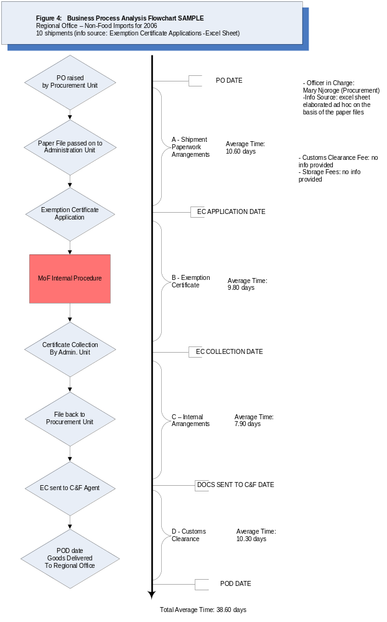
- Regulatory Review(s) with the local authorities of the OCHA-WCO Model Agreement, and if this model is not accepted, regular reviews of each regulation upon Customs Performance. Under the umbrella of the Country Agreement between the Host Country and the Agencies, develop agreements with the Customs Officials at the Ministry of Finance (MoF) level and at the Points of Entry (POE) / Entry Points (EP) to ensure expeditious processing, waivers and ‘no objections treatment’ for relief goods.
- Negotiating with the National / Local Authorities and building links in order to re-design customs handling processes and ensure streamlined flows of commodities. Exemptions for relief goods to bypass standard processes should be applied unilaterally: without having to seek exemptions from the Minister of Finance or the Customs Officers at warehousing facilities.
- Capacity Building Programmes both for Customs Authorities and for Humanitarian Workers. Workshops on Emergency Preparedness or Humanitarian Material Movement Facilitation can help to breakdown barriers between the host government and the humanitarian community.
- Individual agencies/ actors can be provided with training / guidance on Inventories / Warehouse Management Systems, thereby reducing the processing time for the actor and the Customs authorities (as well as other related departments /ministries). For example, assisting with the formulation of SOPs that ensure maintenance of accurate records and filing of original paperwork for equipment such as, VHF radios, vehicles, etc.

13.4 Exit Strategy / End of Mission Tasks

- Collect and archive all relevant information with both the field UNJLC Information and Communications Management (INFOCOMMS) personnel and the UNJLC Core Unit Rome. (Customs Team Planning, Objectives, Achievements, Key performance indicators (KPI), memorandum, Mission Reports, etc).
- Schedule, publicise and implement the handover of any products/activities to partner UN agencies, host governments, or other actors.
  - Products may include guidelines derived from negotiations, compendiums of customs regulations, schematics of customs processing etc.
  - Archive contact lists of Key Customs Focal Points in the different organisations (including any identified designated focal point replacing the UNJLC Customs Officer role) and forward to INFOCOMMS Field and Core Unit in Rome.
  - Activities may include:
    - Capacity building exercises with customs agency, non-specialist national staff, and partner humanitarian organizations.
    - Release Times Studies and if partner agencies intend to continue monitoring Release Times or other such Performance Measures etc.
    - Identifying a designated UN Focal Point for Customs matters to so that common representation to the government customs authorities continues.

13.5 SUMMARY: STAFF OFFICERS’CHECKLISTS

Key Action Points for UNJLC Customs Staff in the first 72 hours of a mission

  - Collate field input for first situation report – EP/POE, actors present – humanitarian, military and commercial.
  - Collate contacts list for the mission: identify key network of agencies representatives (logistics & procurement officers), and Customs Administration focal point(s);
  - Check if the affected country is party to the Revised Kyoto Convention (or previous) and any other Sectoral International agreements (e.g. Tampere), and regional agreements, bilateral Agreements on Mutual Assistance for Disasters with neighbouring countries (See LOG 2 Section 13);
  - Meet with key interlocutors and seek the acceptance of the OCHA/WCO Model Agreement (LOG 2 Section 13);
  - Outline the Customs Team Plan for the Operation to POCs in Figure 1 above.

LOG – PART 1: SECTION 14: SUPPLY AND WAREHOUSING

14.1. INTRODUCTION
In some emergency scenarios, it is possible that UNJLC becomes involved in warehousing. Typical examples are transit warehouses at airports, staging areas and possibly warehouses for storing unsolicited commodities during large-scale natural disasters. In addition, UNJLC could be charged with the establishment of a common logistics system for the receipt, storage, release and onward transportation of supplies, such as is the case in Sudan (LOG 2 Section 8)

The principle is that UNJLC is in charge of the coordination process but responsibilities for warehouse management are transferred to more specialised bodies such as Agencies, IOs and NGOs. In other cases, such as with forward staging areas, UNHRD Brindisi may deploy a Team that will take charge of the management of the warehouse.

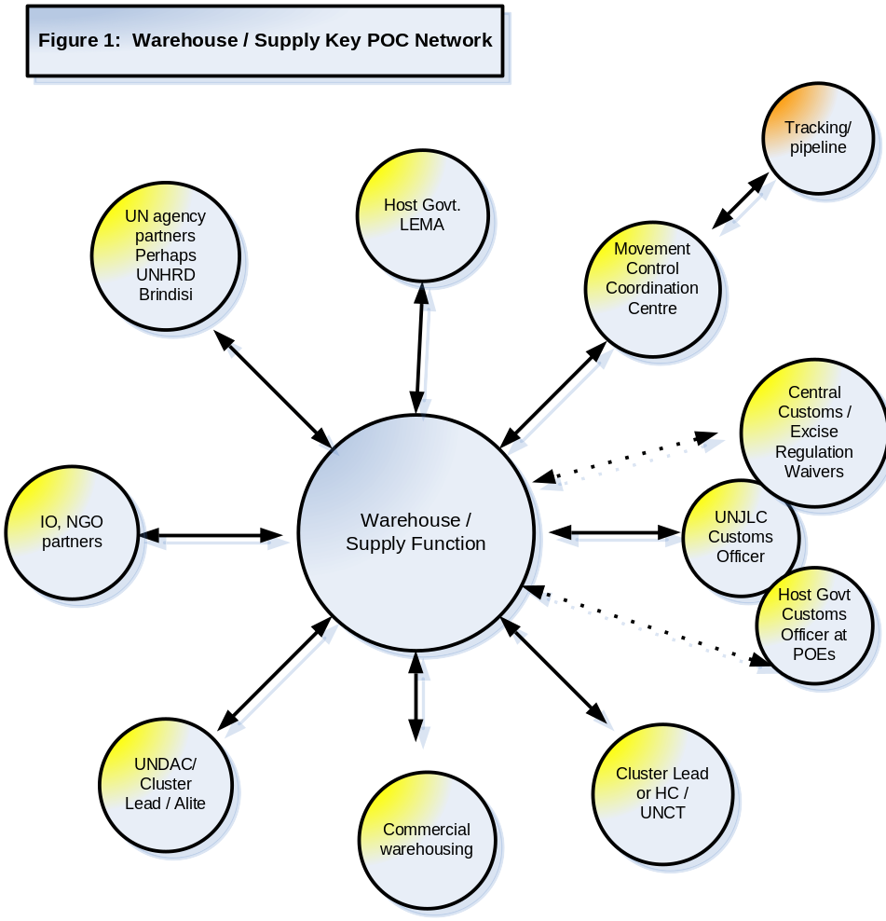
The appointed management authority will be in charge of receiving the commodities, compiling of inventory, storing, issuing and accounting of those relief commodities assigned for Coordination by the UNJLC. In addition, the warehouse manager may be charged for verification, advice on and Coordination of facilitation procedures for import/transit of relief goods. The actions described below should be considered as a checklist for those who are responsible for the warehouse management, but are not exhaustive.

14.2 Key Action Points for UNJLC SUPPLY AND WAREHOUSING Staff in the first 72 hours of a mission
- Obtain information from agencies on warehousing needs;
- If need exists, verify whether a common approach is possible (sharing);
- If required:
  - Identify undamaged or damaged but usable warehouses located in reasonable proximity to the disaster site.
  - Determine the capacity of these warehouses.
  - Determine warehouse availability over a specific period of time.
  - If required, conduct assessments as described in LOG 1 Annex 4. If time permits detailed assessments, use the Forms in LOG 2 Section 14.
  - If involved in the selection of warehouses, remember the basic requirements that are described in Annex 4.
  - If contracting is required, request support of Logistics Cluster Lead Agency (or another agency/partner).
  - Identify potential locations for additional warehousing, storage and airfield staging.
  - Liaise with UNJLC Customs Officer and / or establish contact with local Customs authorities.
  - Self-brief on country laws, documentation, procedures, costs, handling fees, and hours of operation of ports of entry. Refer to LOG 1 Section 13 and use documents in LOG 2 Section 13 as needed.
  - In liaison with the UNJLC Customs Officer, advise all Agencies and humanitarian bodies concerned of import/export procedures and restrictions.
  - With Cluster Lead (or HC, Emergency Coordinator) verify contracts for warehouse space and equipment as well as recommend actions for hire of local labour as necessary.
  - If required, establish locations, facilities, and equipment for receiving, compiling of inventory, storing, and issuing of supplies.
  - Set up ordering, inventory, issuing and tracking systems for team needs and relief supplies. Use standard forms and existing computer programmes (LOG 2 Section 14) as needed. Use existing warehouse management programs / systems as necessary, referring to LOG 3 Section 5, LOG 2 Section 10 and LOG 2 Section 8) Agree on assignment of responsibilities:
- Warehouse ledgers (arrivals, issues).
- Commodity losses and damage.
- Stock reports (balance sheets, stock cards).
- Releases from the warehouse (release order).
- Pipeline reports (tracking from warehouse to distribution points).

Ongoing Activities (Agency in charge for Warehouse Management)

- Ensure that the above systems can provide fast and accurate information as to what is in storage at any one time and in what quantities.
- Ensure use of Delivery Notes (Waybills) as appropriate.
- Work closely with the UNJLC Movement Coordination Section to ensure Coordination of receipt and distribution of relief supplies.
- Ensure the efficient and accurate receipt of all supplies at storage locations and supervise receipt documentation.
- Take responsibility for both the quantity and quality control of supplies delivered to storage locations.
- Prepare and submit stock inventories as requested.
- Inspect storage facilities as needed to ensure that procedures for stacking, cleaning, and record keeping are implemented.
- Review need for replacement parts, equipment and supplies. Provide information on stock levels and anticipated needs, and make requests through the chain of command.
- Ensure that proper safety practices and standards are understood and observed.
- Establish, maintain, and supervise an adequate security system for the warehouse facilities to prevent theft and damage to relief supplies.
- Take necessary precautions to store and label medical, poisonous or hazardous materials in an appropriate manner.
- Monitor the distribution system to ensure that relief supplies are delivered to the appropriate consignees.
- Organise and file all relevant documentation.

14.3 Supporting Documents, Forms and Tables
- General guidance on assessments is in Annex 3 of this Handbook.
- Detailed information on documentation, forms, etc is in LOG 2 Section 14.

14.4 Exit Strategy / End of Mission Tasks
- In coordination with relevant authorities, in particular with the Cluster Lead Agency (HC, UN CT), conclude all contracts (personnel and materials);
- Arrange for disposition of remaining supplies with LEMA and/or Cluster Lead Agency, HC, UNCT as appropriate.
- Conclude In-Out Stock Report (Sample in LOG 2 Section 14)
- Ensure that equipment and supplies are marked for return to their countries of origin, are properly accounted for and prepared for shipment, including completion of customs documents.
- Send appropriate documentation on warehousing contracts, MOUs, lease agreements for office space etc. to UNJLC Head of Mission, to UNJLC Core Unit, and to Cluster Lead Agency.
- Archive all records of warehouse inventories, related contacts, the contact details of handover partner, points of contact in the field warehouses (transit locations) to INFOCOMMS Unit in the mission and/or the Core Unit Rome.

LOG 1 - SECTION 15: ADMINISTRATION OFFICER

15.1. INTRODUCTION
The Office Administrator will report to Operations Coordinator (if appointed) or the Head of UNJLC Mission as the case may be. The purpose of the UNJLC Core Unit is to provide interface between UNJLC staff in the Core Unit and, specifically, the mission UNJLC: this is a pivotal role and vital to the success of any UNJLC mission. The functioning of administrative routines, human resource matters and financial arrangements for the Mission HQ and the satellite JLC offices in the field set the tone for the professionalism of a mission. Implicit in (and essential for) the role of Administration / Finance officer(s) is the capacity to manage multiple competing interests both within the UNJLC hierarchy and between UNJLC and the WFP CO. This means that aside from excellent organisational skills and the necessary attention to details, the incumbent must be capable of developing productive working relationships with all UNJLC staff (including Core Unit) and the WFP CO. A high degree of autonomy is often required: prioritization skills, a responsible attitude, accountability, skills in the supervision (and motivation) of junior office staff, resourcefulness and creative thinking skills. See Figure 1 below – Network of Key Contacts for Administration/HR/Finance.

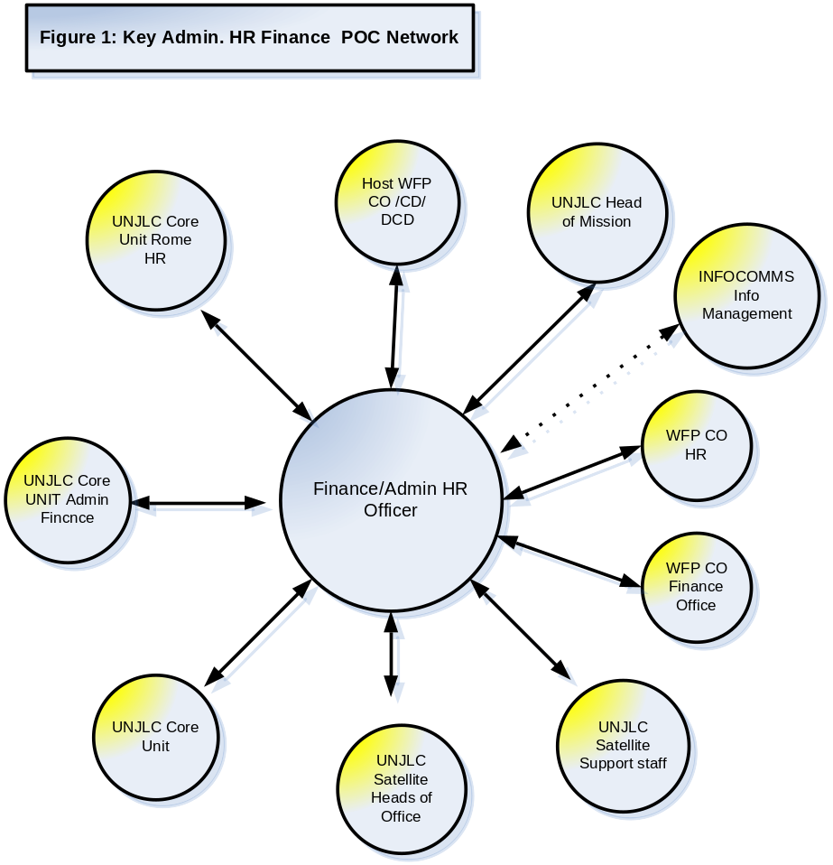

15.2. KEY ADMIN. OFFICER ACTIONS WITHIN THE FIRST 72 HOURS OF A MISSION
- Read the LOG 3 Section 1 – Administration.
- Establish office locations and SOPs: ICT/ HR / Admin. / Finance with WFP CO.
- With the Head of UNJLC mission, identify HR needs and initiate recruitment of support staff, as well as requirements for cars and drivers. Source rental vehicles.
- Check with WFP Security and / or UN DSS regarding country specifics for MOSS compliance in regard to vehicles / ICT / communications and source necessary equipment.
- With the Head of UNJLC identify key information such as budget lines, petty cash procedures etc.
- Establish and designate support staff to maintain movement roster for UNJLC staff and a circulation list for this information.
- Establish security clearance practices and designate a focal point within UNJLC mission for processing of staff clearances.
- Prepare and maintain an inventory of office equipment, including any issued to UNJLC satellite offices.
- With the Head of UNJLC analyse satellite office support needs and prepare field support mission schedule.
- Ensure that all UNJLC personnel are fully briefed on relevant administrative procedures as part of mission deployment / induction.
- Make essential emergency arrangements for equipment and office set-up: consumable, stationary, loans from WFP CO, UNJLC Core Unit and establish a stock pile of such items for immediate use.

ON-GOING DUTIES
- The Administration / Finance Officer will supervise and coordinate the work of local admin clerks, drivers and cleaners and oversee the Administrative activities of the Field Coordinators in the satellite JLCs ensuring compliance with WFP Administrative procedures and financial procedures;
- Maintain and update inventory of office equipment, condition, inventory barcode etc;
- Perform necessary administrative duties including filing of reports and documents;
- Prepare staff TAs, assist staff to complete TECs, follow up processing and payment of TECs and assist staff to obtain advances of DSA;
- Prepare travel itineraries for UNJLC staff, make bookings, initiate procedures for obtaining security clearances and visas;
- Maintain accurate record (including cash registry or journal) of all expenditure from UNJLC funds on office expenses, staff emoluments and miscellaneous purchases;
- Prepare payment vouchers and receipts as appropriate for all financial transactions;
- Prepare necessary paperwork for recruitment and extensions of contract for consultants;
- Supervise and coordinate work of locally-employed administration support staff, ICT technician (if within the administrative section), drivers and cleaners;
- Set up and maintain an appropriate filing system in the UNJLC administrative office, liaise with UNJLC INFOCOMMS and the UNJLC Core Unit Admin Officer regarding back-up procedures for files and the confidentiality of files;
- Arrange procurement of standard office stationery and other items;
- Perform general secretarial duties in the UNJLC office;
- Liaise as required with custodial agency and core UNJLC.

KEY ADMIN./ FINANCE ACTIONS IN THE LAST MONTH OF A MISSION
- Maintain regular contact with Core Unit regarding finalisation of administrative / HR / financial matters.
- Liaise with WFP CO. See Key POC Network in Figure 1 above regarding closure of UNJLC office(s).
- In consultation with the Head of UNJLC Mission, establish a phase-out / shut down schedule including retrenchment / transfer of support staff (See LOG 3 Section 1)
- Initiate discussion to transfer of UNJLC assets either to WFP, host Government body or alternate UN agency OR to repatriate expensive / larger items such as vehicles, computer, servers, printers etc.
- Formally notify office ‘’owner’’ / landlord of intended closure: request final bills, cancel contracts for amenities /services, cancel contracts with vehicle suppliers (if rented) etc. See LOG 3 Section 1 for more detailed outline of these actions/duties.

LOG 1 - Section 16: SATELLITE or HUB JLC

16.1. INTRODUCTION

Satellite (or Hub JLCs) may be deployed at important logistics points such as border crossings, entry points, transit points, airfields etc. (See LOG 1 Section 13). First and foremost, satellite offices are information platforms (See LOG 1 Section 10) for border crossing procedures, custom procedures and expediting customs processing, fees, local road conditions, bottle necks, transport data, fuel prices, available logistical capacities (See LOG 1 Annex 6), warehouse capacity (a template for summarising available warehouse capacity can be found in LOG 2 Section 10), political sensitivities, etc. Coordination aspects may include organising and/or chairing of Inter-Agency logistics meetings or Logistics Cluster meetings at field hubs.

In specific circumstances, satellite JLCs may be charged with Coordination and reception of regional flights, providing information on local airfield capacity and organising local flights (see LOG 1 Section 9). Satellite JLCs may be authorised to recruit local staff (see LOG 1 Section 15 and LOG 3 Section 1). Where MCDA involvement is present satellite JLCs may require CMLog officer support (see LOG 1 Section 17).

Satellite JLCs produce regular Sitreps (daily, periodical or weekly situation reports): samples can be found in LOG 2 Section 10. The timing and content of the reports is based on the operating context; consultation with the Head of UNJLC Mission (and the Information Management and Communications (INFOCOMMS) personnel); and, the coordination structures being used in the emergency (Logistics Cluster or sectoral approach). Coordination and close liaison with the Emergency Coordinator or Humanitarian Coordinator as well as with cooperating partner organizations at the field level is pivotal to the success of the satellite JLC.
16.2. RESPONSIBILITIES
- A Field Coordinator will be assigned to manage each satellite JLC. He/she will report to the Operations Coordinator (if appointed) or the Head of UNJLC and will normally operate from the premises of the local representative of Humanitarian Coordinator or the Resident Representative.
- As the focal point for logistics information in the local region, the Field Coordinator will work in close Coordination with representatives of participating Agencies as well as with any other humanitarian organisations undertaking logistics activities in the area. This is the case regardless of the approach being implemented in the Emergency Response (whether under a Cluster Lead or traditional UN DMT and sectoral leads).
16.3. ACTIONS
16.3.1. ACTIONS TO BE TAKEN WITHIN THE FIRST 72 HOURS OF A MISSION
- Meet with the highest UN authority in the vicinity of the satellite JLC, DSS personnel, relevant local authorities, and military (ies) if involved. In a complex emergency consult with DPKO.
- Inform host government (if present), Agencies, OCHA, IOs, and NGOs of the UNJLC presence and TOR. Refer to LOG 2 Section 10 for generic UNJLC flyers, presentations and examples from previous missions.
- Determine reliable information sources such as local authorities, military entities, UN Agencies and other humanitarian organisations. See LOG 1 Section 10 INFOCOMMS.
- Agree coordination mechanisms on information collection and exchange procedures with OCHA/HIC (if deployed). See LOG 1 Section 10 and LOG 2 Section 10 for templates for data capture and interagency data and information protocols.
- Political sensitivities relating to the affected country; security situation and any potential evacuation strategy: consult DSS and country experts.
16.3.2. Ongoing Operations
Obtain information on:
- Local warehouse capacity, including that of UN Agencies and other humanitarian organisations. In case of shortage of warehouse capacity, propose sharing formulas.
- Type of logistics support required and available assets.
- General road and railroad conditions.
- Situation and facilities at nearest airfield (ATC, security, ground handling, fuel etc). Pass this information, up-dated as required, to the Air Operations Cell at UNJLC (HQ).
- Location of any hazardous or impassable areas, bottlenecks, etc.
- Availability of fuel for trucks and other vehicles. See LOG 1 Section 12.
- Consolidate and distribute all available logistical information to local representatives of humanitarian organisations. See LOG 1 Section 10.
- Note procedures for importing commodities and other material into the area. Negotiate facilitation measures and advise all agencies and humanitarian bodies of local practices. See LOG 1 Section 13 and LOG 2 Section 13.
- Verify contracts and conditions for warehouse space and equipment and recommend actions to hire local labour as necessary. Discuss procurement procedures for obtaining local supplies. See LOG 1 Section 15 and LOG 3 Section 1.
- Conduct assessment of port, railroad and storage facilities in local area. Recommend any necessary repairs and improvements. See LOG 1 Annex 4 as well as LOG 2 Section 10 for templates and examples.
- Liaise with Air Operations Cell in UNJLC (HQ) to obtain schedule of humanitarian flights into local airfield.
- To extent possible, ensure local representatives of Agencies, NGOs and other bodies are kept informed of the humanitarian flight schedule. Liaise with these Agencies, NGOs etc to ensure that arrangements are made in good time to offload and receive incoming cargo and/or passengers.
- Report regularly to the Head UNJLC (HQ) using format in LOG 2 Section 10: frequency of these reports will be determined by the Head UNJLC.
- Send daily Sitreps to UNJLC (HQ) if the situation requires. Template and Samples can be found in LOG 2 Section 10.
- Issue weekly delivery and pipeline reports, and weekly dispatch plans, to UN Agencies and other relevant authorities; if UNJLC is tasked with this function.
- Act as UN focal point for all logistics matters in the local area, vis-à-vis humanitarian organisations, government entities and Donors.
- As required, advise UN Agencies, NGOs, and ICRC etc on all relevant logistics matters.
- Manage the UNJLC satellite office, supervise local UNJLC staff and perform all necessary administrative and financial duties. Maintain accurate record of all expenditure.
- Plan dispatch schedules.
- If needed assist in management of truck fleet in Coordination with lead agency.
- Liaise closely with adjacent Satellite UNJLCs.
- Liaise with UNJLC appointed CMLog officers and CMCoord staffs of local military authorities.

16.3.3. EXIT STRATEGY: Key Actions in the last Month of a Mission
- Debrief local UN representative and Custodian Agency regarding exit of UNJLC.
- Publicise UNJLC exit from mission with all humanitarian, civilian and military actors.
- Identify local handover partners, if appropriate: initiate capacity building.
- Review and file all documentation and accumulated data, such as bulletins, videotapes, photographs, logs, Misreps, Sitreps, faxes and electronic messages and forward to INFOCOMMS personnel for archiving;
- Identify additional requirements for final reports and assign responsibilities as required (refer to Head of UNJLC) ;
- Oversee drafting, editing, reviewing and publication of UNJLC Satellite activity report;
- Ensure that all budgetary procedures are properly concluded, see LOG 3 Section 1;
- Ensure that the necessary equipment is recovered and establish storing modalities as part of the flyaway kit for the next emergency (see LOG 3 Section 1);
- Ensure that requested documentation and final disaster reports are sent to the Head of UNJLC.

16.4. ADMIN MATTERS (Refer to LOG 1 Section 15, LOG 2 Section 10 and LOG 3 Section 1 for more detailed guidance on these matters.)

16.4.1. Recruitment of Local staff
- In order to recruit local staff at least three potential candidates must be interviewed; remember to keep an interview rating sheet for submission to WFP HR Officer for contract issuance. The following documents are also required.
  - CV
  - TOR
  - Medical Certificate
  - Copy of ID

16.4.2. Petty Cash

- Petty cash is advanced so that miscellaneous minor expenditures in a Country or regional office or sub-office can be met. For expenditures less than 50 USD the Field Coordinator Officer is the petty cash holder and will authorize the expenditure.
- For expenditures over USD 50 the authorization of the finance Officer is required to proceed with the purchase. In this case, three quotations are requested.

16.4.3. How to keep track of Petty Cash

- Prepare an excel spreadsheet recording every single expenditure, date of purchase, description of good and balance. If you are using local currency, you should keep two different spreadsheets. At the end of each month, the balance should be returned to WFP and a new replenishment will be given instead.
- All Original invoices will be required.
- Never exceed the petty cash you have: should you need more cash ask for authorization.

16.4.4. Admin for Local Staff

- Field Coordinator is responsible for the regular submission of the monthly attendance sheet report, while WFP is responsible for the contract issuance, salary payment and DSA where applicable.
- Should you require any overtime, please submit the request at the beginning of each month.

16.4.5. Security Clearance

- Security Clearance is very important for insurance purposes. Any travel within the Area requires advanced travel security clearance. Please submit your security clearance request with a copy of the field mission plan to DSS at least 24 hours in advance: dependent on local DSS processing time. For travels to another Country where security clearance is required, staff should request the clearance directly to the DO/FSCO of that Country and Cc: the local DSS Security officer. This should be requested at least 48 hours in advance.

16.4.6. Field Mission Plan

- It is compulsory to submit in advance field mission plan indicating area to be visited/route to be used to the local DSS representative.
- Map indicating route is recommended.
- No mission should leave without written authorization.
- Contact DSS Security Cell for any security related query

16.4.7. TEC – Travel Expense Claim

- The travel expense claim allows you to be reimbursed for costs incurred by official travel. We suggest it be filled in every six weeks together with the R&R request (as appropriate).
- The TEC should be signed by the traveller and by the Approving Officer, after which 3 to 4 working days should be taken into consideration for processing.
- Make sure to include all your extra expenditures, if any (i.e. visa) and specify that you are claiming for eventual terminals and for the Hazard payment.
- Don’t forget to notify what you have taken as an advance.

16.4.8. TA - Travel Authorization

- A TA covering the whole six weeks of the TEC should always be prepared and approved at the beginning of the first week. If you already know the itinerary of your next weeks there will be no need of further TAs otherwise a new one (or an (amendment), for each trip is required.
- When claiming the TEC the TA will always be requested. The TA is generally raised in Rome through the Core Unit and retained electronically: check the administrative procedures that are being utilised in each mission.

16.4.8. Miscellaneous

- Prepare your own inventory list for each single item and vehicle preferably on an Excel spreadsheet with description of item, serial number and owner of item.
- Please submit weekly staff lists to UNJLC Admin/Finance including: Nationality, Title, mobile phone, SATPHONE, radio call sign and location.

LOG 1 - Section 17: CIVIL - MILITARY COORDINATION

17.1. INTRODUCTION
- The decision to use military assets for supporting humanitarian operations in an emergency affects all of the actors, has political consequences, and will impact upon perceived neutrality and impartiality of the assistance effort. Although such perceptions may not be important in natural sudden onset disasters, it will be prevalent in complex emergencies.
- When the saving of lives after a sudden onset disaster is the humanitarian objective, the potential for cooperation between the military and civilian actors is high; however, during complex emergencies, in particular when the population is a military target, mutual cooperation is virtually impossible. Therefore it is of the most importance to fully assess the possible implications of Civil-Military Coordination and /or Cooperation before requesting the military actors to support the humanitarian operations.
- While the scope of Civil-Military Coordination will vary according to the operational context, the elements of cooperation must be supported by management tools, which may be jointly developed as required. In some cases, especially in complex emergencies, both Civil and Military organisations may create their own structures, installed at separate locations but working towards common objectives.
- In humanitarian operations Civil and Military Coordination is identified as CMCoord and is considered as a staff/advisory function integrated into the HC staff. CMCoord staff provided by OCHA, reports to the Humanitarian Coordinator and acts in accordance with the CMCoord Concept in LOG 2 Section 17. The UNJLC may be involved in this Civil-Military Coordination process, by integrating Civil-Military Logistics (CMLog) experts into its structures. These CMLog staff will coordinate Civil-Military logistics activities at operational level. In addition, agencies may assign Military Liaison Officers (MLOs) to perform coordination functions with the military during the execution process of humanitarian operations. Particularly during Sudden Onset Disasters, governments providing MCDA may assign staff within the humanitarian structures to coordinate the use of such assets. The staff will be called National Liaison Officers (NLOs). Any other form of Civil-Military Cooperation, such as CIMIC, CIMOC, etc. will not be submitted to the authority and responsibility of the Humanitarian Coordinator.

17.2 CIVIL/MILITARY COORDINATION at DIFFERENT LEVELS

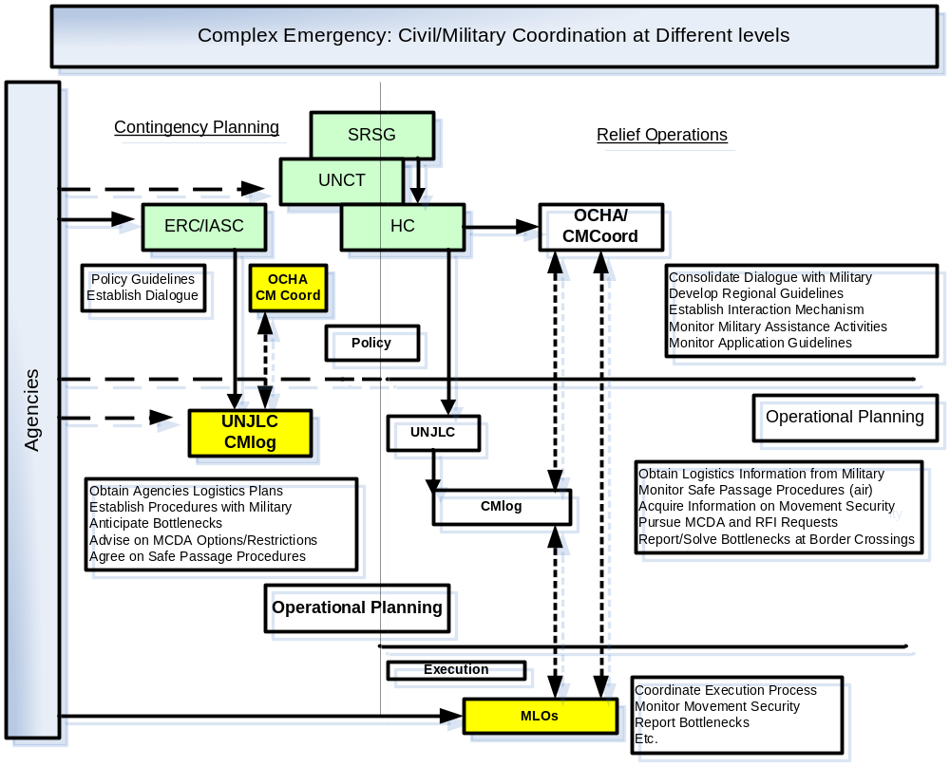
Figure 17.1

17.3. CIVIL/MILITARY LOGISTICS (CMLog) FUNCTIONS WITHIN UNJLC

17.3.1. GENERAL

CMLog officers may be assigned to UNJLC, functions at various levels and locations and with differing responsibilities. Coordination duties in military HQs may be assigned to military staff but Civil-Military Coordination Staff in UNJLC posts will invariably be civilian. Inter alia, CMLog officers in the UNJLC will act as advisors to the humanitarian community on the availability of, and procedures for, requesting MCDA. CMLog officers in military HQs will mainly act as advisors to commanders on humanitarian priorities and MCDA policy.

17.3.2. CMLOG WITHIN UNJLC

CMLog officers will report to the Head of UNJLC, Operations Coordinator or Field Coordinator as the case may be. The CMLog officer will be assigned as Field Coordinator in which case, he/she will fulfil both functions as described in the paragraphs below. The role of CMLog officers in UNJLC posts is to:

- Establish and maintain contact with civilian humanitarian actors in the designated area of responsibility and serve as an information channel for bringing their concerns to the attention of the military authorities.

- Establish and maintain contact with appropriate military counterparts and ensure mutual exchange of information on relevant humanitarian logistics assistance issues.

- Advise local military authorities on humanitarian logistics and general Coordination mechanisms.

- Assure that the principles and guidelines as laid out in the “Guidelines on the Use of Military and Civil Defence Assets” (LOG 2 Section 17) are properly adhered to.

- Coordinate requests and use of Military and Civil Defence Assets (MCDA) for supporting humanitarian operations. (See LOG 2 Section 17 for templates, models and samples of Requests for Assistance (RFAs) and Requests for Information (RFI).

- Advise and support the local Field Coordinator, and any UNJLC logistics and air operations personnel deployed in the area of responsibility, on all issues concerning civil-military relations.

- Advise and support UN security personnel on security issues affecting civil-military relations;

- Establish (if appropriate) an information exchange forum for stakeholders and interested parties in civil-military relations;

- In conjunction with specialist staff in UNJLC (e.g. Air Operations) prepare or assist with submission of formal Requests for Assistance (RFAs) for use of MCDA;

- If operating in the field, submit regular reports to UNJLC Mission HQ on ongoing civil-military activities, and the overall situation relating to civil-military relations in the area of responsibility;

- If operating in the field, provide inputs to strategic and policy processes, and to UNJLC Sitreps prepared by the Field Coordinator;

- Participate in and report on local meetings pertinent to civil-military relations;

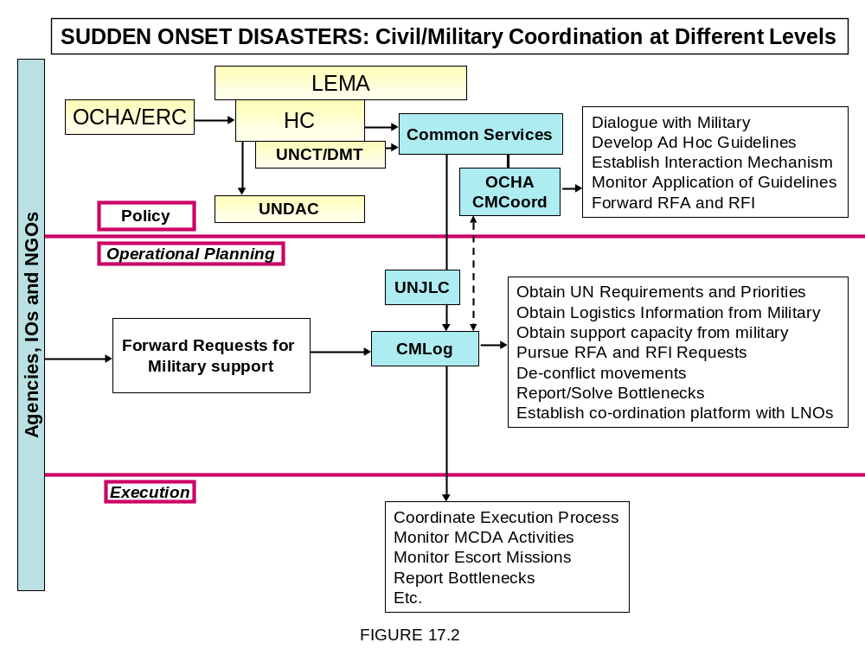

17.4. CMLOG WITHIN MILITARY HQ

17.4.1. Context
- UNJLC CMLog officers assigned to a military HQ should arrange to be introduced to the Commander and senior staff as soon as possible after arrival so that they can explain their role and TOR. UNJLC staff assigned to major military HQs should have sufficient status (equivalent to Colonel or above) to deal on equal terms with their POCs and to emphasize the importance that the UN attaches to its representation at that HQ. (Sample TOR can be found in LOG 2 Section 17 and LOG 3 Section 1.)
- As representatives of the UNJLC, these officers frequently provide the vital link needed for effective Coordination of humanitarian logistic operations with military activities. It is therefore most important that they possess the requisite language skills as well as a sound working knowledge of the doctrine, capabilities, procedures and culture of the organizations concerned. The responsibilities outlined below provide guidance for UNJLC CMLog officers assigned to military HQs.

17.4.2. Responsibilities before Deployment

Before departure CMLog officers should be thoroughly briefed on the current situation and Head of UNJLC’s objectives. He/she should be fully conversant with the UNLC concept of operations, locations, manning and any special logistics considerations. Additionally, UNJLC CMLog officers should obtain:
- Briefing on command relationships and key players in major military formations participating in the operation.
- Details of any specific liaison requirements from individual UNJLC offices and relevant UN Agencies.

- Personal communications equipment (laptop, mobile telephone etc). (See LOG 1 Section 6, LOG 2 Section 6 and LOG 3 Section 2).

- UN Laissez Passer and any other necessary credentials.

- Map of crisis area, showing location of UNJLC (HQ), satellite JLCs, major airfields and seaports. See LOG 1 Annex 7 of this handbook for a list of Useful websites including map sources.

17.4.3. Responsibilities on Arrival

On arrival at the military HQ, the UNJLC CMLog officer should:

- Contact the Commander's office to request a courtesy call on the Commander or Chief of Staff.

- At this first meeting with the Commander or Chief of Staff, show credentials, explain the Liaison Officer's duties and responsibilities and be prepared to brief on the UNJLC’s role and organization.

- Confirm office allocation and arrange access to fixed telephone, fax and e-mail. Notify Coordinates (including mobile telephone number) to UNJLC (HQ) and other organizations as required. See LOG 2 Section 10 for sample presentations and generic flyer.

- Visit all relevant staff officers within the HQ (as authorised by the Commander) exchange information as required and report full details of initial contacts to Head of UNJLC.

17.4.4. Ongoing Operations

The UNJLC CMLog or Liaison Officer will:

- Establish and maintain contact with other liaison officers assigned to the HQ by UN Agencies or actors involved in the relief operation.

- Ensure that he/she remains fully briefed on UNJLC activities and humanitarian operations within the crisis area. Up-date Commander or Chief of Staff (via military POC) as necessary.

- Inform Commander or Chief of Staff (via military POC) of any significant problems being experienced by CMCoord or liaison officers in other locations. If possible, suggest ways in which such problems could be alleviated.

- Notify UNJLC (HQ) of daily schedule to ensure that location of CMCoord or liaison officer is always known. Ensure that he/she can be contacted at all times by military POC and/or Head of UNJLC.

- Attend HQ briefings and military meetings related to humanitarian assistance. Represent UNJLC at regular meetings of relevant working groups.

- Submit comprehensive Sitreps to Head of UNJLC with copies to other staff officers in UNJLC (HQ) and UNJLC (Core). These reports should be sent at least once per week or more frequently if so required by Chief UNJLC. See LOG 1 Section 10 (INFOCOMMS).

- Maintain an accurate record of all actions and reports. Ensure these are filed in accordance with file naming protocol set by UNJLC Core Unit. (See LOG 2 Section 10). Ensure that Information Management for the mission regularly receives copies of these reports etc.

- Accomplish duties and responsibilities without interfering with the work of the HQ.

- Report promptly to Head of UNJLC if unable to accomplish the liaison duties.

17.4.5. End of Duty Responsibilities

- Prepare comprehensive hand-over brief for successor (if any) and introduce him/her to Commander, Chief of Staff and military POCs. If no successor is appointed, brief any UN liaison officers remaining in the HQ on any ongoing issues requiring their attention.

- Submit comprehensive end-of-duty report to Chief UNJLC.

17.5. LIAISON OFFICERS (LNOs)
17.5.1. General
General During large-scale sudden onset emergencies, the provision of spontaneous assistance, including MCDA, may be overwhelming and it is a challenge how to adequately address the pressing humanitarian needs using the capabilities at hand. Within this context, in particular during large-scale sudden onset emergencies, the deployment within the humanitarian civil structures of liaison officers from MCDA contributing countries is extremely useful to ensure sound advice on the use and gradual replacement of the military capabilities as well as proper coordination during both, the relief phase and the transition from relief to rehabilitation.

17.5.2. Accountabilities

The Liaison Officers within the UNJLC will report to the Head of UNJLC through a Senior LNO if present and will:
- Advise his/her military commander’s forces in the crisis area of international humanitarian coordination mechanisms;
- Maintain contact with his/her military commanders and ensure mutual exchange of information about ongoing humanitarian assistance issues;
- Participate in work groups, meetings and consultations with other UN agencies and humanitarian partners
- Obtain information on humanitarian needs and the plans to address these needs;
- Obtain information on shortages of assets and capabilities to address these needs, in particular with regard to infrastructure, equipment and transport capabilities;
- Obtain information on logistics bottlenecks and ways to address these;
- Act as advisors to the humanitarian community on the availability and capabilities of the assets which can provided by their governments;
- Recommend ways to address Requests for Assistance (RFAs);
- Pursue the compliance with relevant RFAs;
- Analyse and report on any major accomplishments and progress;
- Provide information on assessments, pictures, satellite imagery, etc. on logistics infrastructure which can be obtained through national channels;
- Address any other Requests For Information (RFIs), if required.
(If a Senior LNO (Civil or Military) or CMCoord officer have been appointed to a UN body, the NLO will coordinate with them in order to avoid redundancy.)

17.5.3. Responsibilities before Departure

- The LNO should be thoroughly briefed on the current situation.
- If possible, he/she should get in touch with the (Local) Head of the UN Agency, in order to find out about the TOR and ETA.
- He/she should be fully conversant with the UN body’s concept of operation.
- Before departure, the LNO should be briefed on command relationship.
- The LNO should also obtain details of any specific liaison requirements from individual UN offices and/or –Agencies, as well as personal communications equipment (laptop, mobile telephone etc.), UN laissez-passer and any other necessary credentials and maps of the crisis area.
- The LNO may be detached to an adjacent Satellite UNJLC if the centre of gravity will be shifting. (See LOG 1 Section 16)

17.5.4. Responsibilities on Arrival in the Crisis Area

- On arrival, the LNO should contact the (Local) Head of the UN Agency where he will be appointed.
- Start the in processing; arrange access to fixed telephone, fax and e-mail, security/access badge and all other arrangements as required by the agency.
- Visit all relevant staff personnel within the organization as well as outside of it, exchange information as required and report full details of initial contacts to the (Local) Head of the UN Agency

17.5.5. Ongoing Responsibilities

- Establish and maintain contacts with other liaison officers assigned to the UN Agency or actors involved in the relief operation.
- Ensure that he/she remains fully briefed on the UN Agency’s activities and humanitarian operations within the crisis area. Up-date (Local) Head of UN Agency as necessary.
- Inform the (Local) Head of the UN Agency and all other relevant staff personnel of any significant problems being experienced by CMCoord or liaison officers in other locations. If possible, suggest ways in which such problems could be alleviated.
- Notify the Agency of daily schedule to ensure that location of the NLO is always known. Ensure that he/she can be contacted at all times by military and or civilian staff personnel of the Agency.
- Attend briefings and meetings related to humanitarian assistance. Represent the Agency at regular meetings of relevant working group as required.
- Submit comprehensive Sitreps to the (Local) Head of the Agency, national or international military staff and all other relevant personnel on a frequency as agreed.
Maintain an accurate record of all actions and reports.
- Accomplish duties and responsibilities without interfering with the work of the Agency or other personnel.
- Report promptly to the (Local) Head of the Agency if unable to accomplish the liaison duties.

17.5.6. End of Duty responsibilities

- Prepare comprehensive hand-over brief for successor (if any) and introduce him/her to all relevant personnel whether military or civilian.
- If no successor is appointed, brief any UN liaison officer remaining in the HQ on any ongoing issues requiring their attention.
- Submit comprehensive end-of-duty report to all military and/or civilian authorities as required.

17.5.7. Qualification Requirements

- Officer with the rank of Major or higher.
- Being appointed as the representative of his/her country’s military commander in the region;
- Extensive experience in working with humanitarian organisations preferred but not essential;
- Ability to work within in a high pressure environment as a team player as well as under difficult living conditions;
- Ability to communicate clearly in written and spoken English;
- It is preferable that the LNO is also CMCoord graduate and has some field experience (Peace Support Officer (PSO), natural disasters, complex emergencies.

LOG 1 - Annex 1
A1. HUMANITARIAN ORGANISATIONS INVOLVED IN RELIEF OPERATIONS

A1.1. UN AGENCIES

Within the UN system, a number of specialised Agencies are responsible for conducting detailed assessments of needs in accordance with their mandates and operational experience. Some of these Agencies have signed bilateral or multilateral MOUs with one another to share responsibilities in common relief activities. Some of the sectors covered by individual Agencies are indicated in the table below. In addition, such as discussed in Part 4, The ERC and HC may decide on the establishment of Clusters. The cluster approach aims to improve the predictability, timeliness, and effectiveness of humanitarian response, and pave the way for recovery. The approach also aims to strengthen leadership and accountability in key sectors, not replace sectors per se. There are nine clusters: camp coordination and management; early recovery; health; logistics; nutrition; protection; shelter; telecommunications; and water, sanitation, and hygiene. The Cluster Lead Agencies are indicated in the table below. Cluster leads have mutual obligations to interact with each other, and are accountable to the Emergency Relief Coordinator globally and to Humanitarian Coordinators locally.

SECTOR | COMPETENT UN AGENCIES
HEALTH & NUTRITION | WHO ( Health Cluster), UNICEF ( Nutrition, Water & Sanitation, Hygiene Clusters)
FOOD, NUTRITION & LOGISTICS | WFP ( Logistic Cluster)
FOOD & AGRICULTURE | FAO
SUPPLEMENTARY FEEDING | UNICEF, UNHCR
WATER, SANITATION & EDUCATION | UNICEF
SHELTER, NON –FOOD ITEMS,  PROTECTION & REPATRIATION | UNHCR (Shelter, Camps Management, Protection Clusters)
RECONSTRUCTION AND DEVELOPMENT | UNDP
IMMIGRATION & REPATRITION | IOM
REHABILITATION | UNDP ( early Recovery Cluster)
OVERALL COORDINATION | OCHA (ICT Cluster)

Whilst UN Agencies are responsible for ensuring prioritisation within their mandated Clusters of responsibility, there should be a vigorous inter-Agency process to review and decide priorities based on goals established within a strategic framework. This process should take place at country level with the appropriate participation of Non-Governmental Organisations (NGOs), donors and, where appropriate, representatives of the local government. The ERC, and the Humanitarian Coordinator and in-country team at field level, should play a pro-active role in ensuring prioritisation among sectors as well as in instances where there is no inter-Agency agreement.

A1.2. THE RED CROSS MOVEMENT

The Red Cross is a very important humanitarian component that will be prevalent in all aspects of relief work. It is therefore likely to be an integral part of the emergency environment and may play an important role in coordinating humanitarian assistance in complex emergencies. The Red Cross is composed of three elements:
- The International Committee of the Red Cross (ICRC) is the founder body of the Red Cross movement. The ICRC is promoter of the Geneva Conventions and their additional Protocols concerning the treatment of wounded and sick military personnel, prisoners of war and civilian populations in internal and international conflicts. Consequently, the ICRC will play an active role in most complex emergencies.
- The International Federation of Red Cross and Red Crescent Societies (IFRC) is a federation of national societies worldwide. It aims to inspire, encourage, facilitate and promote all forms of humanitarian activities by its member societies with a view to preventing and alleviating human suffering. When disasters occur, the IFRC assists national societies in assessing needs, mobilising resources and organising relief activities. IFRC delegates are often assigned to give direct assistance to national societies. Personnel from other national societies may also be requested and assigned under the auspices of the IFRC.
- The National Red Cross and Red Crescent Societies act as auxiliaries to the public (governmental) authorities and services. They normally concentrate on activities concerned with public health - including first aid and primary health care - and relief. Many national societies also maintain stocks of relief supplies. They receive funds from their own membership, from local fund-raising activities and in many cases from the Government. Especially in emergencies, they may also receive funds, supplies and/or the assistance of personnel from sister Societies in other countries. This support is normally channelled through the IFRC, but may occasionally be given on a bilateral basis. The IFRC and national societies may become important actors during relief operations, particularly with regard to the storage and forwarding of non-assigned relief commodities arriving in the crisis region.
A1.3. NON GOVERNMENTAL ORGANISATIONS (NGOs)
Non-Governmental Organisations (NGOs) can be divided into two main categories: international NGOs working in the international field, and local NGOs working in their own country. The NGO community has become increasingly important in the humanitarian world and has significantly increased in numbers over the past years. Currently there are approximately 20,000 NGOs covering the full spectrum of humanitarian relief activities. NGOs work in all areas of the humanitarian field and provide the greatest international capacity for provision of relief on the ground.

One or more NGOs are often present in the area of an emergency before, during and after the onset of the crisis and will, therefore, have hands-on information and experience of the issues at hand. NGOs tend to specialise in one or two fields, or to direct their efforts towards one needy population group. They usually offer skilled staff, rapid deployment capacity (if they are not already in the area), operational flexibility and resources that might not otherwise be available in an emergency. Local NGOs can be helpful in a variety of ways, especially because they are known locally and because they are familiar with the area, the culture, the population, etc. In many cases, they work together with international NGOs, the UN and others. They are assets that can be helpful not just for information-sharing purposes, but also as implementing partners.
The following table lists some of the major NGOs working as implementing partners with the UN Humanitarian Agencies and summarises their respective areas of specialisation. Mention or omission does not imply any form of endorsement by the UN. Target sector descriptions are not exhaustive.

Organization | Target Sector
ACORD: Organisation for Cooperation , Research & Development | Emergency assistance development  (consortium of agencies)
ADRA: Adventist Development & Relief Agency | Transport/logistics, health/nutrition, shelter, community services, education, food production, legal assistance.
A(I)CF : Action (Intemationale) Contre la Faim | Food, water, health/nutrition, shelter.
AI: Amnesty International | Human rights, legal assistance.
ARC: American Refugee Committee | Sanitation, health/nutrition.
CARE: Cooperative for Assistance & Relief Everywhere | Food, transport/logistics, health/nutrition, shelter, community services, legal assistance.
CARITAS | Food, transport/logistics, domestic needs, water, sanitation, health / nutrition, shelter, education, food production, etc.
CONCERN | Water, shelter.
CRS: Catholic Relief Services | Food, domestic needs, health / nutrition, sanitation, education, and income-generation.
CWS: Church World Service | Transport/logistics, domestic needs, health/nutrition, shelter, community services, education, income- generation.
DRC: Danish Refugee Council | Transport/logistics, shelter, community services.
HI: Handicap International | Food, transport/logistics, health/nutrition, shelter, community services, legal assistance.
ICMC: International Catholic Migration Commission | Transport/logistics, domestic needs,  Health/nutrition community services, education, legal assistance.
IIRO: International Islamic Relief Organisations | Emergency assistance, logistics/transport.
IRC: International Rescue Committee | Food, transport/logistics, domestic needs,  water, sanitation, health/nutrition, shelter,  community services, education, food production, income- generation, legal assistance, etc.
LCHR: Lawyers Committee for Human Rights | Advocacy, human rights.
LIRS : Lutheran Immigration & Refugee Service | Advocacy, migration.
LWF: Lutheran World Federation | Food, transport/logistics, domestic needs, water & sanitation, shelter, health / nutrition, community services, education, food production, income- generation, legal assistance.
MDM: Médecins du Monde | Health.
MSF: Medecin sin Frontiers | Food, transport/logistics, domestic needs,  Water, sanitation, medical services, health/nutrition, shelter, community services.
NRC: Norwegian Refugee Council | Transport/logistics, shelter, community services.
OXFAM: Oxford Committee for Famine Relief | Food, transport/logistics, water, sanitation, community services, income-generation.
PSF: Pharmaciens sans Frontières | Health.
Riidda Barnen (Save the Children) | Domestic needs, community services, education.
Refugees International | Advocacy, migration.
SCF: Save the Children Fund | Transport/logistics, domestic needs, water, sanitation, health/nutrition, shelter, community services.
World University Service | Education.
World Vision | Water, food production.

A1.4. DONORS
Donors may be present in the crisis area and even actively involved in disaster relief activities. Examples of donors include the United States Office for Foreign Disaster Assistance (OFDA), the United Kingdom Department for International Development (DFID) and the European Commission Humanitarian Office (ECHO). Some of these donor organisations have developed a concept for rapid intervention in case of disaster. An example is OFDA’s Disaster Assistance Response Team (DART), which may become actively involved in disaster rescue activities. It is important that Head of UNJLC is aware of such activities and Coordinates with sponsoring donors as necessary for consolidating logistics operations.

LOG 1 - ANNEX 2:
PERSONAL SECURITY
This annex contains only reminders of a few key points related to personal security in the field. UNJLC staff members should complete the security test before deploying. Information on how to conduct this test can be provided by the UNJLC Core Unit.
Be aware of and keep with you the more detailed information and guidance in the LOG 3 Section 1 Security in the Field and Security Tips, and also the guidelines issued by the country-level UN security management team
A.2.1. PERSONNEL SECURITY ISSUES
A.2.1.1. Preparedness
Ensure that at all times you have:
- Your laissez passer/passport, visa, identity card(s), family certificate and health certificate, and that any return travel tickets are valid;
- Cash (local currency and US$) and traveller’s cheques on hand;
- A supply of food, water and candles, flashlights and a first aid kit.
- Ensure that your vehicle is in good working order and has a reasonable quantity of fuel at all times.
A.2.1.2. Information and instructions
- Inform the office/security officer of travel plans and get clearance if needed.
- Get security briefings before travelling to an insecure area and when you arrive.
- Follow local DSS advice and instructions.
- Know the UN security plan for the location you are in, and the warden responsible. Keep the warden (as well as the office) informed of where you are and when and where you propose to travel.
- Follow the instructions of the Designated Official for UN Security (DO, usually the UN resident Coordinator), the warden for the area you are in, or the CD.
- International staff must deposit up-to-date household and personal effects inventory forms with the country office. (If not, you will not be entitled to any compensation in the event of loss.) A refusal to comply with an evacuation instruction may be considered as an act of defiance and could lead to suspension pending investigation. You would be staying on at your own risk and it might not be possible to include you in subsequent evacuation arrangements. The UN would not be able to take further responsibility for your protection.
A.2.1.3. Precautions
- Always be alert and aware of your surroundings. Look out for the unusual and be suspicious. Follow your instincts.
- Avoid routines. Use different routes to and from the office, etc. Vary times of departure to the extent possible.
- Be discrete and keep a low profile. Select your friends with care. Avoid ostentatious behaviour. Respect local cultural norms.
- Stay away from situations that might present or attract threats (e.g. political rallies).
- Be certain that you can explain everything that you have on your person. Don’t carry any items that may call into question your motives or status within the mission.
- In hotels: avoid ground floor rooms that are accessible from the outside, and rooms at the end of long corridors; check that doors and windows are secure; check that the telephone works.
- Don’t be provoked by hostile comments. Don’t say or do anything that might provoke resentment.
- Don’t carry large amounts of money. Don’t display jewellery or keys.
- Don’t touch suspicious objects or packages: report them to local security personnel.
- When an emergency strikes, if you are unable to contact the warden or Head UNJLC, consult the local government, local security personnel and/or any representatives of ICRC or other international agencies present in the locality. Contact the CD or any WFP office as soon as possible.
A2.2. Mines and unexploded ordnance
- Get a briefing on and description of the kind of mines and unexploded ordnance likely to be found in the area.
- Ask local people for advice as to possible locations of mines.
- Never touch any suspicious object, nor pull or cut any wires; avoid walking in the immediate area; mark the spot and inform your colleagues, local people and the authorities.
- Avoid the edges of roads and what appear to be fresh road repairs. Get out of a vehicle in the middle of the road, not at the edge.
- Stop well before any obstacle (something suspicious) in the road. Inspect from a distance (use binoculars). Don’t proceed if you are in doubt.
- If you find yourself in an area where there are mines, ‘freeze’, then retrace your steps slowly and very carefully.

A2.3. Surviving as a hostage
- At the time of your seizure, don’t attempt to fight back. Don’t play the hero; your job is to survive. Don’t talk back or ‘act tough’. The first 15 to 45 minutes are the most dangerous.
- Fear is a normal reaction. Try to relax, pause, take a deep breath and accept the situation.
- Be Cooperative without appearing either servile or antagonistic.
- Follow the instructions of your captors. Keep a low profile.
- Try to gain your captors’ respect and try to build a rapport with them.
- An excellent topic of discussion is family and children.
- Emphasise that as a UN employee, you are neutral and not involved in politics.
- Encourage your captors to let the authorities know your condition and whereabouts.
- Take care of yourself: exercise, stay well groomed, eat and drink even when you are not hungry.
- Be patient and mentally prepared for isolation. Focus your mind on pleasant scenes memories or prayers.
- Never beg, plead or cry.
- Don’t make threats against your captors or indicate that you would testify against them.
- Avoid appearing to study your captors’ features, dress and mannerisms.
- Don‘t attempt to escape unless you are certain you will be successful.
- If there is a rescue attempt by force, drop to the floor and keep your hands over your head. Once the situation has stabilized, identify yourself.
A2.4. UN security phases and their meanings
Phase 1: Precautionary
- Exercise caution
- All travel into the area requires advance clearance by the DO
- Alerted in same manner as international staff
- Same DO travel clearance is required
Phase 2: Restricted movement
- Staff and families remain at home
- No travel into or within the country unless authorized by DO
- Staff do not report for work unless otherwise instructed
Phase 3: Relocation
- Staff and families are temporarily concentrated or relocated to specified sites/ locations and/or
  - Eligible dependants are relocated outside the country
  - According to the local UN security plan and the decision of the DO/CD, staff may leave the duty station on special leave with pay, or  be relocated to a safe area within the county with up to 30-days DSA, and  receive up to 3 months salary advance and, if needed, a grant to cover transport costs for themselves and eligible dependants
Phase 4: Programme suspension
All staff members who are not directly concerned with emergency or humanitarian relief operations or security matters are relocated outside the country
Phase 5: Evacuation (SG approval)
All remaining personnel are to leave.
Arrangements for national staff
National staff members are helped to ensure their own security and may be relocated within the country. They can be evacuated from the country only under the most exceptional circumstances when decided by the UN Secretary-General.
A2.5. Minimum operating security standards (MOSS) for Phase 3 and above
The following are minimum standards defined by the department for Safety and Security (DSS) for all offices and operations in areas of Phase 3 and above.
What each office and sub-office must have/do
Equipment
- A safe haven (bunker or otherwise) located in the building or the compound, equipped with ablution units and stocked with sufficient supplies of food and water for 4 days for all staff
- Trauma kit
- GPS units (2 per CO, 1 per sub-office);
- A back-up power supply system
- In countries with a bomb/war threat environment, the following are also required:
- Blast resistant film must be fitted to relevant exterior windows
- The safe haven must be reinforced for protection against weapon/artillery attack
Procedures and documentation
- General security procedures and security notices
- Specific procedures for: travel clearance; emergency (critical incident) management; medical evacuations;
- Copies of: the UN country security plan31 and security structure; relevant country/ regional maps; the UN field security handbook
Reviews and drills
- Regular drills of the warden system (at least once every 6 months)
- Regular emergency, fire and evacuation drills (at least every 6 months)
What each vehicle must have
- First aid kit; fire extinguisher; water jerry can and fuel jerry can; spare wheel, jack and appropriate tools
- UN flag and UN logo
- In countries with a bomb/war threat environment, operational vehicles travelling in conflict or other dangerous areas must also have:
  - One set of body armour each for the driver and passengers
  - A ballistic blanket and blast resistant film fitted on windows
What staff members should have/do
    - Have a quick escape kit (15 kg) as per DSS guidelines
    - Have the UN Security in the field handbook
    - Make themselves aware of relevant local/country security procedures and comply with local policies
    - All new staff should be provided with full country and security briefing prior to deployment out of main office.
    - Prior to deployment to the field, all staff should have security awareness training and, where appropriate, specialised training in use of body armour, use of a fortified bunker, defensive driving, etc.
13
LOG 1 - ANNEX 3:
GENERIC STRANDARD OPERATING PROCEDURES for TRANSITING and IMPORTING COMMODITIES
a. Introduction
This annex provides a general description of the usual process for importing and transporting goods into countries. It also describes the documents required for obtaining these authorisations. During an operation, additional legal forms and documents will be required in order to comply with international regulations.
Some of these forms are standardised international documents. Others are self-made formats recommended for use in UNJLC operations. Chief UNJLC is authorised to modify the latter as required, but with regard to Air Operations, consultation with UNHAS is required. Although most international formats are standardised (and hence non-negotiable), it is possible that some States will ask for specific documents and clearances not described in this LOG. One of the UNJLC's first tasks will be to identify local procedures and facilitation measures for importing humanitarian goods and moving them within the country.
b. Seaport Procedures
Ports normally have all necessary facilities for handling ships, carrying out customs inspections and storage of cargo: possessing the necessary equipment and machinery for loading and unloading operations. Nowadays, with the increasing use of modern transport technology such as containerization, cargo often moves inter-modally through a port. The port's functions then become mainly limited to transit operations whereby cargo moving in unitized form does not have to be packed or unpacked at the port.
The main formalities connected with the handling of goods by port authorities in the export or import trade are as follows:
• Before any cargo is landed, a copy of the cargo manifest must be delivered to the port authorities.
• When cargo is discharged from the ship, it must be tallied.
• The out-turn report, which is prepared based on such tally, is compared with the vessel's import general manifest to ascertain whether the full manifested cargo has been discharged. There may be short-landed or over-landed cargo.
• Wharfage at the prescribed rates is levied on all goods landed and shipped.
• Goods not removed from the custody of the port authorities within the free storage period allowed are charged rent at the prescribed rate.
• Rent may be waived or reduced under the following circumstances.
• After the expiry of "free time" rent is charged at prescribed rates on cargo that may ultimately be sold at public auction.
• Rent is charged on any un-manifested cargo not removed within the prescribed time after delivery of the "Out-Turn Report.”
• However, in the case of goods landed in a damaged condition for which a claim is made against the carrier, some extension of free time may be allowed to enable a survey of the damaged cargo to be made.
• A similar concession may also be permitted in the case of goods damaged subsequent to landing and for which an "Application for Survey" has been received by the port authorities.
• No rent is charged on goods detained by the Customs authorities for special examination, chemical tests, etc.
• No rent is charged when removal of goods is delayed due to no fault or negligence on the part of the importers.
• Areas used for the landing and storage of imported goods must be declared as Customs Areas under a Customs Act.
• The discharge of some hazardous cargo may be permitted only in mid-stream into barges, or at berths or anchorages specially reserved for that purpose. If necessary, such cargo must be stored in specially designated areas.
• Examination of cargo by Customs will be permitted only if the consignee or clearing agent produces to the port authorities the delivery order issued by the shipping agent together with the Bill of Entry prepared on behalf of the consignee.
• In the case of containerized cargo, containers may be unstuffed in the port area before the cargo is presented for examination by Customs. Alternatively, containers may be taken to an inland container depot, or warehouse, or factory of the consignee where they are unstuffed and delivered to the consignee after completing Customs formalities.
• Carting or transporting of export cargo, if it is Break Bulk, is permitted at the berth where the ship is ready to load. In the case of containerized cargo, carting is permitted to the location assigned to the shipping line by the port authority.
• Like imports, exports attract demurrage after the expiry of free time but port authorities sometimes waive this charge in the case of special cargo. Ports may defer acceptance of export cargo if there is a delay in the arrival of the vessel.
• When export cargo is taken to an inland clearance depot, Customs formalities are completed there and the cargo is stuffed into containers, which are then brought to the port for direct loading onto the ship. The same procedure may also be followed if containers are stuffed at the factory or warehouse of the shipper.
c. Airport Procedures
Many airports provide a full range of services to aircraft operators and ground handling agents to facilitate all aspects of air cargo operations. Typically, airport authorities designate specific areas - including office and/or warehouse space - for use by aircraft operators, handling agents and freight forwarders. In order to offer such services, airports not only need to have the necessary facilities for aircraft maintenance and cargo handling but must also provide infrastructure for receiving different types of surface transport (e.g. road and rail).
In addition to these services, airports normally provide secure storage for cargo ranging from perishables and general freight to high-value goods. Major international airports also provide facilities for Customs authorities to enable the examination of cargo and collection of duties, taxes and other levies. The main formalities connected with the handling of export/import cargo by airport authorities are as follows:
• The original copy of the cargo manifest should accompany the cargo. This document must be produced to Customs. A copy should subsequently be given to the airport authorities if required.
• After cargo is unloaded from the aircraft, tallying is carried out by the airline staff or handling agent. The out-turn report prepared on the basis of this tally is then compared with the airline's manifest to ascertain whether the full manifested cargo has been discharged. Cargo may be either short- landed or over-landed.
• A terminal charge at the prescribed rate is levied on all goods landed and shipped.
• Rent may be levied or waived as follows:
• Rent will be levied on goods not removed from the custody of airport authorities within the permitted free storage period, even if this cargo is ultimately sold by public auction.
• Rent will be charged on any un-manifested cargo not removed within the prescribed time after delivery of the out-turn report.
• Charges may be waived on goods detained by Customs for special examination.
• Locations used for the unloading and storage of imported goods must be designated as Customs Areas under a Customs Act.
• Storage of hazardous cargo will be permitted only in locations specially designated for that purpose.
• Examination of cargo by Customs is permitted only if the consignee or appointed agent produces to the airport authorities or handling agent the delivery order issued by the airline or airline's agents, together with the import declaration prepared on behalf of the consignee.
• Containerized loads may be unstuffed at the airport before being presented for Customs examination. Alternatively, they may be taken to an inland container depot or warehouse nominated by the consignee where they are unstuffed and cleared by Customs prior to delivery to the consignee.
• Cargo destined for export may be cleared by Customs and stuffed into containers at the shipper's factory, warehouse or designated inland depot. The containers are then taken to the airfield for direct loading onto the aircraft.
• Larger airports usually provide facilities inside designated Customs Areas for transit cargo to be de-consolidated and consolidated with local export cargo.
d. Customs Law and Regulations (Ships)
Basic Customs laws or regulations applicable to the arrival and departure of ships and to imported or exported goods are more or less the same in most countries, although they may differ in procedural and documentary details. Several countries have enacted strict legislation for controlling and regulating imports and exports. Rules or regulations issued under such legislation will have to be followed in obtaining Customs clearances. Essentially, imports/exports and vessels carrying such goods are subject to the following procedures:-
• The main arrival formalities are as follows:
• A vessel entering a country from overseas must use a designated Customs Port as its first port of call.
• A vessel can start unloading goods only after Customs have granted the necessary permit (called "Entry Inwards") following submission by the Master or Shipping Agent of an "Import Manifest" containing particulars of the cargo on board in the prescribed format.
• The import manifest must be accompanied by other documents as may be required such as:
- • Certificates of load line.
- • Safety certificates for radiotelegraphy.
- • Certificate of registration.
- • Port clearance from previous port of call.
- • Crew list.
- • Stores list.
- • Declaration of personal property of officers and crew.
• In some countries, Customs authorities will accept the cargo manifest even before the arrival of the vessel under the so-called "pre-entry" procedure (pre-arrival clearance), final "Entry Inwards" being granted after the vessel has berthed.
• Customs clearance:
(1) All imported cargo must be landed at a designated Customs port and should not be removed from Customs control without written permission of the Customs authorities.
(2) Before permission is given to remove goods from Customs control, the owner or agent is required to submit a Bill of Entry, Customs Declaration or Inward Permit, as may be required by law, in the prescribed form to enable Customs authorities to examine the goods. The Bill of Entry includes details such as value, quantity; description of goods, name of vessel, port of shipment, and such other particulars as may be prescribed by the Customs authorities. These particulars must tally with those contained in the relevant import manifest.
(3) The Bill of Entry (Customs Entry) must be accompanied by all supporting documents required by Customs such as invoices, import licenses, certificates of origin, bills of lading and marine insurance certificates. When goods are destined for warehousing, application for permission to warehouse those goods and a bond must accompany the Bill of Entry (Customs Entry).
(4) Customs authorities are empowered to examine all imported goods. The examination may be physical (visual inspection, counting, weighing, measuring, chemical test, etc.) or documentary (involving examination of relevant documents such as invoices, bankers' notes, insurance policies and forms listing the quantity and description of goods).
(5) If goods are dutiable, either Customs tariffs must be paid at the time or the importer must give a bond to guarantee payment of the duty.
(6) If goods are not removed within the prescribed period after the arrival of the importing vessel, they are liable to be sold at public auction by the port authorities who will recover from the sale proceeds all charges due to them, including Customs duty.
(7) Customs authorities are entitled to recover from the importer any shortfall in duty levied or erroneous refund of Customs duty, in accordance with prescribed procedures.
(8) In cases where import licenses are required, Customs authorities will check the legality of the imported goods against those licenses.
• Departure Formalities
• Export goods can be loaded onto a vessel only after the necessary permit "Entry Outwards" has been issued by Customs, and after documents duly endorsed by Customs have been delivered by the exporters to the Master or person in charge of the ship.
• A vessel which has brought in imports or has loaded exports can leave the port only when written permission, known as "Port Clearance,” is granted by the Customs authorities.
• Application for Port Clearance must be made in good time before planned departure. This application must be accompanied by the Export Manifest showing particulars of the cargo loaded and such other documents as may be required by Customs. Examples include the vessel's certificate of registration, load line certificate, safety certificates for radio telegraphy and safety equipment, inward clearance certificate, income tax clearance certificate (if proceeding to a foreign port with export cargo) and certificate of payment of all dues issued by the port authority.
• In many countries, most goods are freely exportable. Only a limited number of specified items or commodities are subject to export control.
e. Required Documents (General)
• Introduction
In the field of freight forwarding, there is no international uniformity of documents or documentary procedures. Nevertheless, efforts have been made by the International Federation of Freight Forwarders (FIATA) to promote the use of standardised freight forwarding documents and thereby improve professional standards. FIATA has produced several documents, which correspond with layouts used by the UN Economic Commission for Europe (ECE). In the air transport sector, ICAO and IATA recommend a series of standardised documents that are used in most countries. The use and application of air transport documents is described in LOG 1 Section 9 and typical forms are at LOG 2 Section 9. General documents usually adopted by national associations of freight forwarders for use by their members and samples can be found in LOG 2 Section 13, including:
• The Commercial Invoice
This is a document issued by the seller to the buyer of the goods. It is often used by Customs authorities at the destination to determine the true value of the goods on which duties will be assessed. It also serves as the basis for consular documentation.
Other documents to be signed by the shipper and handed over to the carrier include:
• Shipper’s Declaration of Dangerous Goods
• Shipper’s Certification for Live Animals
• Shipper’s Certification for Arms and Ammunition
In addition, there may be other documents required by the Customs authorities of the exporting and importing countries, which should be submitted with the Waybill.
• Documents Received From Customer
• FIATA Forwarding Instructions (FFI.)
The customer passes this document to the forwarder thereby establishing a forwarder-customer contractual relationship for provision of transport from place A to place B. The customer is expected to furnish all relevant particulars regarding the goods to be dispatched and to enclose such documents as may be required.
• FIATA Declaration for Transport of Dangerous Goods (SDT)
A shipper will complete, sign and hand this document to a forwarder whenever the transport of dangerous goods is involved. This document provides detailed information about the classification of dangerous goods according to regulations governing the transport of such goods.
• Documents Issued To Customer
• FIATA Forwarder's Certificate of Receipt (FCR *)
This is an official acknowledgement of goods received by the forwarder. The forwarder assumes responsibility for the dispatch and delivery to the consignee named in the document. The FCR should be handed to the consignor (customer) immediately after the consignment is received by the forwarder.
• FIATA Combined Transport Bill of Lading (FBL *)
This is a through transport document used by international freight forwarders acting as combined transport or intermodal transport operators. The forwarder assumes responsibility not only for the performance of the contract but also for the acts and omissions of any third parties employed by him.
• FIATA Warehouse Receipt (FWR *)
A warehouse receipt for use in the forwarder's warehousing operations, subject to any national law and applicable standard trading conditions.
• House Bill of Lading/House Air Waybill
Usually applicable to consolidation services, the house Bill of Lading is issued in respect of sea freight while the house Air Waybill is issued in respect of airfreight. There is no uniformity in the terms and conditions of these documents, which vary from forwarder to forwarder.
* While the FBL is a negotiable document, the FCR is not negotiable. The FWR is not negotiable unless marked otherwise. When a document is negotiable, it can be endorsed by the holder in favour of another party, thereby transferring his right to the goods referred to in the document.

LOG 1- Annex 4: LOGISTICS ASSESSMENTS

A4.1. ASSESSMENT GUIDELINES

A4.1.1. GENERAL

A Logistics Assessment, which can be mental or written, is a logical sequence of reasoning giving a broad but yet detailed logistics situation on the ground during a disaster. This undertaking is a disciplined thought process designed to examine all relevant logistical infrastructure and produce the best reasoned solution. One of the major UNJLC tasks, particularly at the onset of large-scale emergencies is the compilation, analysis, consolidation and publication of logistics assessments.

In sudden onset disasters, it is important to make a quick evaluation of the logistics situation. UNJLC staff may be assigned to the UNDAC Team and at least one of the UNJLC staff will be appointed to oversee the logistics assessments. Therefore, quick assessment layouts are included in this annex. If time permits and more thorough assessments are required, it is recommended to use the forms in this Annex. Using these forms will guarantee that GIS officers have all data to produce accurate maps of the logistics situation. This ensures a systematic analysis of all factors relevant to the problem at hand. In this context, we are referring to the problem of providing timely and effective logistics awareness and solution to the humanitarian community.

Some emergencies have a slow onset, which makes it possible to take precautionary measures before the outbreak. As such, the UNJLC may be involved in contingency planning but another precautionary action is to send or deploy experts to the anticipated crisis area for preparing and logging all possible logistics data.

In most emergency situations, the humanitarian actors such as the LEMA, operational Agencies, UNDP and OCHA which are present in the region will be able to provide relevant information. In general, the collected data should include:
- UN Contingency plans, possibly referenced by the UNJLC Core Unit;
- Impact of the disaster on the most vulnerable populations (especially women and children) that need to be targeted for assistance;
- Humanitarian priorities and urgency;
- Identification of existing disaster relief organisations (if any) and authorities involved (LEMA, Humanitarian Coordinator, UNCT, Donors);
- Ongoing disaster relief actions, including Red Cross Movement and NGOs.
- Based on this information, and with the assistance of the local UN humanitarian authorities and UNDAC team (if deployed), the UNJLC team will conduct a logistics evaluation. In particular WFP may be able to support the logistics assessment by providing data which are available in its Logistics Capacity Assessment (LCA). Depending on the urgency, UNJLC’s evaluation may be done in stages, the first stage being the rapid evaluation, the second, once more staff is available, the more thorough logistics capacity assessment.
- The rapid logistics evaluation should include:
    - Overview of warehouses, road and rail capacity, airfield capacities, sea and river port capacities;
    - Identification of resources available in surrounding countries including relief items that could be locally procured;
    - Identification of shortages in transport capacity to support Agency activities;
    - Identification of shortages in transport capacity to support activities of other humanitarian organisations;
    - Identification of existing and/or anticipated logistics bottlenecks;
    - Recommendation on movement options (road, air, etc);
    - Recommendation on options for UNJLC deployment;
    - Information on local infrastructure capabilities and communication systems to support installation of the UNJLC.
A4.1.2. RECOMMENDED SEQUENCE of ACTIONS
(a) PRE-DEPARTURE
• Follow checklist in Part 1.6.
• Report to the UNJLC Core Unit in Rome.
• Obtain Coordinates of local UN Resident/ Humanitarian Coordinator.
• Obtain Coordinates of relevant UN Agencies' Country Representatives in the crisis area.
• Analyze available information such as the data bank of WFP's Logistics Capacity Assessment (LCA).
• In a Sudden Onset Disaster environment, obtain information on the deployment and activation of OCHA entities in the crisis area, i.e. the UNDAC Team and OSOCC.
• In a Complex Emergency environment, obtain information on the deployment of DPKO/JLOC or other peacekeeping/enforcement entities.
• Obtain overall picture of participation of individual donor countries, and other humanitarian organisations that are operating in the affected country.
• Obtain as much information as possible on all airfields within the crisis area that could potentially be used as distribution points. Obtain similar data on any airfields adjacent to the crisis area that could be used as assembly points or hubs. [Note: detailed information on most airfields can be obtained from information published by Jeppesen. The ICAO airfield catalogue is available on http://www.homepages.mcb.net/bones/06airfields/icao.htm. Information specific to the crisis region may also be obtained from national Aeronautical Information Publications (AIPs) published by Civil Aviation Authorities in the relevant countries].
• Verify availability of - and obtain - relevant maps, charts and other necessary aeronautical documents.
• List aircraft types participating in the relief operation or earmarked for deployment at a later stage. Obtain basic details of aircraft performance (range, payload etc), Ref Annex 4.
- If possible, obtain information on in-country availability of aircraft, aviation fuel, oil, spares and maintenance facilities.
- Obtain details from WFP Aviation Section of any existing agreements with local operators (e.g. Charter, Ground Handling, and Freight Forwarding companies)
- Obtain a copy of the LOG Handbook and CD ROM.
(b) IN-COUNTRY, INITIAL ACTIONS
Note: Representatives of the international community resident in the country may have accompanied the first national government and/or NGO personnel into the crisis area to make their own assessments or participate in formulating joint assessments. To the extent that they can commit resources, they may immediately arrange some initial assistance. The main international assistance effort, where required, will be mobilized only after the findings and recommendations of the initial assessments become known. Some assessments may have been produced and distributed earlier by Agencies, donor countries and organisations on the basis of initial news reports and other preliminary information. However, some of the latter sources might not be entirely reliable or appropriate. Relevant information that is already available should be collected before visiting the crisis sites. As a matter of courtesy as well as practicality, UNJLC logistics assessment officers should meet the following officials and organisations before finalizing their own in-country assessment:
• Humanitarian Coordinator.
• In case of DPKO deployment, the Chief Administrative Officer (CAO).
• Relevant UN Agencies, in particular the country representative of the Lead Coordinating Agency.
• In case of Sudden Onset Disaster, Local Emergency Management Authority (LEMA).
• In the case of a Sudden Onset disaster, Team Leaders of OCHA's United Nations Disaster Assessment and Coordination (UNDAC) Team and On-Site Operations and Coordination Centre (OSOCC), if deployed.
• Donor country teams and representatives of other important humanitarian organisations (e.g. OFDA, DFID, IFRC, ICRC, major NGOs etc).
• Contact local authorities to obtain information on any facilitation measures adopted by local authorities such as waivers of import restrictions, customs declarations, immigration procedures, flight clearances, landing, aircraft parking and air navigation fees etc. Coordinate these actions with relevant UN entities.
• Coordinate with UN Agencies on expected logistics support needs, particularly with regard to common air, sea and ground transport assets. Obtain detailed maps of regional road, railroad and waterway networks.

(c) CONDUCTING/OVERSEEING ASSESSMENTS

- Assessments can be conducted, either by following the Excel formats which are in LOG 2. Part 5.5., or by using the narrative forms below. If time permits, the Excel assessment forms should be used.
- The staff conducting the assessments should be encouraged to stay as close as possible to the layout of the forms. The assessments should be collected, thoroughly analysed and summarised. The information should be:
    - Forwarded to the GIS staff which is in charge of producing logistics maps
    - Passed to the UNJLC Movement Coordinator
    - Distributed to the representatives of Agencies which are conducting logistics operations in the area.
    - Briefed at logistics coordination meetings.

A4.1.3. ASSESSMENT FORMS

(a) AIRFIELD ASSESSMENT (SHORT)

If time permits, use Forms in LOG 2. Part 9.1.
If time does not permit to collect all data, make sure to register the underlined.

- Basic operating information
- its location (with coordinates), code (if any) and altitude; the runway length, width, surface, load classification and orientation
- runway condition
- the location and height of any obstructions along the runway or in the approach/departure zones
- present and potential weather constraints (fog, strong winds, ice) aircraft types that can operate
- available navigation aids and support
- availability (or possibility) of night lighting; the reliability of power supplies
- operating hours; the level of sustainable activity; the times when relief aircraft can best be accommodated
- Customs (airport of entry?)
- air operators that are present or that operate regularly

  - Control and Safety
- control tower (air traffic control service), briefing room and weather reporting facilities
- procedures for obtaining flight clearances
- customs procedures, handling costs, taxes
- superintendence, shipping and forwarding agencies present and their fee rates
- present and foreseeable bottlenecks, and possibilities to overcome
- fire-fighting and rescue equipment
- risks of people, animals and birds on runway
- security: perimeter strength, location, guards, baggage check/controls,
- customs and alert procedures; any specific security concerns and measures

  - Ground facilities for aircraft
- aircraft parking facilities: dimensions, surface strength, number of
aircraft (by type) that can be parked, tie-down facilities; covered hangars aircrafts’ access to fuel, maintenance and unloading areas
- aircraft support services: latrine and disposal servicing; de-icing equipment;
- ground power and starter units; towing equipment
- availability of Avgas and Jet-A1 fuel, storage capacity, bowsers for refuelling
- aircraft (pressure or gravity refuelling)

  - Cargo and passenger facilities
- cargo facilities: handling equipment, loading ramps, storage
- cargo receipt and customs procedures; handling agents present and their fee rates
- trucks’ access to aircraft parking and cargo areas
- passenger (dis-)embarkation procedures; passenger amenities
- passenger and cargo transport to the airfield present and foreseeable bottlenecks, and possibilities to overcome them and increase the efficiency of the relief operation
1 | Airfield Name/ICAO Designator
2 | GPS Coordinates
3 | Distance and Direction from Nearest town
4 | Elevation
5 | Runway Heading (Magnetic).
6 | Length & Width (Meters) |  | Length |  | Width
7 | Type of Surface
8 | Condition
10 | Suitability (Twin & Single) Specify type and max loads in/out.
11 | Obstructions
13 | Parking Area (Size & Location)
14 | Fuel & Services Available
15 | Communications
16 | Airfield Owner/ Operator
17 | Remarks
(b) PORT ASSESSMENT (SHORT)

If time permits, use Forms in LOG 2. Part 5.1

For each coastal or river port of potential use, list/check:
- location, number of quays and draught (with seasonal variations)
- permissible vessel specifications (including length restrictions) for bulk and bagged cereals
- discharge rates into warehouses, trucks, rail wagons, barges
- cargo handling equipment – numbers and capacity of cranes, forklifts, etc.; availability of bulk grain and container handling facilities
- present level of functioning
- any specific security concerns and measures
- customs procedures, handling costs, taxes
  - superintendence, shipping and forwarding agencies present and their fee rates
  - present and foreseeable bottlenecks, and possibilities to overcome them and increase the efficiency of the relief operation

(c) INLAND WATERWAY ASSESSMENT (SHORT)

If time permits, use Forms in LOG 2.Part 5.1

For each river corridor of potential use, list/check:
- draught, speed of current, permissible vessel specifications and carrying capacity (with seasonal variations)
- requirements for pilots, customs and other considerations where the river marks an international frontier
- availability of boats, barges and tugs
- local norms/practices for contracting river transport
- any specific security concerns and measures
- present and foreseeable bottlenecks, and possibilities to overcome them and increase the efficiency of the relief operation

(d) ROAD CONDITIONS (SHORT)

If time permits, use Forms in LOG 2. Part 5.1

List and map roads of potential use to and within the emergency zone noting:

- the type/category: primary roads, secondary roads and village roads/tracks
- any that are, or could become, impassable as a result of floods, snow, landmines or insecurity
- the types and sizes of cargo trucks that are able to pass on each road type/route (noting seasonal variations, if relevant)
- bridges: types and capacities/weight limits
- potentially dangerous overhangs; steep hills (percentage gradient) river crossings and/ or ferries with expected delays, tolls, etc.
- any security concerns and measures for particular routes or locations present and foreseeable bottlenecks, and possibilities to overcome them and increase the efficiency of the relief operation and reduce risks

(e) TRUCKING/VEHICLES CAPACITY/AVAILABILITY (SHORT)

- Trucks

- how the transport market is organized (whether individual truck owners associated in cooperatives, or large transporters in competition);
- local norms/practices for contracting road transport local transport companies: their fleet capacities; most common truck size; approximate rates per tonne-km for the best and worst road conditions;
- any restrictions on where the truckers are willing to go
- government entities and other organizations with truck fleets that are, or could be, available to transport relief supplies: their fleet capacities;
- the conditions and procedures for use; their reliability and arrangements for maintenance

  - Light Vehicles

- Types that are best suited for personnel transport
- Availability of such vehicles for rent or purchase, including rates and prices.

(f) RAIL TRANSPORT (SHORT)

- If time permits, use Forms in LOG 2. Part 5.1

- Map the rail network of interest and describe:

- the condition of rail tracks; the frequency of traffic on different sectors
- present level of cargo movement; any anticipated changes
- major transit points: location, wagon capacity, sidings, storage capacity, cranes
- reliability and security of cargo movements
- type and number of usable cargo rail-wagons
- type and number of usable locomotives
- rate of through-put from points of origin to storage facilities (for storage facilities with sidings, give siding numbers and provide a sketch or map)
- procedures at transit points
- any security concerns and measures for specific routes or locations
- present and foreseeable bottlenecks, and possibilities to overcome them and increase the efficiency of the relief operation

Specify any requirements for: technical assistance in management and scheduling; assigning personnel to marshalling yards to expedite wagon movements; repair or upgrading of facilities at critical transit points; training of personnel; etc.

(g) OVERLAND ENTRY POINTS

If time permits, use Forms in LOG 2. Part 13.2

For each border crossing point of potential use, list:

- its precise location
- crossing, customs and inspection procedures for passengers and cargo (including documentation requirements)
- superintendence agents that are available and their fee rates
- handling capacity
- normal working hours and hours on weekends and holidays
- availability of driver support facilities, communication facilities, fuel
- whether there is frequent congestion: typical delays
- any specific security concerns and measures
- any alternative routes and whether the same customs documentation can be used on these alternative routes
- present and foreseeable bottlenecks, and possibilities to overcome them and increase the efficiency of the relief operation

- WAREHOUSES

If time permits, use Forms in LOG 2. Part 14.1

- Warehouse requirements

- Identify undamaged or damaged but usable warehouses located in reasonable proximity to the disaster site.
- Determine the capacity of these warehouses.
- Determine their availability over a specific period of time.
- Storage requirements are closely linked to transportation and these must be considered together in planning.
- Storage requirements will depend on the following:
  - Type of supplies and materials to be stored.
  - Type of storage facilities and services needed.
  - Average time for which supplies are to be stored.
  - Speed and pattern in which supplies will move in and out.
  - Fluctuation of supply and distribution.
  - Existing transport infrastructure.
  - Type and foreseeable length of the emergency operation.
  - Opportunity to share premises between agencies.

- Specify whether the warehouses are government-owned, UN/NGO/IO-owned, or privately owned. Preferably, use existing UN, IO or NGO stores.
- If this is not possible, check possibility for renting other suitable premises.
- Verify warehouse security or possibilities to secure.

- Considerations when selecting locations

- Vehicle access: Each storage facility should be accessible for trucks with a carrying capacity of at least 10 tonnes even during the rainy season. The aim should be to utilize the largest possible vehicles in order to limit costs.
- Adequacy of storage and other facilities: Suitable storage premises must be available, or be established. Telecommunications, electricity supplies and other utilities should also be available, or be provided.
- Security: Storage facilities should not be in high-risk areas. Roads and/or other transport routes to them should be safe.

- Choosing a warehouse

Aspects to consider when choosing a warehouse include:

- the security situation in the locality:
- the suitability of the building and compound
- the availability of suitable handling equipment;
- the availability of competent warehouse personnel;
- whether the store can become operational immediately; the potential delays and risks if it is not immediately usable;
- the availability of a secure parking area for trucks (attached to the warehouse or close to it);
- cost (of any rental and/or repairs).

A warehouse should:

- be conveniently located in relation to the transport facilities being used (roads, ports, airports, railway sidings)
- be far from sites of potential flooding or landslides
- not be liable to pollution or infestation from nearby industries or other food warehouses
- have easy but controlled access
- be of sound, non-combustible construction
- have floors that are level, strong and watertight
- be dry and well ventilated, and free from rodents, termites and other pests
- be secure (at doors, windows and the perimeter fence/gates)
- have platforms or ramps for ease of loading and unloading
- have an adequate electric power supply and lighting (preferably available 24 hours-a-day)

Additional considerations:

- An office room or enclosure is an advantage.
- If small, high-value items are to be stored, secure rooms or cages are required.
- A single large building with sufficient doors for the loading/ unloading of several trucks simultaneously is usually best.
- Separate buildings can be useful if there are supplies that should be kept well clear of each other.

  - Choosing a site for a prefabricated warehouse

Any site for the erection of a pre-fabricated warehouse should have:

- Good drainage and be far from streams, standing water and risks of flooding or landslides
- A secure compound
- Good road access
- Space for parking trucks and for expansion, if needed.

LOG 1 - ANNEX 5:
A 5 - CONSIDERATIONS on MODE OF TRANSPORT
In large-scale emergencies, the Movement Coordination Section will be the focal point for receiving and processing cargo movement requests. During this process, the most appropriate transportation mode, including air, road, rail, etc will be selected, taking into account priorities and availability of transport assets. The following paragraphs include considerations that may help the Movement Coordinator in selecting the most appropriate mode of transport.
A5.1. Maritime
The UNJLC will normally not be involved in shipping and will refer to WFP shipping section (OTS) for expert advice. Nevertheless, during large-scale emergencies, the UNJLC could be involved in compiling the requirements of humanitarian organisations for transporting heavy and bulky cargo. Some of these requirements may be combined and, in some cases, shipping services may be shared. Also, while the urgency might be the deciding factor to use aircraft for flying the commodities into the crisis area, it might be useful to consider shipping, in particular if multiple flights would be required to transport heavy and bulky cargo. Furthermore, the costs of air transport may be such that shipping provides the only way to efficiently transport commodities over long distances.
A quick reference checklist with the average days that ships require to reach their destination is in LOG 2, Section 8.5. In addition to the on-route time, the charter time and preparation of Bill of Lading should be included. In some urgent cases, it may be more efficient to request governments for assistance with military vessels.
A5.2. Air
Airlift enables the rapid delivery of significant quantities of cargo over long ranges. However, it is the most expensive mode of transportation and should be used only if no alternatives are available. That said, due account must be taken of such important factors as accessibility of the victims and the urgency of the humanitarian crisis. At the onset of an emergency, the use of air transport is very often the only way to reach the victims in a timely manner.
Because of their high cost, airlift assets (fixed-wing aircraft and helicopters) should wherever possible be shared or made available for common use. When significant air assets are deployed to a crisis region, the UNJLC should be structured to include an Air Operations Cell, distinct from and in addition to the Movement Planning Cell (MPC) (which would then handle only the Coordination of surface and river transportation).
The UNJLC Air Operations Cell will be manned by one or more staff with appropriate professional experience and qualifications. Its primary role will be to coordinate the utilisation of all air assets made available for the common use of UN Agencies, IOs, NGOs and other humanitarian organisations. These air assets could include both regional and strategic aircraft.

A5. 3. Road
Road transport plays a major part in the movement of humanitarian relief commodities. In principle, it will be the primary mode of transportation whenever possible. Normally, Agencies and other humanitarian organisations will manage their own trucks and the UNJLC will not be involved in detailed loading and movement planning. Nevertheless, Donors or other benevolent organisations may decide to allocate a number of trucks for humanitarian use. In such cases, UNJLC will allocate the trucks for a certain period or task. Furthermore, the UNJLC will be the focal point on road conditions and transport availability. In that context, UNJLC may advise on avoiding choke points and bottlenecks and recommend alternative options.
A5. 4. Boats and Barges
Boats are slow but economical and can carry large tonnage and cargo that may be too bulky for other means of transportation. River or tidal currents will affect their speed. In view of the UNJLC's mission to react quickly in large-scale emergencies, it will be rare for boats to be recommended for common transport during the initial relief phase. On the other hand, small boats and barges may be the only means of moving relief commodities in flooded areas.
Normally, the Movcoord section will not be involved in detailed scheduling of commonly available boats and barges. In case such assets are made available by Donors, they will be directly allocated for a pre-determined period to beneficiary organisations, which will be responsible for the detailed scheduling. Nevertheless, the UNJLC will maintain an inventory of the allocated assets and may require regular reports on their availability and status. In coordination with Donors, the UNJLC should have the right to re-allocate boats and barges in case of overriding priorities.
In special circumstances, boats or barges may be an important link in a movement plan using different modes of transportation. In such cases, responsibilities for coordinated scheduling may be delegated to the UNJLC.
A5. 5. Train
Railways continue to be outstanding in their ability to move large quantities of cargo and passengers over long distances at minimal cost. The degree of UNJLC involvement in rail transport will depend on the circumstances. If available, rail transport, because of its large capacity, should normally be shared by all participating Agencies and organisations. However, train scheduling will require thorough planning well in advance of execution and may not be the best mode of transport in urgent humanitarian relief situations.
A5.6 Summary
The following table summarises the advantages and limitations of the different modes of transportation.

Mode | Characteristics | Advantages | Limitations
INTERNAL  WATER TRANSPORT | Can be used to supply river-side communities or during floods (barges, small boats). | Capacity  Specificity | Speed  Flexibility
RAIL | Can be useful if tracks and equipment are in good condition | High Capacity  Low Cost  Range and Speed | Inflexible  Needs additional means to load/offload and to transport cargo to warehouses  Long planning time
ROAD | Depends on safety conditions and access routes to delivery points | Flexibility  Cost | Road Conditions  Bottlenecks  Vehicle Maintenance  Fuel Availability  Vulnerability
AIR  (Fixed Wing) | Usually employed when supplies are needed urgently or when there is no other way to reach the affected area | Speed  Range  Flexibility | High Cost  Small Payload  Weather  Airfield availability  Aircraft maintenance  crews
AIR  (Helicopters) | To be employed to deliver staff and commodities at places which cannot be reached by other means | More versatile than Fixed Wing (can land at small sites) | Very small Payload  More expensive than Fixed Wing  Limited Range
MARITIME | Used for transporting bulky and heavy commodities | Enormous cargo capacity  Economical | Slow  Follow-on transport needed  Offloading and Customs processing can be time consuming

LOG 1: ANNEX 6
AIRCRAFT AND HELICOPTER Operating Requirements and Capacities
NOTE: Aircraft performances depend on several variable factors such as operating altitude, air temperature, loading (both cargo and fuel) etc. The figures in the table below are averages.
AIRCRAFT  TYPE |  | Cruise Speed Knots | Runway Length  Metres |  | Cargo  Weight  (MT) |  | Cargo  Volume  (M³) | Door Size  H x W  Metres |  | Pallet Size  2.23 x 3.17  Qty. |  | Pax
A 310 |  | 460 | 2400 |  | 31 |  | 75280 | 3.58 x 2.56 |  | 16
Aeritalia ATR 42 |  | 260 | 1100 |  | 4.9 |  | 58
Aeritalia ATR 72 |  | 260 | 1800 |  | 7.5 |  | 76
AN 12 |  | 260 | 1800 |  | 12-16 |  | 97 | 3.10 x 2.40
AN 22 |  | 290 | 1600 |  | 45 |  | 550 | 4.40 x 4.40
AN 24 |  | 240 | 1600 |  | 3.5-5.5 |  | 56 |  |  |  |  | 52
AN 26 |  | 240 | 1600 |  | 3.5-5.5 |  | 50 | 2.00 x 1.60 |  | 3
AN 32 |  | 260 | 1200 |  | 5-6.5 |  | 66
AN-74 |  | 320 | 1200 |  | 6-10 |  | 50 | 2.4 x 1.50
AN-124 |  | 440 | 2400 |  | 100-120 |  | 850 | 6.00 x 7.44
B 707 |  | 460 | 2800 |  | 40 |  | 160 | 3.45 x 2.35 |  | 13
B 727 |  | 460 | 2400 |  | 17 |  | 112 | 3.40 x 2.20 |  | 9 |  | 120
B 737 |  | 460 | 2400 |  | 15 |  | 78 | 3.40 x 2.15 |  | 7
B 747 |  | 460 | 2800 |  | 100 |  | 588 | 3.40 x 3.10 |  | 37
B 757 |  | 460 | 2800 |  | 39 |  | 190 | 3.40 x 2.18 |  | 15
B 767 |  | 460 | 2800 |  | 55 |  | 300 | 3.40 X 2.59
BAE 146 |  | 400 | 1800 |  | 5.5 |  | 65 | 3.30 x 1.93 |  | 6
BAE 748 |  | 240 | 1500 |  | 6.0 |  | 55 | 2.70 x 1.70
Beech 99 |  | 250 | 1000 |  | 1.2 |  | 8 | 1.22 x 1.35 |  |  |  | 15
Beech 200 (King Air) |  | 240 | 1200 |  | 1.2 |  | 10 | 1.2 x 1.6 |  |  |  | 7-10
BEECHCRAFT 1900 |  | 240 | 1200 |  | 1.8 |  | 20 |  |  |  |  | 19
C 5 (GALAXY) |  | 440 | 2800 |  | 100 |  | 368 | 3.81 x 5.79 |  | 36 |  | 360
C 17 (GLOBEMASTER) |  | 460 | 1600 |  | 75 |  | 592 | 3.20 x 5.48 |  | 18 |  | 120
C 130 / L 100 (HERCULES) |  | 290 | 1600 |  | 14-20 |  | 100-120 | 3.00 x 2.80 |  | 5-6 |  | 90-100
C 160 Transall |  | 260 | 1200 |  | 10-15 |  | 115 | 3.15 x 2.75 |  | 5 |  | 90
Cessna 185 |  | 130 | 700 |  | .4 |  |  |  |  |  |  | 4
Cessna 206 |  | 130 | 700 |  | .5 |  |  |  |  |  |  | 4
Cessna 208 (Car) |  | 170 | 700 |  | 1.5 |  | 9.6 | 1.27 x 1.24 |  |  |  | 7-12
Cessna 340 |  | 230 | 1200 |  | 1 |  |  |  |  |  |  | 6
Cessna 406 (Car II) |  | 230 | 700 |  | 1.5 |  | 8.4 | 1.24 x 1.27
Cessna 414 |  | 230 | 1200 |  | 1 |  |  |  |  |  |  | 6
Casa C 212 |  | 225 | 1000 |  | 2.7 |  |  |  |  |  |  | 26
Casa CN 235 |  | 225 | 1000 |  | 4 |  | 46 |  |  |  |  | 40
DC 3 |  | 160 | 1000 |  | 3.5 |  | 30 | 2.16 x 1.50
DC 4 |  | 160 | 1800 |  | 5.3 |  | 100 | 2.15X 2.03
DC 6 |  | 180 | 1800 |  | 13 |  | 100 | 3.15 x 2.00
DC 8 |  | 460 | 2300 |  | 43 |  | 150 | 3.50 x 2.20 |  | 14
DC 9 |  | 460 | 1700 |  | 14 |  | 105 | 3.50 X 2.15
DC 10 |  | 460 | 2400 |  | 56 |  | 270 | 3.50 x 2.60 |  | 23
DHC – 5 Buffalo |  | 240 | 1000 |  | 8.1
DHC-6 Otter |  | 160 | 700 |  | 1.9 |  | 14
DHC 7 |  | 225 | 1200 |  | 10 |  | 59 |  |  |  |  | 50
DHC 8 |  | 250 | 1500 |  | 7 |  | 40 |  |  |  |  | 37
FOKKER 27 |  | 240 | 1400 |  | 5 |  | 45 | 2.3 x 1.8
FOKKER 28 |  | 440 | 2000 |  | 10 |  | 96 |  |  |  |  | 65
HS 748 |  | 230 | 1200 |  | 5 |  |  | 1.70 x 2.65 |  |  |  | 55
IL 18 |  |  |  |  | 15 |  | 92 | 3.50 x 1.85
IL 76 |  | 430 | 2600 |  | 38-45 |  | 180 | 3.40 x 3.25
L 1011 |  |  |  |  | 57 |  | 270 | 1.68 X 1.42
MD 11 |  |  |  |  | 90 |  | 285 | 3.55 X 2.59
Pilatus Islander BN2 |  |  | 300 |  | .8 |  | 3.7
Pilatus Porter PC 6 |  |  |  |  | .3
Piper Cheyenne |  |  | 500 |  | .3 |  | 9.9
Piper Dakota |  |  | 300 |  | .3.5 |  | 3
Piper PA 44-180 |  |  | 300 |  | .4 |  | 3
Piper Seneca III |  |  | 300 |  | .45 |  | 5.5
 | HELICOPTER  TYPE |  |  | Cruising Speed Knots) |  | Internal  Cargo (MT) |  |  | External  Cargo (MT) |  | Pax
 | Alouette II |  |  | 95 |  | .9 |  |  | 1.3 |  | 4
 | Alouette III |  |  | 110 |  | 1.4 |  |  | 1.6 |  | 6
 | Aerospatiale Sa- 315B Lama |  |  | 80 |  | .4 |  |  |  |  | 4
 | Bell 205 |  |  | 90 |  | .6 |  |  |  |  | 14
 | Bell 206 B3 |  |  | 110 |  | .6 |  |  |  |  | 6
 | Bell 206 L |  |  | 110 |  | .6 |  |  |  |  | 6
 | Bell 412 |  |  | 110 |  | .8 |  |  |  |  | 13
 | H 47 Chinook |  |  | 130 |  | 12 |  |  |  |  | 33
 | Oryx |  |  | 110 |  | 3.2 |  |  | or 4.5 |  | 20
 | MI 8 / MI 17 |  |  | 110 |  | 4 |  |  | or 2-4 |  | 24
 | MI 26 |  |  | 100 |  | 15-20 |  |  | or 15-18 |  | 80
 | Sikorsky S-61 (Seaking) |  |  | 100 |  | 2-4 |  |  | or 3-5 |  | 26
 | Sikorsky S-64 |  |  | 100 |  | 8 |  |  | or 8 |  | 45
 | Sikorsky S70 (UH-60) Blackh |  |  | 145 |  | 2.4 |  |  |  |  | 14-17
 | Super Puma |  |  | 110 |  | 3.2 |  |  | or 4.5 |  | 20

LOG 1- ANNEX 7:
Acronyms, Terms and Useful Websites

This chapter lists acronyms and terms used in humanitarian operations. Acronyms and terms of military origin are marked with an asterisk*.
AA Agency Agreements
AA Action Aid (UK)
AAH Action Afrika Hilfe
AC Aircraft Commander
Acceptable Risk Degree of human and material loss that is perceived by the community of relevant authorities as tolerable in actions to minimise disaster risk.
ACF (Action Contre la Faim), Action Against Hunger
ACL Accounts Recoverable Locally
ACMI Costs of Aircraft, Crew, Maintenance and Insurance.
ACP African, Caribbean and Pacific
ADR Regulations for international movements of hazardous goods by road.
ADRA Adventist Development and Relief Agency
Afloat Cargo on High Seas.
Affected Country Term used to define a country stricken by a disaster.
Affected Population People requiring immediate emergency assistance from outside sources as a result of a disaster situation or event.
AI Amnesty International
AIMS Afghanistan Information Management Service
AIP Aeronautical Information Publication
ALITE Augmented Logistics Intervention Team for Emergencies (WFP)
AO * Area of Operations.
AOC Air Operator Certificate
AOR * Area Of Responsibility.
AOS * Area Of Separation
APC * Armoured Personnel Carrier.
ARC (American Red Cross, American Refugee Committee)
ASG Assistant Secretary General
ASN Advanced Shipping Notification

Assessments: - Damage assessment: The process of evaluating the damages and losses caused by a disaster.
- Logistics Capability Assessment. WFP’s inventory on logistics capabilities.
- Needs assessment: The process of evaluating the needs of the affected population as a result of the disaster.
- Situation assessment: The process of evaluating the situation caused by a disaster, such as the number killed, injured, and affected.
Assisting Country Term that more specifically defines a country providing aid to a disaster-stricken country (affected country). Assisting countries may or may not be a donor country.
ASAP * As Soon As Possible.
ATA Actual Time of Arrival.
ATA Admission Temporaire (Temporary Admission)- Custom warehousing term.
ATC Air Traffic Control
ATD Actual Time of Departure
At-Risk Populations: A group that may suffer the effects of drought, conflict, severe food shortages, or other phenomena resulting in humanitarian hardship. Includes but is not limited to vulnerable groups (see definition).
ATS Air Traffic Services
AVL Automatic Vehicle Location. Location of vehicles using satellite or ground-based tracking.
AWB Air Waybill
Bailey Bridge Transportable (in pieces) temporary bridge.
Basic Foods Commodities which constitute the main bulk of distributed general rations and provide the greatest part of the requirements of the beneficiaries in terms of energy, protein and fat. They can normally be supplied by WFP and the international donor community and include cereals, edible oil or fat, protein-rich foods and salt.
BDE * Brigade, Army or Marine Corps, 2,000 to 3,000 personnel.
Biological Disaster Disaster caused by the exposure of living organisms to germs and toxic circumstances.
Blended Foods Foods such as Wheat-Soya blend, Corn-Soya blend, and Soy-Fortified Bulgur are fortified/processed commodities used for targeted, vulnerable groups in an at-risk population.
Block Time Time between engine start-up before flight and aircraft stop after landing.
BN * Battalion, Army or Marine corps, 600 to 800 personnel.
CA * (Civil Affairs Units, USA). Unit to assist civil governments and their citizens in disasters.
CAA Civil Aviation Authority (or Authorities)
CAO Chief Administrative Officer (DPKO)
CAP Consolidated Appeal
CARE Cooperative for Assistance and Relief Everywhere.
Cargo Abbreviations and Terms:
- Air Waybill (AWB): A document serving as a guide to a carrier’s staff in handling, dispatching, and delivering the consignment. It is a non-negotiable document.
- Cargo Manifest: Document that provides full information about all cargo on board of the aircraft. It contains the number of the corresponding Airway Bill, weight and number of parcels, description of the contents and nature of the parcels
- Bill of Lading: A receipt for goods, contract for their carriage, and documentary evidence of title to goods. As such it is a Bill of Exchange, a negotiable document of title usually issued in sets of three originals and several copies.
- C and F: Cost and Freight. The shipper pays for freight to the named port of destination.
- CIF: Cost, insurance, and freight.
- COD: Cash on delivery.
- Dead Weight (DWT): A vessel’s dead weight in the number of tons (2,240 pounds) required to sink the vessel in the water to its load line. DWT includes cargo, bunkers, and stores. DWT cargo capacity is the weight available for cargo after all other allowances have been made.
- FAS: Free Alongside Ship. Price of goods dockside at port of discharge.
- FOB: Free on Board. The price of goods covers transportation to the port of shipment, loading, and stowage, not transportation costs to final destination.
- Long Ton: A measure of weight equivalent to 20 hundredweight (cwt.) of 112 lb. each = 2,240 lb. = 1016 kilos.
- MT: Metric Ton. MT = 1,000 kilos = 2,205 lb.
- Short Ton: 2,000 lb. = 907.2 kilos
Cas * Casualty
CBD Cash before Delivery
CCA Common Country Assessment
CCTI Committee of Commodities, Transport and Insurance (WFP)
Cdr * Commander
CHE Complex Humanitarian Emergency.
CHLC* Coalition Humanitarian Liaison Centre (in the Region of Afghanistan)
CIDA Canadian International Development Agency. (Canadian government’s foreign assistance and development agency).
CIF Cost, Insurance and Freight. Price including cost (of goods), insurance and transport.
CIMIC * Civil-Military Cooperation . NATO term analogous to CMCoord in UN terminology and CMO in US military terminology.
CINC * Commander in Chief
CISS Chief Integrated Support Services (CISS).
Civil Defence The system of measures, usually run by a governmental agency, to protect the civilian population in wartime, to respond to disasters, and to prevent and mitigate the consequences of major emergencies in peacetime.
CJCMOTF* Coalition Joint Civil Military Operations Task Force (Afghanistan Crisis, located in Tampa in the Coalition Partners’ Headquarter)
CJTF * Commander, Joint Task Force, or Combined Joint Task Force.
CM Chief of Mission (Refers to the highest-ranking official in a country’s embassy).
CMCoord Civil and Military Cooperation UN acronym “The essential dialogue and interaction between civilian and military actors in humanitarian emergencies that is necessary to protect and promote humanitarian principles, avoid competition, minimize inconsistency, and when appropriate pursue common goals”
CMG Crisis Management Group (Afghanistan)
CMO * Civil Military Operations.
CMOC * (Civil Military Operations Centre-USA). A centre established by a (USA) JTF commander to carry out decisions.
CO * Commanding Officer
Cold Chain The refrigerated transportation system for vaccines from the manufacturer to the individual.
Complementary Foods Food items which are required in addition to and in smaller quantities than basic foods, in order to provide additional nutrients and increase palatability, and for cultural reasons.
CONOPS * Concept of Operations.
COE Contingent Owned equipment (DPKO)
Contribution in kind Non-cash assistance in materials or services offered or provided in case of disaster.
CONUS * Continental United States.
CP * Command Post.
CRO* Crisis Response Operation
CRS Catholic Relief Services
CSB Corn-Soya Blend. A fortified cereal blend used for targeted vulnerables in an at-risk population.
CTF * Combined Task Force. Military force made up of two or more allied nations. May also be called a Coalition Task Force.
CTS Commodity Tracking System
CTS Chief Technical Services (DPKO)
CWS Church World Service
Cyclone Name given to severe tropical storms in the Indian Ocean and South Pacific Ocean with wind speeds in excess of 120 km/hr.
DCA Director of Civil Aviation.
Damage Classification:

- Severe damage Precludes further use of the structure facility or object for its intended purpose.
- Moderate damage Damage or degree of damage to principal members, which precludes effective use of the structure, facility or object for its intended purpose, unless major repairs are made short of complete reconstruction.
- Light damage Visible damage not severe enough to preclude use of the installation for its intended purpose.
DART Disaster Assistance Response Team. Name for OFDA’s field operational response capability.
DAST Disaster Area Survey Team. A group deployed into an area after a disaster to ascertain the extent of damage to population and property and to recommend appropriate responses.
Data Collection
Platform Automatic measuring facility with a radio transmitter to provide contact and transmission of data via satellite.
DFID Department for International Development. British government foreign assistance and development Agency.
DFMS Deep Field Messaging System
DP Displaced Person. An individual temporarily uprooted from his or her home who is expected to eventually return. Internally displaced persons have relocated within their country, while externally displaced persons have crossed an international border
DPKO Department of Peacekeeping Operations (UN)
DOA Dead on Arrival
DOD Department of Defence.(USA)
Donor Country Country that provides aid to a developing country.
DPO Documentary Proof of Origin.
DRA Deployment Requirements Assessment (UNJLC)
DRC Danish Refugee Council
DSA Daily Subsistence Allowance
DSC Direct Support Costs
DSM Dry Skimmed Milk.
DTP Diphtheria-Tetanus-Pertussis. Immunisation for small children against these diseases.
DUP Duty Unpaid
DWM Dry Whole Milk.
DWT Dead Weight Tonnage. Ship’s cargo capacity.
EC European Commission. The Commission of the EU.
ECHO European Community Humanitarian Office. ECHO’s mandate from the Community covers general humanitarian aid, emergency humanitarian aid, financing food aid, aid for refugees or displaced people and financing for disaster preparedness.
EDP Extended Delivery Point.
EFD Electronic Funds Transfer
ELT Emergency Locator Transmitter (aircraft equipment)
EMERCOM Ministry of Russian Federation for Civil Defence, Emergencies and Elimination of Consequences of Natural Disasters
EMOP Emergency Operation
EOC Emergency Operations Centre
EOD Explosive Ordnance Disposal
EPI Expanded program for immunisation.
ERC Emergency Relief Coordinator (OCHA)
ETA Estimated Time of arrival.
ETD Estimated time of departure.
ETE Estimated Time Enroute.
EU European Union. European nations pledged to unite into a federation with a single currency, central bank, and a common defence and foreign policy. Headquarters are in Brussels, Belgium.
Expat Expatriate. An individual residing in a country other than her/his own.
FAK Flyaway Kit
FAO Food and Agriculture Organisation.
FB Freight Bill
FALD Field Administration and Logistics Division (DPKO)
FCL Full Container Load.
FCSS Field Coordination Support Section (OCHA)
FEMA (Federal Emergency Management Agency): US agency responsible for coordinating federally declared disasters in the United States and its territories.
FFI Freight Forwarder Instructions. FIATA Form delivered by Customer.
FFW Food for Work (WFP)
FIATA International Federation of Freight Forwarders Associations, derived from the French name “Fédération Internationale des Associations de Transitaires et Assimilés”. It is the world body of freight forwarders represents more than 35,000 forwarders in more than 130 countries.
FITTEST Fast Information Technology & Telecommunications Emergency Support Team (WFP)
FLT Fork Lift Truck
Fly Term used to describe weather covers for a tent or shelter cover set up to keep individuals sheltered from the elements.
FMC Fully Mission Capable.
FOC Free of Charge
FOM Field Operations Manual (UNJLC)
Food:
- Food Basket: The particular selection of food commodities that are handled by the assistance operation and included in the rations distributed to the target beneficiaries.
- Food Categories or Types: Food distributed in disaster relief usually falls into four categories or types:
Cereals: Corn, wheat, rice, sorghum.
Pulses: Beans, peas, and lentils.
Oils: Vegetable oil, butter oil.
Blended foods: Wheat-soya blend, corn-soya blend, etc.
- Food for Work: Disaster relief intervention designed to use capabilities of the affected population to improve infrastructure and support systems within the community by paying workers with food.
- Food Pipeline: Term used to describe the various location points and the amount of food going to an affected population. Locations include the port of origin, the ship on the high seas, the port of entry, and the distribution system in the affected country.
FHA Foreign Humanitarian Assistance. Programs or operations conducted to relieve or reduce the results of natural or manmade disasters or other endemic conditions that might present a serious threat to life or that can result in great damage to or loss of property.
GATT General Agreement on Tariffs and Trades.
GFA Global Freight Agreement.
GMT Greenwich Mean Time. Time synchronised worldwide to the time at the zero meridian of longitude which passes through Greenwich. Also known as Coordinated Universal Time (UCT). Can also be referred to as Zulu time.
GPS Global Positioning System. Satellite navigation system.
Grant The transfer by a nation or organisation of money to various PVO/NGO/IOs and UN relief agencies to perform predefined relief activities.
GTZ German Technical Assistance Agency. German government’s foreign assistance and development agency.
HA Humanitarian Assistance: the aid to an affected population that seeks, as its primary purpose, to save lives and alleviate suffering of a crisis-affected population. Humanitarian Assistance must be provided in accordance with the basic humanitarian principles of humanity, impartiality and neutrality.
HAB Humanitarian Aviation Board
Hazard An external risk factor, represented by the potential for a natural or human-caused event to occur in a specific location, with a given intensity and duration.
HAST* Humanitarian Assistance Survey Team. Deployed by a CINC to assess existing conditions and need for follow up forces.
HDR Humanitarian Daily Ration. US DOD ration designed to be acceptable to all ethnic and religious groups. Each HDR has approximately 2,000 calories.
HF Radios High Frequency Radios. Radio communication system that does not rely on line of sight.
HI Handicap International
HICFA Humanitarian Information Centre for Afghanistan
HOC * Humanitarian Operations Centre. Established by a CJTF, it is a group of decision-makers from the JTF and PVO/NGO/IOs, USAID/OFDA, and host nation authorities.
HQ Headquarters.
HRO * Humanitarian Relief Operations. Also referred to as HUMRO.
HUMINT * Human Intelligence. A category of intelligence derived from information collected and provided by human sources.
Hurricane Name given to severe tropical storms in the eastern Pacific and western Atlantic with wind speeds in excess of 120 km/hr.
IASC Inter-Agency Standing Committee
IATA International Air Transport Association. Organization of airlines registered in countries which are members of the ICAO. The aims of IATA are to promote safe, regular and economical air transport and to provide means for collaboration among air transport enterprises engaged directly or indirectly in international air transport services.
IBRD International Bank for Reconstruction and Development.
IC International Community
ICAO International Civil Aviation Organisation. A special body of the United Nations governing aviation among member countries. The aims and objects of ICAO are essentially to develop the principles and techniques of international air navigation and to foster the planning and development of international air transport.
ICDO International Civil Defence Organisation
ICRC International Committee of the Red Cross.
ICMC International Catholic Migration Commission.
ICVA International Council of Voluntary Agencies
ICT Information and Communication Technology
IDP Internally Displaced Person. (See also DP, Displaced Person.)
IFR Instrument Flight Rules
IFR Package Navigation and Radio Equipment for IFR Flights
IFRC International Federation of Red Cross and Red Crescent Societies
IGO Intergovernmental Organisation.
ILS Instrument Landing System
IIRO International Islamic Relief Organisations
IMF International Monetary Fund
IMO International Maritime Organisation.
IMTF Integrated Management Task Force
INSARAG International Search and Rescue Advisory Group.
IO International Organisation. Acronym for organisations such as ICRC, IFRC, and IOM that are international in their scope.
IOM International Organisation for Migration.
IRC International Rescue Committee.
IRIN Integrated Regional Information Networks. Provides reports on 46 countries in sub-Saharan Africa and eight countries in Central Asia
ISAF International Security Assistance Force (Afghanistan)
ISDN Integrated Services Digital Network
ISP Institutional Strategy Paper (DFID Grant to WFP)
ISS Integrated Support Services (DPKO)
IT Information Technology
ITSH Inland/Internal Transport, Storage, and Handling). Costs associated with the internal transport, storage, and handling of relief commodities from the seaport of entry to the distribution point.
ITT Invitation to Tender
ITU International Telecommunications Unit.
JAA Joint Aviation Authority. Group of national civil aviation regulatory agencies in Europe cooperate in developing and implementing common safety standards and procedures
JCMOTF* Joint Civil Military Operations Task Force.
JFC * Joint Force Commander.
JICA Japan International Cooperation Agency. Japanese government’s foreign assistance and development agency.
JIT Just in Time (logistics delivery principle)
JLOC Joint Logistics Operations Centre (DPKO)
JMC * Joint Movement Centre. Coordinates employment of all means of transportation supporting e CJTF’s concept of the operation. May also be referred to as JMCC (Joint Movement Control Centre - DPKO).
JOC Joint Operations Centre (DPKO).
JOA * Joint Operations Area.
KPH Kilometres per Hour
JTF * Joint Task Force. A defence Force made up of two or more military services and used in an operation.
LA Local Authority, Letter of Agreement that is less formal than a MOU or Contract.
LAT Logistics Assessment Team
LCA Logistics Capacity Assessment (WFP)
LCHR Lawyers Committee for human Rights
LEMA Local Emergency Management Authority.
LIRS Lutheran Immigration and Refugee Service
LO or LNO * Liaison Officer.
LOC * Line of Communication, Logistics operations Centre (DPKO).
LOGCAP * Logistics Civilian Augmentation Program
LOI Letter of Indemnity
LMS Logistics Management System
LRCS League of Red Cross Societies
LSA Logistics Support Analysis
LSP Logistics Service Provider
LSS Logistics Support System (PAHO/WHO/UN)
LTSH Landside Transport Storage and Handling
LWF Lutheran World Federation
MCDA Military and Civil Defence Assets
MCDU Military and Civil Defence Unit (OCHA)
MCH (Mother-Child Health) Refers to programs that are targeted at improving the health of mothers and children.
MDM Médecins du Monde
MHE
Military Command Staff Designations * S, Special; G, General; J, Joint
- S/G/J 1: Administration
- S/G/J 2: Intelligence
- S/G/J 3: Operations
- S/G/J 4: Logistics.
- S/G 5: Civil Affairs
- J 5: Plans and Policies
- S/G/J 6: Communications
MIS Management Information System
Misc * Miscellaneous.
MMC Movement Monitoring Cell (UNJLC)
MNF * Multi-National Force.
MOA Memorandum of Agreement
MOU (Memorandum of Understanding) A common form of agreement that is less formal than a contract.
MPC Movement Planning Cell (UNJLC)
MPG Miles per Gallon
MPH Miles per Hour
MPT Manpower, Personnel and Training
MPV Multi-Purpose Vehicle
MRE * (Meal, Ready-to-Eat). Complete individual combat meal in a pouch. Usually heated in boiling water.
MSF Médecins sans Frontières. Doctors without Borders.
MT Metric Tonne(s)
MTG Metric Tonne Gross
MTN Metric Tonne Net
NAC North Atlantic Council. (The Supreme Council of NATO).
NATO * North Atlantic Treaty Organisation
NBC * Nuclear, Biological, Chemical.
NDB Non-Directional Beacon
NEO * Non-combattant Evacuation Operations.
NFI Non Food Item
NGO Non Governmental Organisation
NLC National Logistics Cell
NMC Not Mission Capable. A system that does not work.
NOTAM Notice to Airmen (Special aeronautical information published on an ad hoc basis)
NRC Norwegian Refugee Council
OAS Organisation of American States. Inter-governmental organisation of all North, Central, and South American and Caribbean countries except Cuba and Canada.
OAU Organisation of African Unity. The OAU headquarters is in Addis Ababa, Ethiopia.
OCHA Office for the Coordination of Humanitarian Affairs
OFDA Office of Foreign Disaster Assistance. (USAID’s Bureau for Humanitarian Response).
OHCHR Office of the United Nations High Commissioner for Human Rights
OOS Out of Stock
OPCOM * Operational Command.
OPCON * Operational Control..
OPCW United Nations Office for Prevention of Chemical Weapons
OPORD * Operations Order.
OPLAN * Operations Plan
OPS * Operations.
OPSEC * Operations Security.
Org * Organisation
OSCE Organisation for Security and Cooperation in Europe.
OSOCC On-Site Operations Coordination Centre (OCHA)
OTF Operational Task Force
OXFAM Oxford Committee for Famine Relief
PAHO Pan-American Health Organisation. UN Agency responsible for monitoring health training, health systems, and disaster-related health issues in the Americas. PAHO is a part of the World Health Organisation (WHO).
PAM (Programme Alimentaire Mondial). French acronym for WFP
PAX * Passenger
PDA Personal Digital Assistant (Palmtop Computer)
PIC Pilot in Command (the aircraft commander or AC).
PHS Packaging, Handling and Storing
PO * Purchase Order.
POC Point of Contact
POL * Petrol, Oil and Lubricants.
POW * Prisoner of War
PSF Pharmaciens sans Frontières.
PSI Pounds per Square Inch (measurement of pressure i.e. tyres)
PSO Peace Support Operations
Pulses Beans, lentils, and peas.
PVO (Private Voluntary Organisation): Private non-profit humanitarian assistance organisations, registered with USAID, that are involved in development and relief activities. PVO is the equivalent term of NGO, which is normally used by non-U.S. organisations.
Qty * Quantity
Qual * Quality
RADAR Radiological Detection And Ranging
RAMCC* Regional Air Management and Coordination Centre
Rat * Rations
Ration The particular amount of food provided by an assistance programme for beneficiaries in a specified target group to meet defined nutritional objectives. The “daily ration” is the amount provided per person per day. The “distribution ration” is the quantity provided to each individual or household at each distribution.
RCB Regional Coordination Bureau
RCO Regional Coordination Office
RDC Regional Distribution Centre
RDR Retail Delivery Record (Paper-based delivery manifest)
Recce * Reconnaissance
Reconstruction Medium- and long-term repair of physical, social, and economic damage to a condition or level of development equal to or better than before the disaster.
Ref * Reference
Refugee A person who is outside of his or her country of origin and who, because of a well-founded fear of persecution, is unable to return to the country or to prevail upon that country for protection.
Rehabilitation Short-term recovery of basic services and initiation of repair of physical, social, and economic damages.
Rep * Representative.
Reproductive
Health (RH) RH activities include safe motherhood; prevention and management of the consequences of sexual and gender-based violence; prevention and care of Sexually Transmitted Diseases (STDs), including HIV/AIDS; family planning; management of other reproductive health concerns; meeting the special needs of adolescents; and reproductive health surveillance and monitoring.
Req * Request
Reqt * Requirement
Response Actions carried out in the face of an adverse event aimed at saving lives, alleviating suffering, and reducing economic losses.
RFA Request For Assistance. Formal procedure for requesting use of Military or Civil Defence Assets to support humanitarian operations.
RFDC Radio Frequency Data Communications. Real-time inventory control system.
RFI Request for Information. Procedure for asking information to the Military for supporting humanitarian operations
RFID Radio Frequency Information Data. Electronic tags replacing conventional bar-codes.
RFP Request for Proposal
RFQ Request for Quote
RFO Request for Offer (term used in commercial air charter)
RHC Regional Humanitarian Coordinator
Risk Probability of exceeding a specific value of social, environmental, and economic damages, in a given place and during a specific exposure time.
ROE * Rules of Engagement. (Defines when and how force may be used)
RORO * Roll-On-Roll-Off) Refers to a type of transport ship that rolls equipment and supplies up into one end of the ship and rolls it off the other end at the port of delivery.
RPM Revolutions per Minute. Measure of the speed of an engine.
RRT Rapid Response Team
RTA Road Traffic Accident
RV * Rendez-Vous
SAD Single Administrative Document. Usually Customs Form C 88 (frontier declaration)
SAR Search and Rescue. Component of disaster relief function, responsible for searching for and rescuing victims.
SATCOM System Satellite Communications System. Refers to International Maritime Satellite (INMARSAT) communications system, which can provide almost worldwide communications for voice, data, and fax using a system of geostationary satellites.
SCF Save the Children Fund.
SCHR Steering Committee for Humanitarian Response.
SDC Swiss Development & Cooperation Agency. Swiss Government agency responsible for international development and assistance.
SDT Shippers Declaration of Transport of Dangerous Goods (FIATA Form)
Sect Section
Seeds and Tools Distribution of seeds and tools is a relief intervention designed to give affected populations an opportunity to become more self-sufficient in food production.
Selective Feeding A collective term used for all feeding and food distribution programs in which food is provided to specifically selected beneficiaries. It typically includes both supplementary and therapeutic feeding.
SF * Special Forces.
SFP Supplementary Feeding Programme. Feeding programme offering extra calories for vulnerable populations of displaced persons.
SHA Swiss Humanitarian Aid ( successor to Swiss Disaster Relief), branch within SDC which deals with international disaster relief.
SHAPE* Supreme Headquarters Allied Powers Europe. NATO military headquarters located in Mons (Casteau), Belgium.
Sitrep A situation report on the current disaster situation and on the current response activities. Completed as required.
SMO* Senior Military Officer (DPKO)
SO Special Operation (Appeal for funding of a Special Operation)
SOFA * Status of Forces Agreement.
SOF * Special Operations Forces.
SOP * Standing Operating Procedures or Standard Operating Procedures.
SPIC Simplified Procedure for Import Clearance
SPINS Special Instructions for Aircrew
SRC Swedish Relief Council
SRSA Swedish Rescue Service Agency
SRSG Special Representative of the Secretary General.
STDs Sexually Transmitted Diseases.
SUMA WHO/PAHO’s Humanitarian Supply Management System -now known as LSS (Logistics Support System)
Sup * Supplement
Svc * Service
Svy * Survey
Swiss Rescue Rapid Response Team for urban SAR
TA Travel Authorisation.
TACOM * Tactical Command.
TACON * Tactical Control.
TCNs Trans-Country Nationals
TF * Task Force.
TDY * Temporary Duty.
TFP (Therapeutic Feeding Program): Intensive feeding program offering total calories for severely malnourished infants and small children in a health care setting (sometimes referred to as “nutritional rehabilitation”).
Theatre * Region of the world for which a CINC has responsibility for military operations.
TMS Transport Management System
Tropical Storms Tropical cyclonic systems with wind speeds between 64 km/h and 119 km/h. If the wind speed is <64 km/h, the system is referred to as a tropical depression.
Tsunami Progression of large sea waves capable of propagating for thousands of kilometres. They are caused by the sudden displacement of massive volumes of water by underwater earthquakes, volcanic eruptions, or landslides.
TW Tare Weight. Weight of truck or container without cargo.
Typhoon Name given to severe tropical storms in the western Pacific with wind speeds in excess of 120 km/hr.
UHF Radios (Ultra High Frequency Radios)—Radio systems that are dependent on line of sight or repeaters.
UNCHS United Nations Centre for Human Settlements (Habitat)
UNDAC Team United Nations Disaster Assessment and Coordination Team (OCHA)
UNDAF United Nations Assistance Framework
UNDG United Nations Development Group
UNDMT United Nations Disaster Management Team
UNDCP United Nations Drug Control Programme
UNDP United Nations Development Programme
UNCDF United Nations Capital Development Fund
UNEP United Nations Environmental Programme
UNESCO United Nations Educational, Scientific and Cultural Organisation
UNHAS United Nations Humanitarian Air Service
UNHCR United Nations High Commissioner for Refugees

UNHRD United Nations Humanitarian Relief Depot
UNICEF United Nations International Children’s Emergency Fund
UNIDAR United Nations Institute for Disarmament Research
UNITAR United Nations Institute for Training and Research
UNJLC United Nations Joint Logistics Centre.
UNOE UN Owned Equipment (DPKO)
UNOPS United Nations Office for Project Services
UNRWA United Nations Relief and Work Agency for Palestine Relief in the near East
UNSECOORD United Nations Security Coordinator
UNV United Nations Volunteers
USAID (U.S. Agency for International Development). The official USG agency responsible for international assistance and development.
USG Under Secretary General or United States Government
VOR Very High Frequency omni-directional Radio-ranging
VHF Radios Very High Frequency Radios, which rely on line of sight. Used for air and ground communications, but on different frequency bands.
VAT Value Added Tax
VOSOCC Virtual On-Site Operations Coordination Centre
Vulnerable Groups Children, especially unaccompanied children, the unaccompanied elderly, persons who are handicapped or chronically ill, single women, and single heads of households.
Vulnerability Internal risk factor of a subject, object, or system exposed to a hazard that corresponds to its intrinsic susceptibility to damage.
WEU Western European Union.
WFP World Food Programme.
WHO World Health Organisation.
WHO Emergency Kit Standard list of drugs and medical supplies WHO has identified and can make available as needed for an emergency. The kit is configured to be used by 10,000 people for 3 months.
WMD * Weapons of Mass Destruction.
WMO World Meteorological Organisation.
WVRD World Vision Relief and Development.
WSB Wheat-Soya Blend. A fortified cereal blend used for targeted, vulnerable groups in an at-risk population.
YMCA Young Men’s Christian Association.
Zulu Time Also known as Greenwich Mean Time (GMT) or Coordinated Universal Time (UCT). Method of synchronising time worldwide to the time at the zero meridian of longitude.

USEFUL HUMANITARIAN WEBSITES
ADPC - Asian Disaster Preparedness Centre, Bangkok | http://www.adpc.net/
Afghanistan Information Management Service (AIMS) | http://www.aims.org.af/
ALERT | http://www.alert.org
Alert net | http://www.alertnet.org
American Council for Voluntary International Action (InterAction) | http://www.interaction.org
Asia Disaster Preparedness Centre | http://www.adpc.net/
Asia Pacific Disaster Management Center | http://www.apdmc.com
Canadian Centre for Emergency Preparedness | http://www.ccep.ca
CDC - Centre for Disease Control and Prevention | http://www.cdc.gov/
Centre of Excellence in Disaster Management and Humanitarian Assistance | http://www.coe-dmha.org
CIA World Fact Book | http://www.cia.gov/cia/publications/factbook
Civil Protection within the European Countries | http://europa.eu.int/comm/environment/civil/prote/cp06-en.htm
Cranfield Disaster Management Centre | http://www.rmcs.cranfield.ac.uk/dmc/
Current Peacekeeping / Building Missions | http://www.un.org/Depts/dpko/dpko/cu_mission/body.htm
DMC - The Disaster Management Center, University of Wisconsin/Madison | http://dmc.engr.wisc.edu/about/educationalresources.html
DMSIA - Disaster Management Institute of South Africa | http://www.disaster.co.za/index.php
DPKO – United Nations Peacekeeping Operation | http://www.un.org/depts/dpko
DRC - Disaster Research Centre | http://www.udel.edu/DRC/
ECHO - European Community Humanitarian Office | http://europa.eu.int/comm/echo/en/index_en.html
EMA - Emergency Management Australia | http://www.ema.gov.au
EPIX - Emergency Preparedness Information Exchange | http://epix.hazard.net/
FEMA - Federal Emergency Management Agency | http://www.fema.gov
Field Operations Guide for Disaster Assessment and Response, Characteristics of Military Culture from the perspective of the United States | http://www.usaid.gov/policy/ads/200/fog_v3.pdf
Works to build sustainable peace in areas of affected or threatened by violent conflict. | http://www.international-alert.org
Food and Agriculture Organisation | http://www.fao.org  http://www.fao.org/geonetwork
GDACS- The Global Disaster Alert and Coordination System (provides real near time alerts about natural diasters around the world and tools to facilitate response coordination) | http://www.gdacs.org
Geneva Centre for Security Policy | http://www.gcsp.ch/e/index.htm
Geohazards International, Hurricanes | http://www.geohaz.org
Globalhand | http://www.globalhand.org
Global IDP Project | http://www.idpproject.org
ICRC – International Committee of the Red Cross | http://www.icrc.org
USEFUL HUMANITARIAN WEBSITES (continued )
IFRC - International Federation of Red Cross and Red Crescent Societies | http://www.ifrc.org
Integrated Regional Information Network | http://www.irinnews.org
International Council of Voluntary Agencies (ICVA) | http://www.icva.ch/
Intervention (International law), 2. Sovereignty, 3. Security, international, 4. United Nations Security Council, 5. Humanitarian assistance, I. International Development Research Centre (Canada), II. Title. | http://www.iciss.gc.ca/pdfs/Supplementary-Volume.pdf
IOM - International Organisation for Migration | http://www.iom.int
IRIN – United Nations Intergrated Regional Information Networks | http://www.irinnews.org
ISDR International Strategy for Disaster Reduction | http://www unisdr.org/
ITU International Telecommunication Union | http://www.itu.int/home/
Map action | http://www.mapaction.org
Military Civil Defence Unit (MCDU) a specialized unit within the Office for the Coordination of Humanitarian Affairs (OCHA) for the mobilization of Military and Civil Denfence Assets | http://www.reliefweb.int/mcdls/mcdu/mcdu.html
MSF – Medicins Sans Frontières | http://www.paris.msf.org
NASA - Natural Disaster Reference Database | http://ndrd.gsfc.nasa.gov/
NASA - Natural Hazards Programme | http://earthobservatory.nasa.gov/NaturalHazards/
National Hurricane Centre | http://www.nhc.noaa.gov
NATO / Military Acronyms | http://www.nato.int/ifor/general/acronyms.htm
Natural Hazards Centre, University of Colorado | http://www.colorado.edu/hazards
OCHA | http://ochaonline.un.org
OFDA - U.S. Office of Foreign Disaster Assistance | http://www.usaid.gov/hum_response/ofda/
Overseas Development Institute, think-tank on international development and Humanitarian issues | http://www.odi.org.uk/about.html
Pacific Emergency Management Centre http://www.unige.chlhazards/sdrulwelcome.html | http://epix.hazard.net/
PAHO – Pan American Health Organisation | http://www.paho.org
Partnership for Peace Information Management System | http://www.pims.org
Regional Air Movement Coordination Centre (RAMMCC) | http://ramcc.dtic.mil
Reliefweb | http://www.reliefweb.int/w/rwb.nsf
SDRU - The Swiss Disaster Relief Unit | http://www.unige.ch/hazards
Swiss Seismological Service, weblinks to other pages, lists of most recent earthquakes | http://www.seismo.ethz.ch
The Internet service for the relief community and anyone interested in the world of aid agencies | http://www.alertnet.org
The Carribean Disaster Emergency Response Agency, Managing Disasters with preparedness | http://www.cdera.org
The Centre for Resaerch on the Epidemiology of Disasters | http://www.cred.be
USEFUL HUMANITARIAN WEBSITES (continued )
The Center for Systemic Peace is engaged in innovative research on the problem of http://members.ao1.com/espmgm/cspframe.htm political violence within the structural context of the dynamic global system. | http://members.aol.com/cspmgm/cspframe.htm
The Collaborative for Development Action is a small consulting firm specializing in surrounding humanitarian assistance. | http://www.cdainc.com
The Consortium functions as a network to share knowledge and to connect and leverage resources to reduce disaster risk. | http://www.proventionconsortium.org
The CRED/OFDA initiative responds to this need by making available a specialised, validated database on disasters that facilitates preparedness, thereby reducing vulnerability to disasters and improving disaster management | http://www.cred.be
The International Committee of the Red Cross and Red Crescent | http://www.icrc.org
The Priorities of Civil-Military Cooperation (July 2001), The Journal of Humanitarian Assistance | http://www.jha.ac/articles/a068.htm
The Stockholm International Peace Research lnatitude (SIPRI) studies Conflict and Peace Enforcement and the Conflict Prevention. | http://www.sipri.org/
The UN System, links to all entities | http://www.unsystem.org
The United Nations Non-Governmental Liaison Service (NGLS) Roundup is produced for NGOs and others interested in institutions, policies and activities of the UN System | http://www.un-ngls.org
The United Nations Office for the Coordination of Humanitarian Affairs | http://ochaonline.un.org
UN Disaster Management Training Programme, Complete Training inventory with all UN Training Modules | http://www.undmtp.org
UN-CMCoord Training | http://www.reliefweb.int/training/t57.html
UN-CMCoord Training, Curriculum | http://www.reliefweb.int/mcdls/mcdu/cmcoord/curriculum.html
UNDP - United Nations Development Programme | http://www.undp.org
UNHCR - UN High Commissioner for Refugees | http://www.unhcr.org/cgi-bin/texis/vtx/home
UNICEF - United Nations Children Fund | http://www.unicef.org
UNICEF Humanitarian Principles Training, On-line session | http://coe-dmha.org/Unicef/UNICEF2FS.htm
UNJLC – United Nations Joint Logistics Centre | http://www.unjlc.org
United Nations Home Page | http://www.un.org
US Geological Survey; Earthquakes, Hurricanes, etc. | http://www.usgs.gov
USAID | http://www.usaid.gov
Virtual Humanitarian Information Centre (HIC) | http://www.humanitarianinfo.org
WFP - World Food Programme | http://www.wfp.org
WHO - World Health Organisation | http://www.who.ch

LOG 1 - ANNEX 8:
Conversion Tables and Container Sizes

Metric to English English to Metric

Length

1 cm = 0.394 inches 1 inch = 2.54 cm
1 m = 39.4 Inches 1 foot = 30.5 cm
1 m = 3.28 feet 1 foot = 0.305 m
1 m = 1.09 yards 1 yard = 0.914 m
1 km = 0.621 Miles 1 mile = 1.609 km

Weight
1 g = 0.035 ounces 1 ounce = 28.3 g
1 kg = 2.2 pounds 1 pound = 0.454 kg
1 tonne = 2200 pounds 1 Ton (US) = 1020 kg

Surface
1 cm² = 0.155 Sq in 1 sq inch = 6.45 cm²
1 m² = 10.76 sq ft 1 sq foot = 930 cm²
1 m² = 1.2 sq yd 1 sq foot = 0.093 m²
1 ha = 2.47 sq acres 1 sq yard = 0.836 m²
1 km² = 247 acres 1 acre = 0.405 ha
1 km² = 0.386 sq miles 1 sq mile = 2.59 km²

Volume

1 cm³ = 0.061 cu inch 1 cu inch = 16.4 cm³
1 m³ = 35.3 cu feet 1 cu foot = 0.028 m³
1 m³ = 1.31 cu yd 1 cu yard = 0.765 m³

1 m³ = 35211.27 fl Oz 1 fl ounce = 28.4 ml
1 l = 1.76 pints 1 pint = 0.568 l

1 l = 0.22 UK gall 1 UK gall = 4.55 l
1 US gall = 3.79 l 1 US G = 0.833 UK-G

Temperature Conversion Formula
(Celsius x 1.8) + 32 = Fahrenheit
(Fahrenheit – 32): 9 x 5 = Celsius

CONTAINER SIZES

DRY CARGO CONTAINER SPECIFICATIONS:
This specification is a general description of containers. Specifications vary with manufacturer and are subject to change. Some containers have a Tare weight which is less than specified below i.e. 1550 Kg for a 20’ container

Ratings | 20' Standard | 40' Standard | 40' High Cube | 45' High Cube
Max. Gross  Weight | 30,480 kg (67,200 lb.) | 30,480 kg (67,200 lb.) | 30,480 kg (67,200 lb.) | 32,500 kg (71,656 lb.)
Tare Weight | 2,200 kg (4,850 lb.) | 3,530 kg  (7,782 lb.) | 3,730 kg (8,223 lb.) | 4,740 kg (10,449 lb.)
Payload | 28,280 kg (62,350 lb.) | 26,950 kg (59,417 lb.) | 26,750 kg (58,976 lb.) | 27,760 kg (61,200 lb.)
External Dimensions
Length | 6,058 mm (19'-10") | 12,192 mm (40'-0") | 12,192 mm (40'-0") | 13,716 mm (45'-0")
Width | 2,438 mm (8'-0") | 2,438 mm  (8'-0") | 2,438 mm (8'-0") | 2,438 mm (8'-0")
Height | 2,591 mm (8'-6") | 2,591 mm  (8'-6") | 2,896 mm (9'-6") | 2,896 mm (9'-6")
Internal Dimensions
Length | 5,898 mm (19'-2") | 12,032 mm (39'-1") | 12,032 mm (39'-1") | 13,556 mm (44'-6")
Width | 2,352 mm (7'-6") | 2,352 mm  (7'-6") | 2,352 mm (7'-6") | 2,352 mm (7'-6")
Height | 2,390 mm (7'-8") | 2,390 mm  (7'-8") | 2,695 mm (8'-7") | 2,700 mm (8'-10")
Door Opening
Width | 2,340 mm (7'-6") | 2,340 mm  (7'-6") | 2,340 mm (7'-6") | 2,340 mm (7'-6")
Height | 2,280 mm (7'-4") | 2,280 mm  (7'-4") | 2,585 mm (8'-4") | 2,585 mm (8'-4")
Cube
Cubic Capacity | 33.2 m³ (1,172.3ft.³) | 67.6 m³ (2,386.1ft.³) | 76.3 m³ (2,694.2ft.³) | 86 m³ (3,037ft.³)
Fork Pockets Dimensions
Width | 355 mm min. (1'-2")
Height | 115 mm min. (4.6")
Pitch | 2,050-2,080 mm (6'-7"-6'-8")

LOG 1 - ANNEX 9
MEDICAL EVACUATION (MEDIVAC, MEDEVAC)

NOTE: The procedures described below are based on regional directives, which were developed by WFP. The procedures are generalised and it is assumed that in case that (UN)HAS aircraft are present in the Region, they may be tasked for MEDEVAC missions. Normally, the (UN)HAS SAOPs will contain more details on airfields, hospitals, etc.
The procedures described below should only be considered as general guidelines for UNJLC staff, if the latter would be requested to coordinate MEDEVAC missions.
A 9. 1. GENERALITIES
a. Definition
Medical air evacuation is the transportation of patients (injured, heavily burned or ill) and/or organs between medical facilities by means of air transport. Except in extreme cases of emergency, no medical evacuation will be executed without the presence of a medical support team that will be responsible for taking care of the patients on board of the aircraft.
b. Kinds of medical air evacuation
* Primary evacuation
(1) Normal circumstances
Evacuation executed from the place of accident to an adapted hospital.
(2) In wartime
Evacuation from the combat zone to a first aid post.
* Secondary evacuation
(1) Normal circumstances
Evacuation from a hospital where the patient has already been treated, towards a hospital that is better equipped for treatment and recovery.
(2) In wartime
Evacuation from the operations zone or the combat zone towards the communications zone.
c. Priorities and categories.
The patients will be ordered depending on their physical and mental situation, in such a way that the serious casualties will have priority in case of lack of space. The serious casualties will be evacuated first and the classification is as follow:
* Priority 1 (URGENT)
Patients for whom a rapid evacuation is vital in order to avoid a permanent serious disability
* Priority 2 (PRIORITY)
Patients who need immediate transport in order to avoid unnecessary suffering or who need urgent medical assistance that cannot be provided in site.
* Priority 3 (ROUTINE)
Patients who can profit from the local medical help but for whom the routine evacuation flight would considerably improve their situation.
* Priority 4
Patients for whom a medical evacuation is not absolutely necessary. Sitting ill and injured people are part of this category.
A9.2. Categories of ill or injured people for a medical evacuation
A9.2.1. Category 1: Ill people classified as neuro-psychiatric
(1) Category 1A: serious cases. Interned patients for whom it is necessary to use the strait waistcoat or sedatives and for whom permanent surveillance is necessary.
(2) Category 1B: medium serious cases. Interned patients for whom means of coercion are not necessary but who react badly to air transport and can thus compromise their own security or the security of the aircraft. These patients require permanent surveillance and eventually sedatives during the flight.
(3) Category 1C: not serious cases. Ill people that are prepared to cooperate or who showed, during observation that they can be trusted.
A9.2.2. Category 2: Lying diseased and injured
(1) Category 2A : immobilised ill and injured people. Ill and injured people that cannot move by their own means.
(2) Category 2B : lying ill and injured people that can move. Lying diseased that can move by own means if really necessary.
A9.2.3. Category 3 : sitting sick and injured people
Sitting ill and injured people who don’t need medical treatment and who are psychologically able to travel without escort.
A9.2.4. Category 4: so-called “valid” ill and injured people
Sitting ill and injured people who don’t need medical treatment and who are able to travel without escort.
A9.3. MEDICAL EVACUATION
A9.3.1. INTRODUCTION
Medical Evacuation (Medevac) from the field is provided as required to all internationally/locally recruited staff members located in a duty station other than that of their home country where the Chief Medical Officer considers that adequate medical facilities are unavailable.
A9.3. PURPOSE
The purpose of these guidelines is to clarify the medical evacuation procedures for UN staff, based on joint consultation of the relevant UN Authorities in the region.
A9.3. GENERAL
a. Principle
Medical evacuation by humanitarian organisations will be limited to civilian casualties. The relevant military authorities will be responsible for evacuation of military personnel.
b. Planning
Normally the head of the medical support team or his representative shall take part in the planning and tasking progress. The head of the support team should make a medical statement with regard to the ability of the patients to be transported and will determine the amount of personnel needed for the mission.
c. Preparation of the aircraft.
* For mass evacuations, special aircraft equipped with litters may be chartered. Careful cooperation should take place between the medical support team, the sponsoring humanitarian organisation and the aircraft operator to ensure that all the necessary equipment and personnel is available for the medical evacuation. Medical personnel will determine whether special equipment is needed. Every effort should be made to ensure that the required medical equipment be aboard the aircraft for the relevant mission.
* If the number of casualties to be evacuated is limited, normal passenger aircraft may be used. Medical personnel will determine whether special equipment is needed and/or whether the configuration of the aircraft has to be adapted to the condition of the casualties.
d. Responsibility of the escorting team.
The escorting team should provide the necessary medical support to the patients including the provision of food. The escorting team should report to the aircraft commander anything that influences the health condition of the patient during the flight and should give a list of the names of all patients to the aircraft commander.
e. Responsibility of the aircraft commander.
To adapt the flight profile in accordance with the comments of the medical personnel (speed, altitude, pressure, temperature, turbulence, etc…)
f. Feeding of patients
Supply of in-flight food is the responsibility of the unit conducting the casualties to the aircraft. The food requested by the escort team will be supplied in sufficient quantity for the duration of the flight and it will be suitable for preparation aboard the aircraft.
g. Transport of the patient from the hospital to the aircraft and vice-versa.
The departure and destination hospitals will both provide an ambulance and personnel that will escort the patient(s) from and to the hospital.
h. .Identification and armament for a Medevac mission during an armed conflict.
* Identification.
In order to claim the protection by the Conventions of Geneva the crew and the patient will ensure:
(1)The Medevac cabin crew is equipped with the official Red Cross armband and with the Medical Personnel. ID according to the Conventions
(2)The aircrew is equipped with the Red Cross armband and a temporarily Medical Personnel ID according to the Conventions.
(3)The Medevac aircraft is equipped with the Red Cross signs according to these Conventions.
(4)Every flight plan is filed early enough according the directives of the Convention.
* Armament.
In order to protect the patients and the material against actions of terror and pillage the aircrew and the Medevac personnel are allowed to carry individual weapons in accordance with the Conventions of Geneva.
Regarding application/liability/responsibility procedures, two categories of staff members are eligible:
(1) internationally recruited staff under UN contracts and their legal dependents, away from Headquarters and their home countries;
(2) locally recruited staff

A9.3.4. PROCEDURES AT COUNTRY OFFICE LEVEL
Internationally recruited staff (including Consultants, Interns, JPOs)
Definition: Medical Evacuation (Medevac) is medical travel in emergency situations. Medical travel is “travel at the Organisation’s expense from a duty station at which adequate medical or dental facilities are unavailable, to the nearest place at which such facilities are available, or to the home country, and return to the duty station”.
DSA is calculated under different rates (in-patient/out-patient) as per the treatment modalities specified in the medical report submitted at the end of Sick Leave.
The Evacuee may be accompanied by an Attending Assistant if specified by the approving Medical Officer.
Approval Procedures: (see Table 1 – Survival Chain: Internationally recruited staff and legal dependents)
(1) Local UN Examining Physician or Attending Physician requests/certifies in writing the need for a Medical Evacuation (Medevac) to Country/Regional Director to be carried out by air ambulance or commercial flight.
(2) Country Director/Regional Director calls HQ Security Desk-Rome which then contacts the relevant Medical Service which in turn contacts the requesting local UN or Attending Physician.
(3) The relevant Medical Officer either: a) authorizes the Humanitarian Coordinator or relevant Country/Regional Director to proceed with Medevac via a commercial airline flight (in the case where this is sufficient), or b) authorizes (UN)HAS or SOS International to proceed with the Medical Evacuation (Medevac) (in the case where an air ambulance is required on the grounds of the reported clinical conditions), or c) refuses the request for Medevac, providing clarification to the Country/Regional Director as to the reasons based on clinical conditions and specifying any liability arising therein.
(4) In the case where the relevant Medical Officer cannot be reached, the HC or Country/Regional Director: a) authorises the Medical Evacuation (Medevac) in accordance with the local UN or Attending Physician’s orders, or b) refuses the request, providing written justification.
(5) If authorized to proceed directly with Medevac, the HC or Country/Regional Director will either: a) proceed with all necessary arrangements for a Medevac via commercial airline flight, where that is indicated or b) alert (UN)HAS or SOS International directly (see Annex II) in the case where an air ambulance is authorized (in such cases SOS International itself will try to get in touch with the relevant Medical Officer to confirm the relevant authorisation).
(6) In the case where not even (UN)HAS or SOS International can get in touch with the relevant Medical Officer, SOS International is allowed by contract to take the decision to proceed with the Medevac via air ambulance.
Locally recruited staff
Definition, DSA, Attending Assistant: (same as that for internationally recruited staff)
Approval Procedures: (see Table 2 – Survival Chain: Locally recruited staff under UNDP contracts)
(1) Local UN Examining Physician or Attending Physician requests/ certifies in writing the need for a Medical Evacuation (Medevac) to the HC or Country/Regional Director to be carried out by air ambulance or commercial flight.
(2) HC or Country/Regional Director either: a) proceeds with Medevac on a commercial flight or b) contact (UN)HAS or SOS International to arrange an Medevac by air ambulance, where necessary, and in either case, informs relevant UN Medical Service.
(3) HC or Country/Regional Director sends written Note for the Record by fax or e-mail to relevant Agency which informs appropriate Security and medical authorities.

Injured or Ill Staff Member

UN Examining Physician/
Attending Physician
Recommends
MEDEVAC


HC
Country Director
Regional Director

Alerts/Informs

Security


Relevant
Medical Officers


NO!!!
Clarifies Organisation’s
Liability according
to clinical conditions to Authorizing Officials and
Staff Member

YES!!!
Authorises MEDEVAC or MEDICAL TRAVEL on commercial flights

YES!!! UNHAS or SOS International
Proceeds with
MEDEVAC

Table 1 - Survival Chain: Internationally recruited staff and legal dependents
Injured or Ill Staff Member

UN Examining Physician/
Attending Physician
Requests
MEDEVAC

Country Director
Regional Director
- ALERTS -
RC/HC Representative

Organises
Alerts
Informs

Air Ambulance
Service
(when necessary)
MEDEVAC
(on commercial flights)
Relevant Medical Service

Table 2 - Survival Chain: Locally recruited staff

ANNEX I – CHAIN OF COMMAND FOR EMERGENY MEDICAL EVACUATION

First: Injured or Ill Staff Member

Second: UN Attending or Local Physician

Third: RC/HC or relevant Country Office/Regional Bureau

Fourth: Regional Security Desk –

Fifth: Agencies’ Medical Service - Rome

Chief Medical Officer:
Senior Med. Officer
Medical Officer: Dr.
Medical Officer: Dr.

Sixth: Security Supervisor:

Chief of Security:

ANNEX II – SOS INTERNATIONAL CONTACT INFORMATION

Authorization

For all cases SOS will seek the authorization of the Chief Medical Officer or designated Medical Officer who can be reached by SOS on a 24 hour basis. Only in exceptional cases, when the Medical Officer cannot be reached, may the RC/HC or relevant Country or Regional Director contact SOS directly.

The services of SOS do not constitute a medical insurance arrangement. In very grave medical emergency situations where SOS services are utilized, the extraordinary expenses involved will be borne by the Organization as is the case with other authorized medical travel.

How to contact SOS

To contact SOS for assistance, telephone one of the Worldwide Control Centres listed below. Fax may also be used. Details of these centres are as follows:

Western Hemisphere

This office covers all the countries located in North, Central and South America. The SOS access office to be contacted for these countries is in Philadelphia, USA, and the telephone number is: 1 (215) 244 1550. The facsimile number is 1 (215) 244 9617.

If contact is to be made from within the USA, the telephone number
1 800 523 6586 should be used.

Eastern Hemisphere

This office covers all the countries located in Europe, Africa and the Middle East. The SOS office to be contacted for these countries is in Geneva, Switzerland and the telephone number is: 41 (22) 785 6464. The facsimile number is: 41 (22) 785 6424.

Asia Pacific Region

This office is located in Singapore. The telephone number is (65) 226 39 36; facsimile number is: (65) 226 39 37.

The offices above are open 24-hours a day for service. There are also SOS Regional Services Centres and SOS Monitored Local Medical Centres whose mailing addresses and telephone numbers are given in FAO Manual section 409 – Medical Travel, Appendix A. These centres are also available for assistance in the event of a failure in contacting the offices referred to above.

Procedure

When SOS is contacted the authorized official should provide the nature of the problem, the location and a telephone number where the patient or his attending physician and the designated physician may be reached. This information will enable SOS to arrange the required assistance.

MEDICAL LIABILITY EXEMPTION CERTIFICATE
I ................................on behalf of ................................... certify that she/he is willing, due to medical circumstances, to undertake air travel by United Nations (Agency) flight UN ...... from.............. to ...................... at her/his own risk and responsibility and that no liability or claims will be filed against the United Nations (Agency).
Signed: .......................................
Address: .......................................

Annex 10: MINIMUM OPERATING SECURITY STANDARDS (MOSS)
INSTRUCTIONS FOR IMPLEMENTATION

GENERAL

Introduction

MOSS is a fundamental policy document for all UN field operations. It was developed in response to the United Nations requirement to ensure that minimal essential security practices are established and maintained in the delivery of security support to United Nations staff. MOSS is a system-wide initiative that is managed by UNDSS.

These instructions provide detailed guidance for the development and implementation of a country-specific MOSS.

Baseline MOSS

A ‘Baseline MOSS’ document (attached as Annex A) has been developed through discussion and coordination between UNDSS, Designated Officials and representatives of United Nations Agencies, Programmes, Funds and other organisations. This ‘baseline MOSS’ is a generic document that sets the minimum operating security standards for United Nations field operations globally. In accordance with United Nations Security Management policy, all Designated Officials and their Security Management Teams, regardless of the extant security Phase within their countries, are required to develop and implement a country-specific MOSS, using the ‘baseline MOSS’.

Purpose

The purpose of MOSS is to establish standard field based criteria for minimum security arrangements to enhance staff security and reduce risk to enable UN field operations.

Accountability

With reference to the Report of the Secretary-General, 28 August 2002, ‘Inter-organizational security measures: framework for accountability for the United Nations field security management system’, MOSS is a defined responsibility for senior managers in the field and at agency headquarters. As such it is subject to accountability.

Variations to Baseline MOSS

It is to be stressed that MOSS has been developed to ensure the absolute minimum standards of equipment, structures and procedures required at each field duty station. The ‘baseline MOSS’ indicates, “what you must have” and not, “what you would like to have” in order to reduce risk and safely conduct operations within your country.

Varying circumstances and environments may require Country Teams to increase the requirements of ‘baseline MOSS’ when developing their own country-specific MOSS. This is a decision by the Country Team and is funded by the Country Team. Similarly, and on an exceptional basis only, Country Teams may request to go below ‘baseline MOSS. If this extraordinary measure is necessary, a detailed justification is required to be forwarded to UNDSS for consideration.

Format

‘Baseline MOSS’ is presented at Annex A in a tabular format. It commences with the requirements for countries in ‘no phase’, and then the five separate security Phases of the United Nations Security Plan.

The tables are cumulative, with those requirements starting at ‘no phase’ being implicit to all other Phases; e.g. the requirements of MOSS under Phase Three include all the requirements of ‘no phase’, Phases One and Two.

When changing from one Phase up to a higher Phase (e.g. Phase One to Phase Two) the increased measures for the new phase are required to be implemented as soon as possible. Typically full implementation is expected to be completed within 60 days from declaration of the Phase change.

Financial Implications

MOSS implementation has certain financial and resource implications at the country level and funding for this remains the responsibility of the Country Team; UNDSS does not have funds for MOSS implementation. Any financial implications will have two aspects:

- The inter-agency, or common system, requirement for joint funding.
- The single-agency requirement for Agency equipment.

Example: The country-specific MOSS requires a 24 hour/7 days per week communications centre, plus VHF handsets for all international staff and selected national staff, plus blast protective film for all UN offices. Common system costs will include the communications centre; however single-agency costs of the same MOSS will include VHF radios for that Agency’s staff and for the required blast protective film for that Agency’s offices only.

Malicious Acts Insurance Policy

The underwriters of the Malicious Acts Insurance Policy (MAIP) have aligned the United Nation’s compliance to MOSS with the cost of premiums. Further, non-compliance of MOSS measures may be used by the policy underwriters as justification for denying or reducing compensation in the event of an incident involving United Nations staff.

Development

The development of each country-specific MOSS must be preceded by a detailed and thorough Threat Assessment conducted by a ‘competent authority’ in accordance with the UNDSS guidance as reflected in the Security Operations Manual. For the development of a formal Threat Assessment, ‘competent authorities’ are considered to be; UNDSS Security Coordination Officers, Field Security Coordination Officers (FSCO), Security Officers (SO) from United Nations Agencies, DPKO Chief Security Officers (CSO) or any other person specifically approved by UNDSS for that purpose.

For those countries that have different security Phases within the country, separate MOSS documents may be required. For example, the Capital city and the surrounding areas may be at Phase One whilst the outer areas of the country may be at Phases Three or Four – each with varying requirements for security measures.

The five steps required in the development of country-specific MOSS are as follows:

Step 1: Conduct a Threat Assessment and determine the level of Risk. Confirm Security Phases.

Step 2: Compare the United Nation’s current, extant security measures in each security Phase against those required in the baseline MOSS, and determine shortfalls.

Step 3: Identify what additional measures are required above the requirements of baseline MOSS, if any.

Step 4: Once all MOSS requirements have been considered and documented, the table should be completed in the format of Annex A. The SMT then concur to the country-specific MOSS and forward it to UNDSS for review.

Step 5: UNDSS will authorise the country-specific MOSS. The MOSS is implemented at the country level with equipment obtained and installed, with training undertaken and structures put in place.

Implementation

The implementation of MOSS should be conducted as rapidly as possible when Phases are changed - hence the need for pre-planning is paramount. A country in Phase One MUST has a contingency for the implementation and procurement of assets and resources necessary to move to Phase Two. The MOSS is designed to ensure, as far as possible, a logical and smooth transition from a lower to higher phase with minimal increase in actual resources.

The following explanations provide clarity to some of the concepts and terminology used in the baseline MOSS document.

1. Telecommunications

ECS. The concept of an Emergency Communications System (ECS) allows for reliable communications between those United Nations staff appointed with security and safety responsibilities (i.e. DO, FSCO, SMT members, Wardens, ASCs and selected staff). The ECS is a structural and procedural element of MOSS that is reinforced by radios at Phase One. It has two elements; (1) the ability for the security officials to communicate within the country, and (2) the ability for senior security officials to communicate to UNDSS and other organisations outside the country.

No Phase. Under conditions of ‘No Phase’ the ECS is based on ‘appropriate and available means’ to ensure reliable security/safety communications between the SMT members, Wardens and ASCs. This may be a combination of cellular telephones, landlines telephones, email and radios as appropriate. Mobile satellite telephones are required to enable the FSCO and DO to maintain communications with UNDSS and others.

Phase One. In Phase One the ECS is reinforced with a fully operational independent radio network. There is the MOSS further requirement that ECS communications are ‘monitored’ on a 24-hour basis - this ensures that emergency calls can be effectively serviced. A simple system of identifying a ‘duty officer’ or using the UN compound Security Guard-House would be appropriate (assuming, of course that the guards were trained and authorised to answer a radio call and then telephone a security official). In this way security linkage is made between all security officials at the duty station. Lastly, there is a requirement to equip and establish an Emergency Coordination Centre (ECC). There is no requirement to have these manned 24-hours a day, but it must have all the necessary resources to ensure that should it be necessary, it can be operated on a 24-hour basis.

Phase Two. Phase Two is typically considered as an interim Security Phase during which the SMT considers whether the security environment is likely to deteriorate further (perhaps to Phase Three) or to improve (return to Phase One). As per the Field Security Handbook, ‘essential staff’ are identified and provided with VHF/UHF radios. The dedicated radio/communications room (with operators) are required to maintain 24/7 communications operations. This will likely include email, fax and satellite telephone operations.

2. Vehicles

No Phase. All UN vehicles may be utilised throughout all areas of the country not under any Security Phase. All UN drivers must have appropriate driving documentation (National driving licenses and/or relevant UN certification). UN vehicles must be able to be identified as UN vehicles at all times, and must be correctly registered and insured in the country.

Phase One. Under Phase One the DO becomes responsible to be aware of the location of all UN staff at all times and an effective and reliable system to monitor their whereabouts is required. Further, all vehicles are to have an ‘effective and reliable’ means of communications – this may be achieved by proven reliable, cellular telephone system with wide area coverage. This allows the implementation of the necessary system of movement control (or tracking) of UN vehicles so that the DO can fulfil his responsibilities. In addition, ‘Field Vehicles’ need to be clearly identified as UN vehicles and equipped according to MOSS standards. These are vehicles equipped with radio communications for field mission outside of the Capital area/region – these are typically 4x4 ‘land cruiser’ type vehicles.

Phase Two. All vehicles operating in a Phase Two environment are to be equipped with radios.

Phase Three. All drivers are to be provided with VHF/UHF, handheld radios. Specialised equipment may be identified and procured for these ‘Field Vehicles’ as appropriate (e.g. extra spare tyres, spare fuel, emergency lights, ballistic blankets, etc).

3. Training

All Phases. All UN staff are required to complete the basic Security Awareness’ CD-ROM. In addition, throughout the process of MOSS development and implementation, security managers must be aware of the need to provide training and briefings for the general staff and for those with security responsibilities. The FSCO is required to undertake such training and UNDSS can provide additional resources as appropriate.

Phase Three. Specialised training provided top selected staff on protective equipment/facilities, etc, as appropriate.

4. Equipment

No Phase. Emergency power supply means an independent and reliable source of electrical generation to ensure communications equipment is operative, security lighting is available at all times, essential business functions can be conducted even after the loss of ‘city supplied’ power. In certain locations, electricity or other power supplies may be critical for basic warmth (e.g. Mongolia). Emergency fuel is required for these facilities in all instances.

Phase Two. Contingency plans required for the procurement and installation of appropriate Specialised Equipment (see paragraph 6 below).

Phase Three. Specialised protective equipment such as medical trauma kits and emergency supplies of fuel and foods.
5. Security Plan

No Phase. A functional Security Plan, based on a formal Threat Assessment, is required for all UN duty stations as described in the Field Security Handbook (FSH) to include an operational Warden system and the appointment of ASCs as appropriate. In addition each Country Team must establish local security Standard Operating Procedures (SOP’s) for various emergency scenarios. All buildings are to have a Fire Plan in place. Staff should be fully briefed on the contents of these documents and have access to all relevant UN policy and operational security documents.

Phase One. Security clearance procedures (in accordance with the FSH and Security Directive #4) are to be established and implemented. This includes country-specific travel clearance procedures. An Emergency Coordination Centre (ECC) is to be identified and usable in an emergency or crisis. SMTs are required to meet at least monthly.

6. Specialised Equipment

FSCO Equipment. The FSCO is provided with certain standard equipment by UNDSS. Additionally, the FSCO security budget provides for specialised field kit. This will be purchased by the FSO/UNDSS from the UNDSS supplied FSO budget.

Protective Equipment. Bunkers, body armour, and blast resistant film (Phase Three) are required only if the country/area threat assessment performed substantiates a threat from a bomb and/or war environment and when endorsed by a competent authority.

Trauma Kit. A trauma kit is required in Phase Two. It is an advanced first aid kit with appropriate medical equipment to treat major trauma injuries. Normally this requires the attendance of a qualified paramedic, nurse or doctor. At least one UN staff member should be trained in the capabilities of this equipment.

PEP Kit. PEP kits are provided and managed by WHO. At the field level the PEPs are typically held under the care of the WHO representative. They are designed for use under the supervision of a medical doctor but can be initiated without such

Conclusion

The MOSS baseline is an enabling document that provides a minimum level of security preparedness necessary for United Nations operations globally.

TERMINOLOGY

In general, the terminology used in the Field Security Handbook is used throughout MOSS.
However, the following words and phrases are also noted within the MOSS ‘baseline’
document:

Country Offices. Although various Agencies may use variant terms, the term ‘Country Offices’ (used in MOSS) describes those country headquarters offices typically located in the Capital city of that country, e.g. Those UNDP, UNFPA and IMF offices in Colombo, Sri Lanka.

Offices outside the Capital. Those offices considered to be sub-offices, or affiliated
offices, to those Country Offices (above). They are typically located well outside the Capital
city, and come under the responsibility of an ASC for security matters.

Common-system. Used to indicate at least one such facility, equipment or capability is to be
provided for the UN system in that country or specific Area within the country.

Area. As per the Field Security Handbook in relation to security planning. In general, the
term ‘Area’ defines a geographic area within which an Area Security Coordinator (ASC) is
appointed by the DO. The ASC, in addition to his/her normal Agency duties, has specific
security related responsibilities within his/her Area similar to the DO.

Monitored. In relation to the ECS in No Phase declared situations, the term ‘monitored’
implies that all staff within the ECS are to be capable of calling an identified individual or
callsign/number through a reliable and un-interrupted means of communication, and be able
to pass on relevant security information and to receive an appropriate response. The
mechanism for this ‘monitoring’ is determined by the DO/SMT.

Security Risk Assessment. This is to be conducted as described in the UN Security Risk
Management policy document.

Independent radio network. The term ‘independent radio network’ (Phase One
Telecommunications) indicates that the UN communications system, particularly radio
networks, are to be owned and operated by the UN whenever possible. This implies that
shared arrangements (e.g. co-use of the same VHF Repeater with an NGO, government body
or commercial organisation, etc) should be avoided whenever possible.

Security Channel. A separate frequency, perhaps through a separate VHF/UHF Repeater,
that is dedicated as a security channel with limited access to the relevant security
management personnel as directed by the DO.

Field Vehicles. Those vehicles appropriate for heavy duty in a crisis or high-risk
environment. Typically high quality, full-size, 4x4, four door utility sedan type vehicles,
fitted with appropriate communications and specialised equipment as appropriate.

Specialised Equipment. That protective equipment or facility utilised in high-risk
environments where the threat of aerial bombardment, roadside attack or random antipersonnel landmines is considered to be significant. For the implementation of MOSS this
includes; Body Armour, Ballistic Blankets for vehicles, Bunkers and Blast Protective Film
for windows.

Mobile Satellite Telephone. As opposed to a static, embedded satellite telephone that would
not be capable of rapid deployment to a Concentration Point, DO’s residence, or ECC, etc in
time of crises.

Radio Room. More accurately defined as a communications centre, the ‘radio room’ is to be
equipped and fitted with those means of communications appropriate for the country security plan and may include, email, satellite telephone, facsimile, VHF/UHF radio base stations, HF base stations, landline telephone, Telex or other system. An identified alternate site should also be identified so that a rapid change can be instigated if necessary.

Crises Coordination Centre (CCC). An identified room equipped and fitted with
appropriate equipment to allow for the convening of crisis management groups and to enablethem to access appropriate documents, facilities and resources in a comfortable group working environment. This may be a designated conference room but should not be an operating office or storage area. It should be near to, or share some facilities of, the Radio
Room. Consideration should be given to the site of the CCC so that access in times of crisis
is possible. An identified alternate site should also be identified so that a rapid change can be instigated if necessary.

