Experience on Bamboo Reinforced Pillar

Practical Action, Bangladesh

Introduction

The idea of the bamboo reinforced column was tested in one of the projects titled Vulnerability to Resilience (V2R) of Practical Action, Bangladesh. This project has been working in four Upazilas of Sirajganj district since June 2009 with financial support from Zurich Foundation. The main objective of the project is to help the selected vulnerable families of Sirajganj to be better prepared and able to cope with shocks and hazards for attaining food and nutritional security. As a part of vital assets and services protection of ultra poor and poor beneficiary households of the project, there was a plan to rehabilitate 50 families in two flood-proof housing in cluster form and 700 households through stablilised plinth raising. The 1st cluster housing for 25 selected landless families was completed and rehabilitated on 21 May 2011 at Vatpiary village of Sirajganj. Practical Action, Bangladesh provided technical assistance to its implememnting partners (SHARP and MMS) to demonstrate this innovative idea.

During construction of the RCC pillars for the shelter components of the cluster village, this idea was introduced and piloted to learn the performance and cost benefit compare to RCC pillars. The detail information was reported in the following sections:

Why Bamboo Reinforced Pillar?

In our country almost every household cultivate bamboo in their homestead for multiple purposes like house making, burning, decoration, prepare handicraft items etc. Iron rod is not available in the community level particularly in the remote rural areas and costly to the poor people. So, their houses in most of the cases are very weak and fragile condition and not able to face the normal wind pressure during monsoon period. Every post monsoon, they need to invest a certain amount of money from their income to its operation and maintenance. In order to add extra value or to increase strength of the existing structure, we have done this study under V2R project.

How it was made?

Using a forma or mold it was made. First the matured bamboo was splited and made small piece like MS rod of 10 mm dia. 3 bamboo bar tied together with ring @ 6 inch center to center and placed inside the concrete. The pillar was removed from the forma after 2 hours and rest it for curing about 7 days.
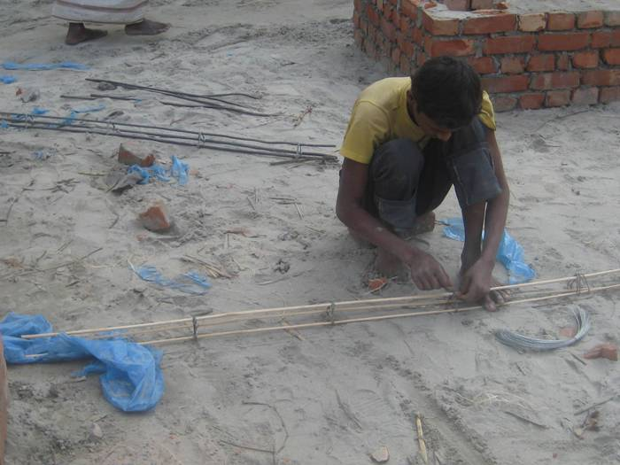
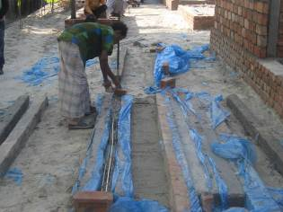
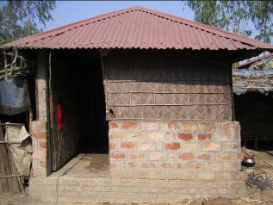
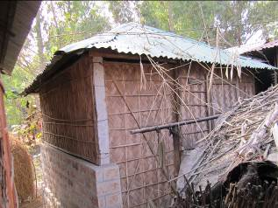
Bamboo bar tie with ring
Bamboo reinforced pillar
Store house front side
Store house back side

Location of piloting

Initially it was tested in four corner pillars of a store house not in the living house to avoid any risk. It was implemented under the 1st cluster village at Vatpiary of Sirajganj. People are storing seeds and crops in this houses.

Findings so far

The houses were handed over to the beneficiaries on 21 May 2011. About 2 and half years have passed. During this tenure it is working as a RCC pillar and no fault or defects were found in the pillar and house as well. A comparative cost analysis is given in the table below which reflects that cost reduced to 50%. It is easy to make. More durable and less operation and maintenance cost. Wind resistant up to the certain level during monsoon based on field observation but not tested the wind speed at which it withstand.

- Cost analysis: RCC pillar vs. Bamboo reinforcement concrete pillar

Sl. No. | Item | Cost in BDT
Sl. No. | Item | RCC pillar | Bamboo Reinforced concrete pillar | Remarks
1 | Cement- 0.20 bag | 90.00 | 90.00 | Material rate as of March 2010 Pillar size: 4 inch x 4 inch and 10 feet long
2 | Sand - 0.50 cft | 7.00 | 7.00
3 | Brick Chips - 1.00 cft | 60.00 | 60.00
4 | 10 mm dia MS rod-5kg | 275.00
5 | 10 mm (Aapprox.) dia bamboo bar |  | 30.00
6 | Polythin | 10.00 | 10.00
7 | Forma or Mold | 5.00 | 5.00
8 | Mason | 25.00 | 25.00
9 | Helper | 15.00 | 15.00
 | Total amount per pillar | 479.00 | 234.00

Future scope of application
Housing status in Bangladesh based on type of Structure

 | Total in thousands (% based on individual item) |  | Urban |  | Rural
Type of structure | Number | Percent | Number | Percent | Number | Percent
Jhupri | 2202 | 100 | 434 | 20 | 1768 | 80
Kutcha | 18625 | 100 | 2732 | 15 | 15893 | 85
Semi-Pucka | 2535 | 100 | 1321 | 52 | 1213 | 48
Pucka | 1673 | 100 | 1241 | 74 | 431 | 26
Total | 25034 | 100 | 6035 | 100 | 19456 | 100

As per the above table we can use bamboo reinforcement for the houses under the type of Jhupri, Kutcha and Semipucka.

