# Cholera/ Watery Diarrhea Preparedness and Response in Schools, Daycares and Child Friendly Spaces

* **Cholera can lead to death within hours**
* Early treatment with fluids such oral rehydration salts (ORS) saves lives
* Cholera is spread through contamination of drinking water and food from stools or vomit from an infected person, and sometimes contaminated surfaces
* Spread can be prevented by treating water (e.g. chlorination), washing hands, decontaminating areas infected by diarrhea and vomit and making sure food is washed with clean water and well cooked

**Be prepared…**

* Have a plan ready so everyone, including children, knows what to do if the community is at risk of cholera including where to go for help (community leaders, health centres) and when to close schools.
* Make one staff member responsible for coordinating cholera preparedness and response.
* 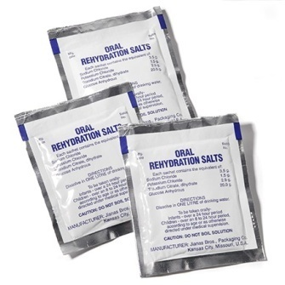Educate children, teachers and child caregivers on the basics of cholera; how it is spread, ways to prevent it, how to administer early treatment and seek health care.
* Have a supply of ORS sachets and safe drinking water available (and easily accessible at all times) to start rehydrating immediately. Have a way of measuring 1 litre ready to ensure the proper doses of ORS. If ORS sachets are not available ORS can be made with sugar and salt: in a clean container mix: 1 litre safe water, ½ flat small spoon salt (3gms) and 8 big spoons of sugar (18gms).
* Know where to send sick children or staff for health care, and be informed about opening hours.
* Train staff who prepare food in the kitchen on hygiene and safe food practices.
* Educate all children and kitchen staff to wash their hands with running water before handling food, eating and after toilet use. Only use treated water for drinking and cooking purposes.
* Have a small quantity of chlorine (HTH or bleach) in stock or know how to get it.

## If a child or staff member has acute watery diarrhea

* Start to give ORS immediately
* Seek professional healthcare as soon as possible as cholera can kill in hours. Continue ORS while going to the health centre. It is safe to assist cholera patients as long as safety measures like washing hands and disinfecting contaminated clothes are respected!
* Contact the family members or caretakers of the ill child or staff member, while looking for immediate medical attention (ORS point, or medical facility), provide them with key messages on how it is spread including disinfection of the home, early treatment and how to seek health care
* Wash hands with soap or a 0.05% chlorine solution if in contact with patient’s vomit and or stool as they are highly contagious (see reverse for how to make chlorine solution).

**Once someone is suspected to having cholera…**

* 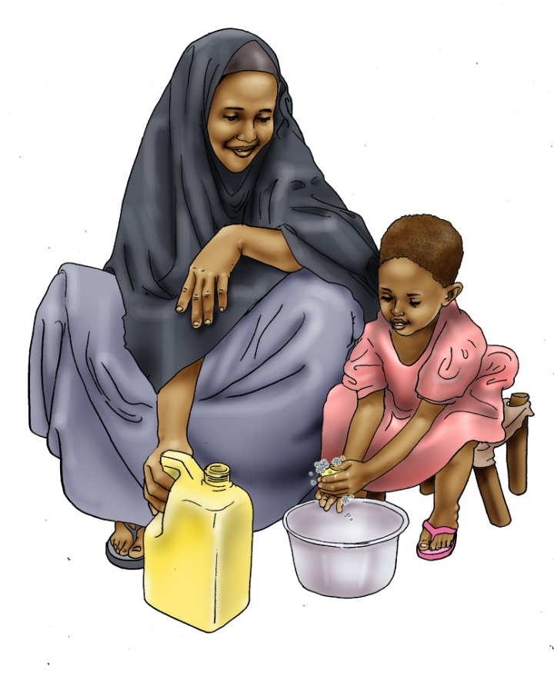Wash caretakers’ clothes with a 0.05 % solution and dry in direct sunlight. If no chlorine is available boil contaminated clothes. If boiling or disinfection with chlorine is not possible; wash contaminated clothes with soap or leave them to dry in direct sunlight. Infected clothes should never been washed close to a drinking water sources!
* Disinfect toilets and places the person might have had diarrhea or have been vomiting with a 0.2% chlorine solution or soap.
* Disinfect chairs, dishes, etc used by patient with a 0.05% chlorine solution and dry in the direct sunlight. If no chlorine is available direct sunlight in a dry environment will be a very effective disinfectant.
* Place a caretaker near the latrine to make sure everyone washes their hands. Only around 20% of the people affected by cholera will show there may be more infected people who can transmit cholera without you knowing.
* Disinfect latrines (latrine slab door-handles etc) with a 0.2% solution on a daily basis. If no handwashing facilities are available it might be advisable to close the school of facility after the first case is reported.
* Follow kitchen hygiene instructions (see separate sheet).

|  |  |
| --- | --- |
| **http://www.pollardwater.com/images/HTHPace3.gifHOW TO MAKE A CHLORINE SOLUTION** | |
| **0.05 %** | **0.2%** |
| With HTH 70%:   * **1 tablespoon in 20 litres of water** | With Chlorine HTH 70%:   * **1 tablespoon in 5 litres of water** |
| With Bleach 5 % (Sodium hypochlorite solution):   * **14 tablespoons in 20 litres of water**   **HTH**   * **¼ of cup in 20 litres of water** | With Bleach 5 % (Sodium hypochlorite solution):   * **20 tablespoons in 5 litres of water** |
| Note: 1 table spoon = 10 mL, 1 cup = 200 mL | |