**KITCHEN and COOKING Recommendations for Schools and Children Centres for Cholera Response**

***~ If you can’t cook it or peal it don’t eat it ~***

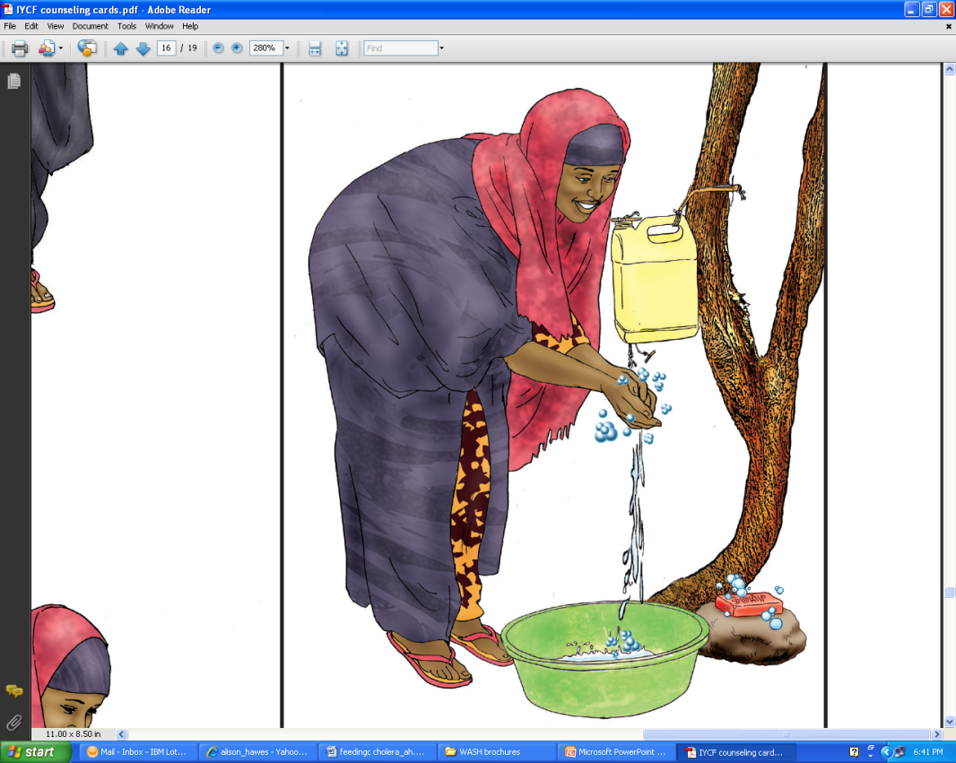**Preparedness…**

* **Cholera can lead to death within hours**
* Early treatment with fluids such oral rehydration salts (ORS) saves lives
* Cholera is spread through contamination of drinking water and food from stools or vomit from an infected person, and sometimes contaminated surfaces
* Spread can be prevented by treating water (eg chlorination), washing hands, decontaminating areas infected by diarrhea and vomit and making sure food is washed with clean water and well cooked
* Educate all staff on the basics of cholera, its common transmissions routes and ways to prevent it. (see school leaflet on cholera and the above points on common sources of infection)
* Educate all staff members working in the kitchen and handling food or cooking utensils to wash their hands with soap or 0.05% chlorine solution* before cooking or handling food.
* Only allow kitchen staff to enter the kitchen and to serve food.
* 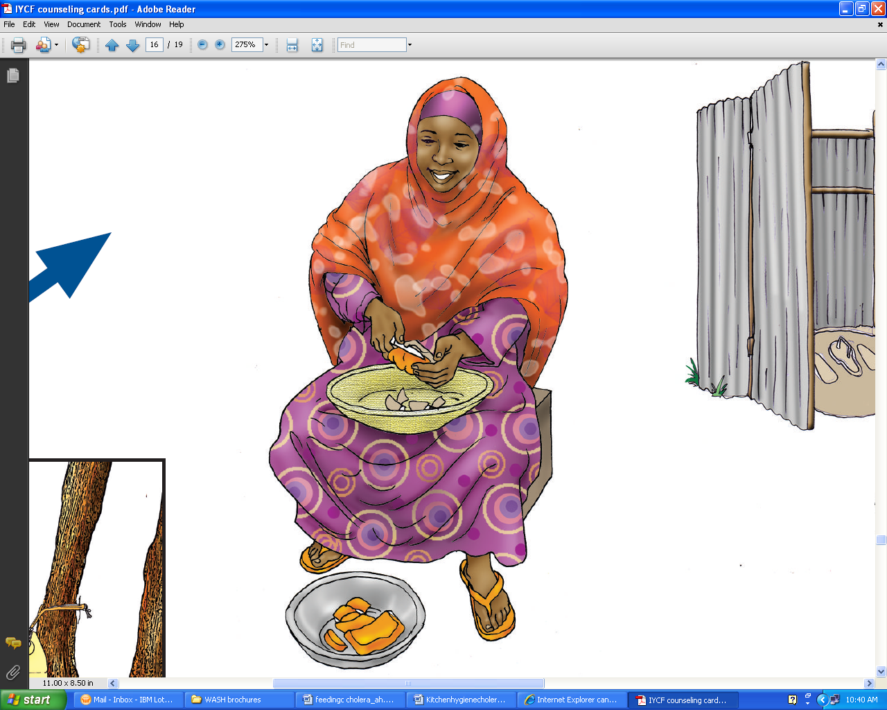All food served should be properly cooked, and served hot.
* Wash all food in treated running water.
* All food should be properly stored to prevent contamination from insects etc.
* Preferably only use fruits that can be pealed. Wash other fruits with running treated water (not a bowl) before eating.
* Wash dishes with soap or a 0.05% chlorine solution* and rinse under running treated water. Dry dishes in a rack well above the ground and in the direct sunlight (sunlight will help to disinfect).
* All students should wash their hands with soap and running water or a 0.05 % chlorine solution before eating
* Never wash your hands in a bowl of standing water, always use running water!
* Do not allow children and or teachers to eat with their hands form the same plate/pot etc.
* Bury and leftover food so it is inaccessible to scavengers.

**\* NOTE: SEE REVERSE FOR INSTRUCTIONS ON HOW TO MAKE 0.05% and 0.2% CHLORINE SOLUTIONS**

**If a cholera case is suspected**

* Avoid salads when cholera patients have been reported in nearby communities
* Do not use raw fish
* Rinse cooking utensils in a 0.05% chlorine solution after washing with soap. If no chlorine is available exposure to direct sunlight can disinfect cooking utensils.
* In case a staff member has been vomiting within the kitchen, all food within the kitchen and already prepared or cooked should be destroyed. All places infected with vomit should be washed with a 0.2% Chlorine solution.

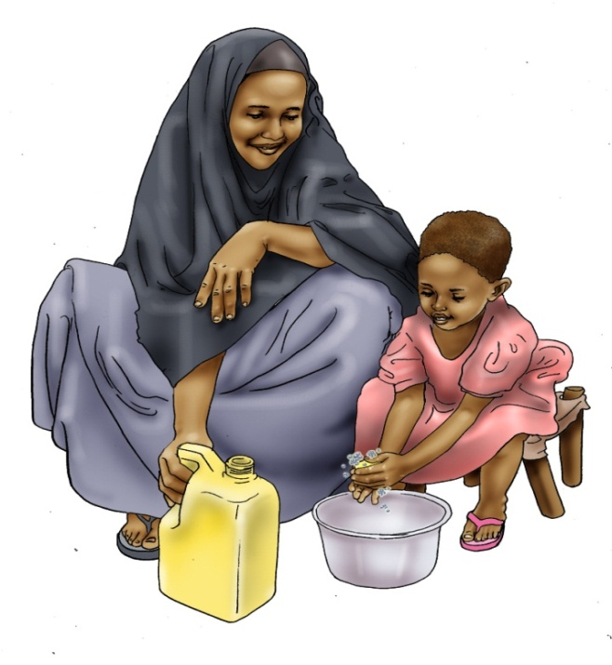**Common sources of infection**

* Drinking-water that has been contaminated at its source (e.g. by contaminated surface water entering an incompletely sealed well), during transport and/or supply, or during storage (e.g. by contact with hands soiled by faeces).
* Ice made from contaminated water.
* Cooking utensils washed in contaminated water.
* Food contaminated during or after preparation. Moist foods (e.g. milk, cooked rice, lentils, potatoes, beans, eggs, and chicken) contaminated during or after cooking/preparation and allowed to remain at room temperature for several hours.
* Seafood, particularly crabs and other shellfish, taken from contaminated water and eaten raw or insufficiently cooked or contaminated during preparation.
* Fruit and vegetables grown at or near ground level and fertilized with night soil, irrigated with water containing human waste, or “freshened” with contaminated water, and then eaten raw, or contaminated during washing and preparation.

|  |  |
| --- | --- |
| **http://www.pollardwater.com/images/HTHPace3.gifHOW TO MAKE A CHLORINE SOLUTION** | |
| **0.05 %** | **0.2%** |
| With HTH 70%:   * **1 tablespoon in 20 litres of water** | With Chlorine HTH 70%:   * **1 tablespoon in 5 litres of water** |
| With Bleach 5 % (Sodium hypochlorite solution):   * **14 tablespoons in 20 litres of water**   **HTH**   * **¼ of cup in 20 litres of water** | With Bleach 5 % (Sodium hypochlorite solution):   * **20 tablespoons in 5 litres of water** |
| Note: 1 table spoon = 10 mL, 1 cup = 200 mL | |